Week 5 Lesson 1:
Indoor Air Pollution –
and Why We Should Get Outdoors

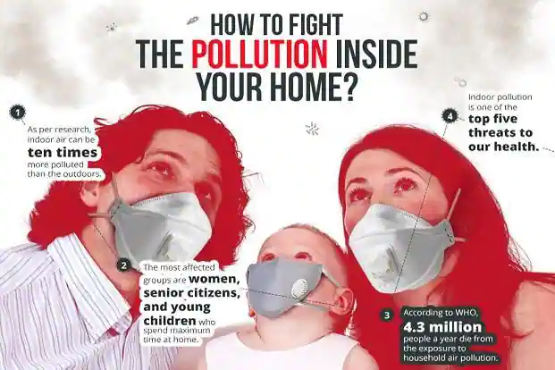

Success Criteria: By the end of the week, students will be familiar with the physical health benefits of being outdoors and the risk of a number of health problems from breathing indoor air – especially for children – and what can be done about it. In most cases in New Zealand, outdoor air is better than indoor air.

Task 1: Watch the short video clip on indoor air pollution.
https://www.youtube.com/watch?v=b_o5lLXTbc4
Studies show that indoor air pollution affects adults and children in different ways. Write the following questions and answers in your Red Book.
1. Why does indoor air pollution harm children more than adults?

2. List seven major impacts that indoor air pollution has on the health of children.
1.
2.
3.
4.
5.
6.
7.

3. What is the one thing that can be done to reduce the risk of indoor air pollution?

4. The claims made about how indoor air pollution affects children are supported by studies conducted where?

5. Do you think that indoor air pollution is a problem in your home? How could you reduce it?

Week 5 Lesson 2:
One of the Biggest Threats to being Stuck inside in New Zealand – is Mold.*
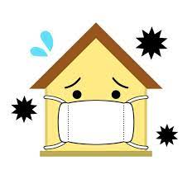
*also spelled mould

In this lesson we are going to look closer at the issue of indoor air pollution in New Zealand. We are going to read the article, “Indoor Air Pollution” from Kids Health. Here is the link: https://kids.niehs.nih.gov/topics/pollution/air/talk-about-air/index.htm.
Please write thefollowing questions and answers in your Red Books.
1. One of the issues with indoor air pollution is ‘particulate matter’ or PM in the air. Google ‘particulate matter’ and write down the definition.
2. List several examples of indoor air pollution in New Zealand homes (see paragraph #2)
3. What are dust mites? What do the eat? Why are they a problem?
The following questions are based on the video clip that is embedded in the article titled ‘The Monte Mold Chronicles)-
4. What is mold and why is it good for the environment?
5. Why are their spores (tiny particles that float in the air) a problem in Kiwi homes? (6:12 sec.)
6. What factors determine whether someone has a bad reaction to breathing in mold? (7:00 mark)
7. What are mycotoxins?
8. Why do some natural disasters involving flooding, help generate mold?
9. What is the best thing you can do to prevent mold from growing in your home?
10. What is the best way to bet rid of mold (10:10 mark)
If you are all caught up and would like to do some extra work – try the following Extension Exercise – Extra Credit – Optional (YOU DO NOT HAVE TO DO IT)
Indoor Versus Outdoor Air –
What every student should know

Read the article “Indoor Air versus Outdoor Air” at: https://www.mana.md/indoor-air-vs-outdoor-air/

Write down the question and answers in your Red Books.

1. Overall, if you compare how clean the air is inside and outside your home, which is usually healthier?

2. Studies have shown that indoor air pollution is how much worse than outdoor air quality?

3. List several health problems that have been linked to air pollution.

4. What can be done to improve the quality of air inside your home?

Week 5 Lesson 3
A Lesson on Anxiety and a Chance to Catch up
on all our Global Studies Work

With so much happening in New Zealand with Omicron and the start of the school year, we are taking this lesson time to make sure that ALL students are caught up on their work. I will be going around and checking your Red Books. But before we do, we are ALL going to watch on short video on kids and coping with stress – followed by a class discussion.

For those students who are caught up, I want you to write an imaginary letter to a friend who has been stressing out. What advice can you give him or her based on the video?

Every student in class will be doing either:

A. Catching up on unfinished past assignments (I will work with you all separately on these during class)

Or

B. Writing a letter to a friend on how to deal with stress (based on the advice in the video).

