Global Studies – Year 7
Week 6 Lessons 1-3
Cultural Identity

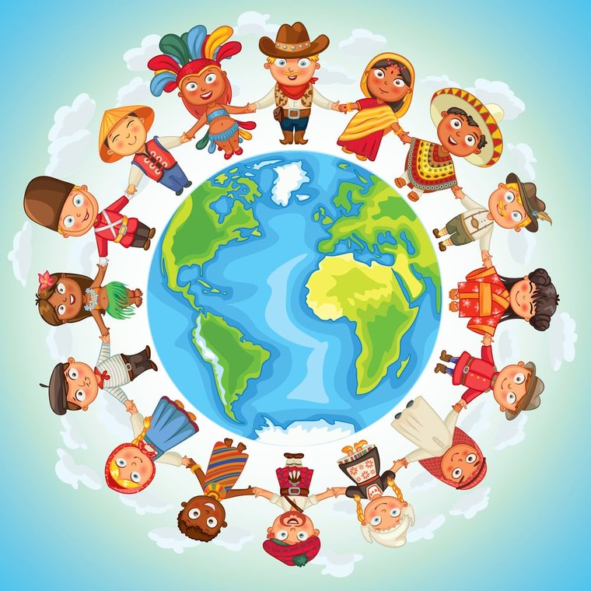

Success Criteria
This week we will focus on the concept of cultural identity in order to help us to better understand who we are and where we fit into New Zealand society. Students will become familiar basic vocabulary and ideas related to identity and what it means to live in a multicultural society.
Lesson 1: Students will watch the video on cultural identity
“Well-being for Children – Identity and Values.”
https://www.youtube.com/watch?v=om3INBWfoxY
Write the following definition of cultural identity into your Red Books:
Cultural identity refers to a person’s sense of belonging to a particular culture or group. This process involves learning about and accepting traditions, heritage, language, religion, ancestry, aesthetics, thinking patterns, and social structures of a culture.

CLASS DISCUSSION on cultural identity

Ordinarily I would have you look up the definitions below, however, I want you to have the definitions exactly as I have written them. Please write them into your Red Books.
Key Vocabulary words:
Culture: a belief or customs handed down through generations, often by word of mouth or through accepted practices and ways of working.
Race: a group of people thought to have the same ancestors and with physical characteristics (e.g., skin colour and hair colour; eye and nose shape) that differ from those of other groups.
Ethnicity: a social group that has a common national or cultural tradition.
Multicultural: a society that includes groups of people from many different cultures living together.
Values: a person’s principles or standards; judgements of what is valuable and important.
Beliefs: judgements of what is valuable or important and are held to be true.
Diverse: varied – having different kinds
Tradition: transmission of customs or beliefs from generation to generation.
Racism: a belief that one race is better than another (*race is a myth there is no such thing!) but because many people believe it – it is real to them just like Santa or the Easter Bunny.

Week 6 Lessons 2:
We will spend this time focusing on understanding YOUR own cultural identity and NEW ZEALAND cultural identity. This will help you with the assessment that is coming up.
We will also hear from those students who have yet to give their cultural icon presentations in class.

Write the following headings in your book.
Our Culture – Who Am I?
Write down your ideas below (include ethnicity – your ethnic group, for example, Indian, Fijian Indian, Korean, etc. Please note – your nationality is not an ethnic group. American, Canadian, etc. are not ethnic groups, they are nationalities).

Describe your Mission Heights Junior College Identity (The school; the whanau; the class (e.g., 7M1); the community (e.g., Auckland, Flat Bush, Jeffs Road, etc.)

Week 6 Lesson 3 – Cultural Identity Continued:
Write about how Mountains Whanau differs from other Whanaus

Write about what our identity is as a New Zealander

Class discussion – students will also discussion what they have written and share it with the class.

