Week 10: Current Events Analysis

New Zealand Bees are in Trouble –
Why it’s a Big Deal

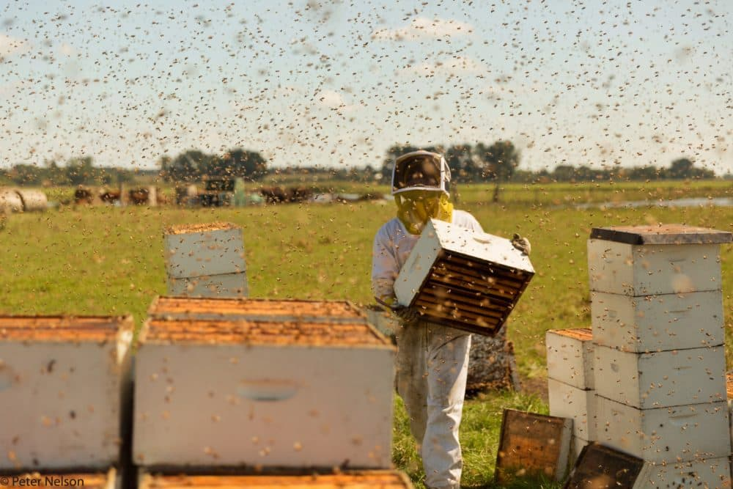

Success Criteria: This week we will focus on Current Events in New Zealand. By the end of the week they will be able to identify two key issues facing Kiwi society, why they are major problems, and what can be done to address them.

Week 1 Lesson 1: Kiwi Honey Bees

Kiwi honey bees are being lost in great numbers and this could have an adverse impact on our plant life.

Task 1: Watch the short video clip on the importance of bees and pollination at:
https://www.youtube.com/watch?v=rac_D_v-nrc

Class Discussion: Why are honey bees important to life in New Zealand?

Task 2: Read the article at:
https://www.stuff.co.nz/national/300494358/new-zealand-bees-may-soon-become-endangered-due-to-pest-threat-expert-warns
then answer the question below:

According to the article there are two major issues facing honey bees in New Zealand: 1) varroa mite exposure and 2) toxic exposures

1. Look up information about varroa mite exposure – explaining the problem and its significance, and what can be done to stop it. Here is an article you can consult -

https://www.stuff.co.nz/business/farming/111749642/bee-colony-deaths-continue-highlighting-need-for-more-research

2. Research information on honey bees in New Zealand and the threat from pesticides. You can do this on Google or the EPIC database under Australia & New Zealand Reference Centre.

Lesson 2: How to Avoid Being Scammed by Online Scammers

They are a dime a dozen in 2023 and scams are not slowing down, coming in all forms through calls, text messages and emails. In this lesson we will look at a common scam and then talk to Telstra's cyber security expert Darren Pauli who shared his top tips on what to look out for and how to avoid getting scammed. Before we listen to

Class Discussion: How susceptible do you think you are to being scammed. Have you ever been part of an online scam that took your money?

Task:

Watch Clip 1) on scams in New Zealand at: https://www.youtube.com/watch?v=wu4PSPFYrcU (6:12 sec).

Watch Clip 2) https://www.stuff.co.nz/business/132493369/the-email-text-and-phone-scams-that-are-catching-people-out 2:16 sec.)

Paragraph Writing:

Based on the clips, in a paragraph outline what are some common scams in New Zealand, and in a second paragraph, describe what steps can people take to avoid them?

Paragraph #1: Define what an online scam is and describe some common ones.

Paragraph #2: What can Kiwis do to avoid being scammed?

Lesson 3: A class discussion on how the term has gone – what went well and what didn’t - and a discussion for possible topics in Term 4.

