Create an informative educational brochure of an Auckland Volcano to persuade your parents to go there on a family trip.

You must include:
- Geological origins of the volcano
- A map of the volcano including natural and cultural features
- Directions describing how to get there from your house
- Benefits to your own and your families well being because of the visit

You may choose ANY Auckland volcano, below see some choices of the volcanoes in Auckland
- North Head
- Mt Victoria
- One Tree Hill
- Rangitoto
- Mt Albert
- Mt Roskill
- Auckland Domain
- Mt Wellington
- MtEden

Planning - Session 1 - (mind map)
- Use the mind map diagram below to help you plan your informative / educational resource
- Decide on how you are going to present your educational resource
- Start researching
- Please show this to your teacher (Mrs Bartlett Ms Steel, Mr Hishey or Mr Gardi )BEFORE you start on your assignment

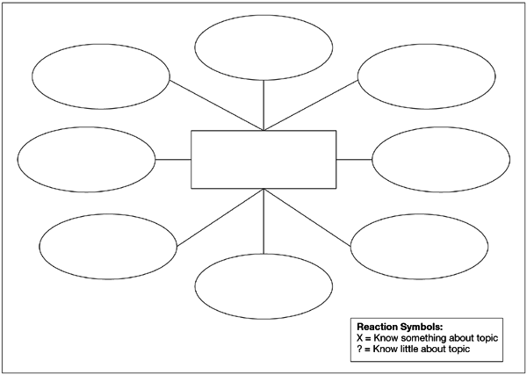

Below is a list of words/information that needs to be included in your resource.
Check that you have covered all the criteria before handing in your assessment

Criteria to discuss in educational resource | Tick if done
Where is NZ in terms of tectonic plates
How are volcanoes formed - use the following words and include a diagram
Magma pipe, magma chamber, cone, vent, eruption plume
What kind of volcanoes are there - composite / shield/ cinder / super
Describe the differences
Describe the differences between volcanoes up in Auckland and volcanes further south
Name some New Zealand volcanoes and the effects of their eruptions
What Volcano have you chosen to research ? What kind of Volcano is it
Where exactly is it in NZ - show this on a map
What kind is it ? When did it last erupt ? Is it classified as dormant, extinct or active ?
Maori name for your volcano
Civil defence- what should people do to be prepared in the event of a volcanic eruption ? What must we do in a volcanic emergency ?
Other words that could appear in your informational resource
- Mantle
- Magma
- Lava
- Crust
- Igneous
- Sedimentary
- Metamorphic
Visual aids have been included, they are age related. Pictures and diagrams
Session 2:
- Start the research
- Decide on the volcano
- Start writing
Session 3:
- Assessment should be near completion
- Check in with Mrs Bartlett, Ms Steel or Mr Gardi
Session 4: UPLOAD DAY !!
- Final Brush up and checking that all criteria are included in the resource
- Check upload can this be opened ?
TAAB for Year 8 Assessment 1: SCIENCE ONLY

Science | Earth Forms | You have identified forms that make up our planet | You have described different forms that make up our planet | You have described, with examples, different forms that make up our planet | You have accurately described, with a variety of examples, different forms that make up our planet
 | Rocks and Soil | You have identified how rocks and soil make up our planet | You have described how rocks and soil make up and changes our planet | You have described , with examples, how rocks and soil make up and changes our planet | You have accurately described, with a variety of examples, how rocks and soil make up and changes our planet
Accuracy in writing |  | You have made errors in grammar, spelling and/or punctuation. These are intrusive and affect meaning | You have made errors in grammar, spelling and/or punctuation. These are intrusive at times, but the reader can infer meaning | You have made some errors, but minimal reader inference is needed.  Meaning is consistently clear | You have carefully edited your writing to ensure you have few (or no) intrusive errors.  Meaning is consistently clear
Time management |  | You have yet to complete and submit your assessment | You have submitted your assessment late | You have submitted your assessment by the date 27 May | You have submitted your assessment by the date 27 May
Overall |  | WORKING TOWARDS Curriculum expectation | Working AT curriculum expectation | Working ABOVE curriculum expectation | Working BEYOND curriculum expectation

