Week 5:
Women, Inequality
& Work Around the World
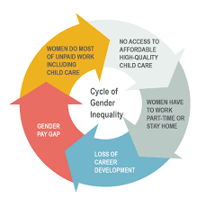

Success Criteria:
Students will be able to describe examples of gender inequality in different parts of the world and the specific human rights that are being violated in the United National Universal Declaration of Human Rights.

Lessons 1 & 2: Gender Inequality Around the World

This week we are going to look at inequality in females – their unequal treatment in different parts of the world.
Task 1: Watch the Video clip:

“Malala Yousafzai, 16, and Her Miraculous Story of Survival.”
https://www.youtube.com/watch?v=CXvs1vwiD0M (4:04 sec.)
Task 2: 2-minute Write – what is your reaction to the video and your opinion on Malala in general?

Class Discussion:
Why should we consider ourselves lucky to live in New Zealand? Why is something like this less likely to happen hear (hint: we value tolerance, diversity and inclusion).

Task 3: Look up and write into your Red Books the definitions of the following words:
Vocabulary words:
1. Gender:
2. Equality:
3. Adolescence:
4. Gender role:
5. Poverty:
6. Human rights:
7. Conservative:
8. Guardian:
9. Tolerance:
10. Diversity:
11. Inclusion:
12. Displace:

Task 4: Read the article below:

Surprising Examples of Gender Inequality

Around the World
By Tess Lowery, Global Citizen, September 10, 2022

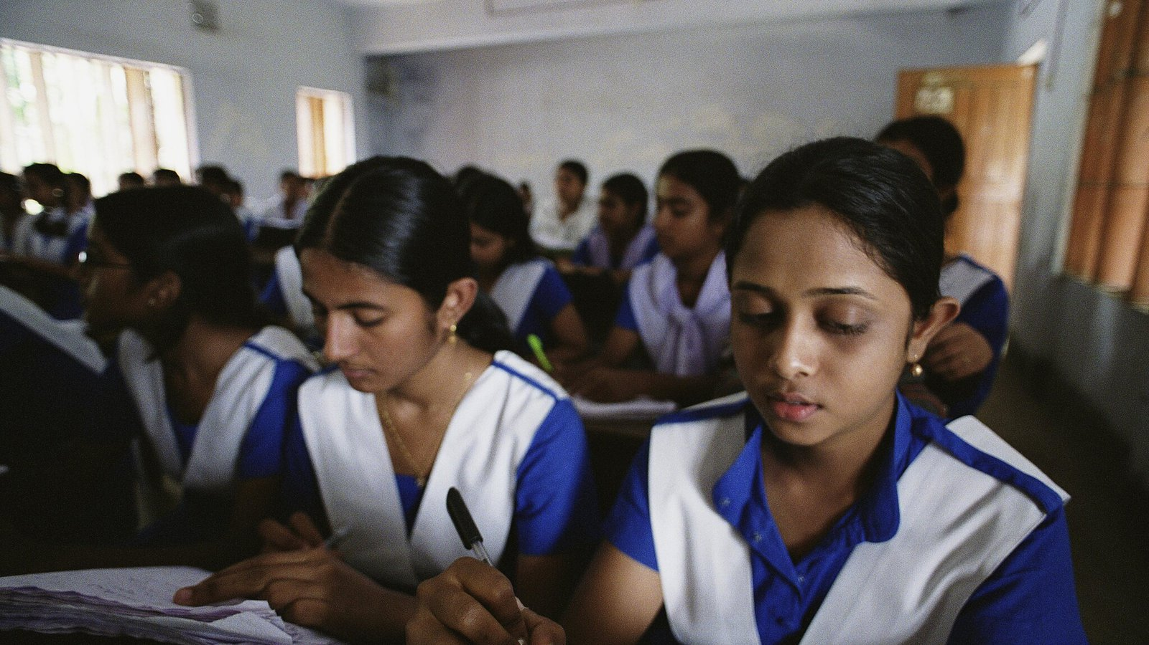

1. Not a single country in the world has achieved gender equality.
The worst countries for gender equality in 2022 were Sudan, Yemen, Afghanistan, and Chad.
South Sudan has some of the highest rates for forced marriage and female mortality. In Chad, child marriage is also widespread among girls, reducing girls’ education and resulting in one of the highest rates of early childbearing worldwide. In Yemen, women cannot marry or receive health care without the permission of their male guardian and do not have equal rights to divorce or child custody. The legal system has few provisions for the protection of women who experience domestic and sexual violence — leaving some women vulnerable to becoming the victims of so-called honor killings.
*An honor killing is the practice in some countries of killing a family member who is believed to have brought shame on the family – for instance, by marrying someone without the permission of the parents or doing something that is seen an embarrassing.

2. Over 380 million women and girls are living in extreme poverty.
That’s more than the entire population of the United States living on less than $1.90 a day.
Worse still, if current trends continue, more women and girls will live in extreme poverty in sub-Saharan Africa by 2030 than today. In fact, the majority of the world’s poor are women. Why? Poverty disproportionately affects women because they do not have as many opportunities as men to receive an education, work, or own property.

6. There are more forcibly displaced women and girls than ever before.
Some 44 million women and girls were forcibly displaced by the end of 2021 whether by climate change, war, conflict, or human rights violations — a record level.
For women, displacement isn’t the end of their problems, it’s only the beginning. They often lose their property, assets, livelihoods, and access to health care. It also exposes them to greater risks of violence, trafficking, and sexual abuse. In some countries, women do not have a choice – they must follow their husbands and do what they say.

7. 130 million girls remain out of school worldwide.
Around the world, girls miss out on education more than boys. A third of the world's poorest girls between 10 and 18 have never attended school, and in rural areas, 61% of girls do not attend secondary school. Girls’ education is an important part of addressing every aspect of ending extreme poverty. When girls receive a quality education, every area of their lives and communities benefit. Women who complete secondary education go on to make higher incomes with each additional year of schooling boosting a girl’s earnings as an adult by up to 20%.

8. Women shoulder billions of hours of unpaid childcare globally.
You’d be forgiven for thinking that women doing all the chores around the house is lower down on the list of gender equality priorities. It’s just a bit of washing up, right? Well, those hours add up, especially for women and girls who live in poverty and and it keeps them out of schools and jobs. This is referred to as unpaid care work. Unrecognized and undervalued, this invisible labor falls largely on mothers and daughters.

9. Almost 1 in 3 women experienced food insecurity in 2021.
Women are more likely than men to experience food insecurity, and the gender gap is growing. Globally in 2021, nearly 1 in 3 women experienced moderate or severe food insecurity — and it’s only predicted to get worse if action isn’t taken immediately.

12. Women hold just 26.4% of parliamentary seats
As of July 2022, women held just over a quarter of parliamentary seats around the world. In 23 countries, they held less than 10% of seats. This isn’t about to change any time soon with the earliest date for parity forecast for 2062.

13. Women earn just 77 cents for every dollar men earn.
Women earn less money over the span of their working lives than men.
Factors that contribute to this gender-based wealth inequity are gender pay gaps, unequal career progression trajectories, gender gaps in financial literacy, and life events. For frontline operational roles, for example, the overall gender wealth gap amounts to 11%; for professional and technical type roles, the gender wealth gap nearly triples to 31%; and for senior expert and leadership roles it expands further to 38%, according to the World Economic Forum.

Task 4: Brainstorm examples of gender inequality involving females:
1.
2.
3.
4.
5.
6

Task 5: Now look at the List of Human Rights under the United Nations Declaration:
https://www.un.org/en/about-us/universal-declaration-of-human-rights

List those rights that are being violated in the examples given in the reading. Write down the Article that is involved and HOW their rights are being violated.

*You may wish to revisit List week’s lesson for examples.

For example:
1. Article 23: “Everyone, without any discrimination, has the right to equal pay for equal work. Everyone who works has the right to just and favourable remuneration (pay)...”

Response: 380 women are living in poverty in part because they do not receive nearly as much money as men for the same work.

List at least 3 more Article here -------------------------

Week 4 Lesson 3:

How Much Screen Time is Too Much:
There are Fears Over How Much Time Kiwi Kids are Spending on their Computers

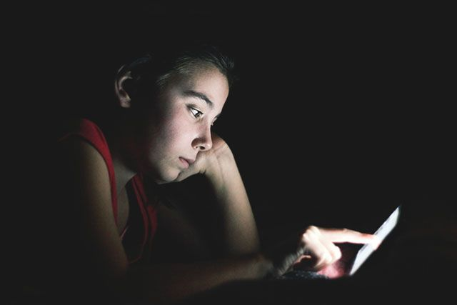

Success Criteria
Students will gain a thorough understanding of the recent research conducted in New Zealand on the impact of screen time on an array of health issues. By the end of the lesson students will be able to identify at least three health problems associated with too much screen time and be able to recount the recommended amount of time that experts say students should be limited to over any given 24-hour period.

Reading: Read the article and answer the questions below:
Davison, Isaac (2023). “NZ kids spend a third of after-school time on screens, call for urgent online regulations.” New Zealand Herald, July 7, 2023.

1. After school hours, how much time on average are Kiwi kids spending on their computers (this includes your mobile phone!)?

2. Why did an Auckland mother ban TikTok in her household?

3. What problem can be caused by spending 10% of your screen-time on more than one screen?

4. According to Dr Moira Smith, what are some of the problems caused by too much screen-time for kids?

5. When comparing screen time, how much time Kiwi girls spent online compared to boys? Who spends more time on their screens?

6. Who spent more time online in New Zealand – European students or Māori and Pacific students?

7. Research by the University of Auckland recommends that Kiwi children not exceed how much time on their screens each day?

8. How much time do you spend online during the average school day?

9. Do you believe that you spend too much time online?

10. What is the best way to reduce the amount of time students are spending online? What action do you think the Kiwi Government should take to cut online screentime?

How much time do you spend online during a typical day?* (includes mobile phone!)
Make an estimate below and tally up the times.
Minutes per hour
6 am
7am
8am
8:30am
10:30am-11am
3pm
4pm
5pm
6pm
7pm
8pm
9pm
10pm
11pm Midnight 1am
2am
3am
+
____________
Total hours per day ________________________________________________
*If you finish early create a poster on a single page in your Red Book to help Year 7’s to better deal with issues related to too much screen-time. List issues & possible solutions.
Reading:
NZ Kids Spend a Third of After-School Time on Screens, Call for Urgent Online Regulations

Alarmed experts have sounded a warning for the mental and physical wellbeing of Kiwi children after new research revealed our kids are spending about a third of after-school time on screens. The high rate of screen time is exposing youngsters to cyberbullying, harmful sexualised content and inappropriate advertising for sectors such as alcohol and gambling.
YouTube and Netflix are the most popular websites, with one in three children under 14 using social media, most commonly TikTok, which is rated R13. An Auckland mother of five says her family try to limit screen time and use of devices during the school week and has banned TikTok in the house due to inappropriate content and swearing. In a University of Otago study, adolescents’ habits were tracked by body cameras between 3.30pm and bedtime, with screen time exceeding the recommended level – which is less than two hours a day outside school hours.
Kids were found to spend around 10 per cent of their time on two screens. Developing research says multiple screen use could be linked with poorer sleep (compared to single screen use).

The significant amount of time spent in front of screens raised health and wellbeing concerns, said senior researcher Dr Moira Smith, from the University of Otago’s Department of Public Health in Wellington. “It is associated with obesity (being overweight), poor mental wellbeing, poor sleep and mental functioning and lack of physical activity,” she said. “It also affects children’s ability to concentrate and regulate their behaviour and emotions.”

The Auckland mother said she and her husband were “pretty strict” about how much time the kids spent on electronic devices during the school week.
“If they’ve got homework, or maybe a movie, then we’ll let them on. Otherwise, they’re pretty busy from Monday to Friday with school sport training.
“In the weekend we’re a bit more lenient, but they have to do their chores first and maybe do a bit of reading and then they can spend a bit of time on their devices.”A lot of her friends had kids who were already on social media. “It’s scary, in case they’re watching something inappropriate and rude that we don’t know.”
While screen time was reasonably easy to navigate at home as both parents were on the same page, she said it would be harder in a single-parent home where kids might get left on devices more often “so they can do housework or whatever”.
The paper’s authors said the amount of time young people spent online also raised concerns around cyberbullying, exposure to sexism and racism, and exposure to advertising for vapes, alcohol, gambling and junk food.
New Zealand legislation was outdated and failed to adequately deal with the online world children were being exposed to, Smith said.
“While screen use has many benefits, children need to be protected from harm in this largely unregulated space,” she said. Last month, the Government began consulting on changes to how online content is regulated in New Zealand. That could eventually mean social media companies with a presence in New Zealand have to sign codes of practice requiring them to proactively manage harmful content.
The Otago study involved placing body cameras on 108 children and analysing images, which were taken every seven seconds.
A young person from the study wearing a body cam to track their screen time.

On average, children were in front of screens for 23 minutes of every hour outside school time. Boys were more likely to spend more time in front of screens, and Māori and Pacific adolescents had more screen time than young people of European descent.
Around 10 minutes per hour were spent in front of more than one screen. Researchers said this could carry additional health risks to single-screen use, with preliminary studies indicating an association with poorer sleep.
High rates of screen time raised health concerns because they displaced activities like active play and sleep. It also negatively affects a child’s ability to focus their attention and regulate their behaviour and emotions.
It was also problematic because of exposure to cyberbullying. New Zealand has high rates of cyberbullying, with around one in four parents reporting their children had been bullied online.
Research by the University of Auckland concluded that blanket screen limits - such as the two-hour recommendation - did not reflect contemporary family life.
The World Health Organization recommends school-aged children, up to 17, limit their recreational screen time.
Children aged 2 to 4 should not have more than one hour of screen time per day and even less is better, the WHO advises.
It also suggested kids younger than 2 should have zero screen time.
In March, Health insurer NIB New Zealand released findings from its annual State of the Nation Parenting Survey that showed technology use and the impact of screen time was the number one concern for 70 per cent of parents.
Half of those parents surveyed said children spent too much time on devices, and 66 per cent admitted relying on screens as a bargaining chip and distraction tool for children.
Seventy per cent of parents had taken action: limiting kids’ screen time (52 per cent) and taking away devices as punishment (57 per cent).
How much time should kids spend in front of screens?

