The Flowers | A | B | C
 | Explain why the story focuses on racism and loss of innocence and if it reminds you of anything else important like that. | Definition finder:  - Cove  - Sharecropper  - Discernment | Write about Myop’s personality throughout the story.
 | Describe what Myop does in the story. | Compare and contrast where Myop lives with where you are living right now. | What is an example of sibilance in the short story?
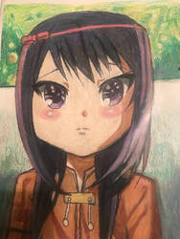 | Draw, design and label your own flowers which you would like to pick. | Describe what you would have done if you were in the same situation as Myop. | List the ways that the author prepares us for the ending of the short story.

