Like, Share, Subscribe | A | B | C
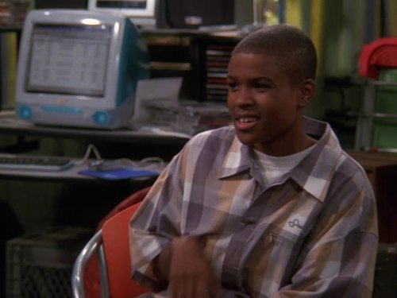 | Explain why the play focuses on screen time and if it reminds you of anything else important like that. | Definition finder:  - Exclusive  - Influencers  - Sheepishly | Write about the personalities of all the different characters throughout the play.
 | Describe what Emma is saying throughout the play. | Compare and contrast what the characters are doing with what you are doing right now. | What is an example of alliteration in the play?
 | Draw, design and label your own type of social media. | Describe what you would have done if you were in the same situation as Emma. | List the ways that the author prepares us for the ending of the play.

