Article Study Learning Grid | A | B | C
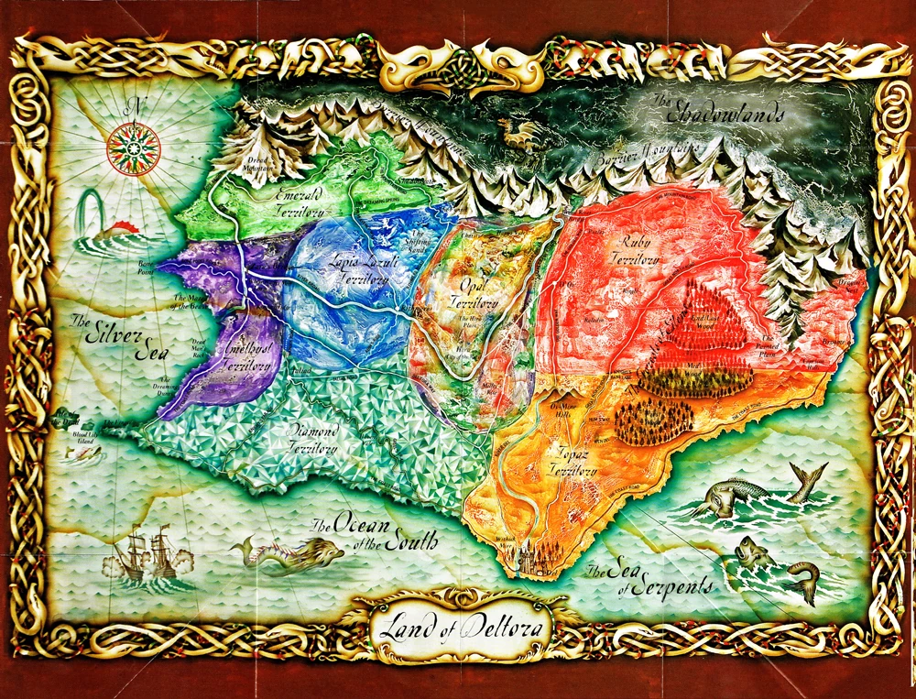 | Make a travel brochure to entice people to visit where your article is set in. Think about it as you read. What does it look like, what would it feel like to be there? | The plot is what happens in the order it happens. You will be asked to do a plot map of the article you have read after you have finished, so do a mind map or list of major events as you go along. | What other books have the same themes, genre similar like in the article that you are reading?
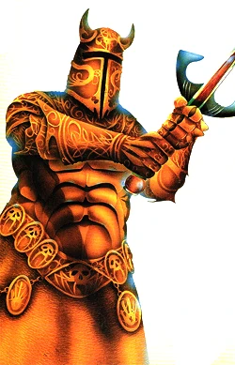 | Here is a list of themes that your article could be about, (articles can have more than one theme): Love, nature, identity, race, racism, sexism, religion, memory, family, history, politics, self-discovery, innocence, lost innocence, experience, wealth, life, death, power, age, war, conflict. Look out for these and write down the themes you finished reading in the article. | Writing to physically describe a Character:  Look over the examples in here (read 2-3) and record examples of the author describing a character's movements, origins, personality or appearance.  Then write about the similarities and differences the characters in the article that you read share with the one which you have chosen. | Write an alternative opening AND an alternative ending for the story that you read in your article.
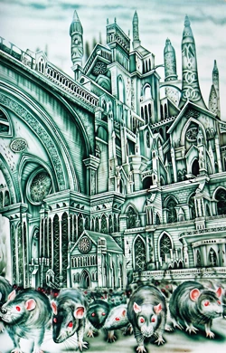 | Attempt to write a nice PHYSICAL description of the characters in the chapter you have read AND one of the Mountains Teachers  (focus on what they look like and their personality) | Draw your favourite scene or moment from the article you have read. | Write THREE questions you would like to discuss about the article you have read. Questions may be about why a certain character may have acted in a certain way, what was their motivation or catalyst to action.

