Waiting For Toni | A | B | C
 | Explain why the play focuses on patience and if it reminds you of anything else important like that. | Definition finder:  - Incorporated  - Apocalyptic  - Exasperated | Write about the personalities of all the different characters throughout the play.
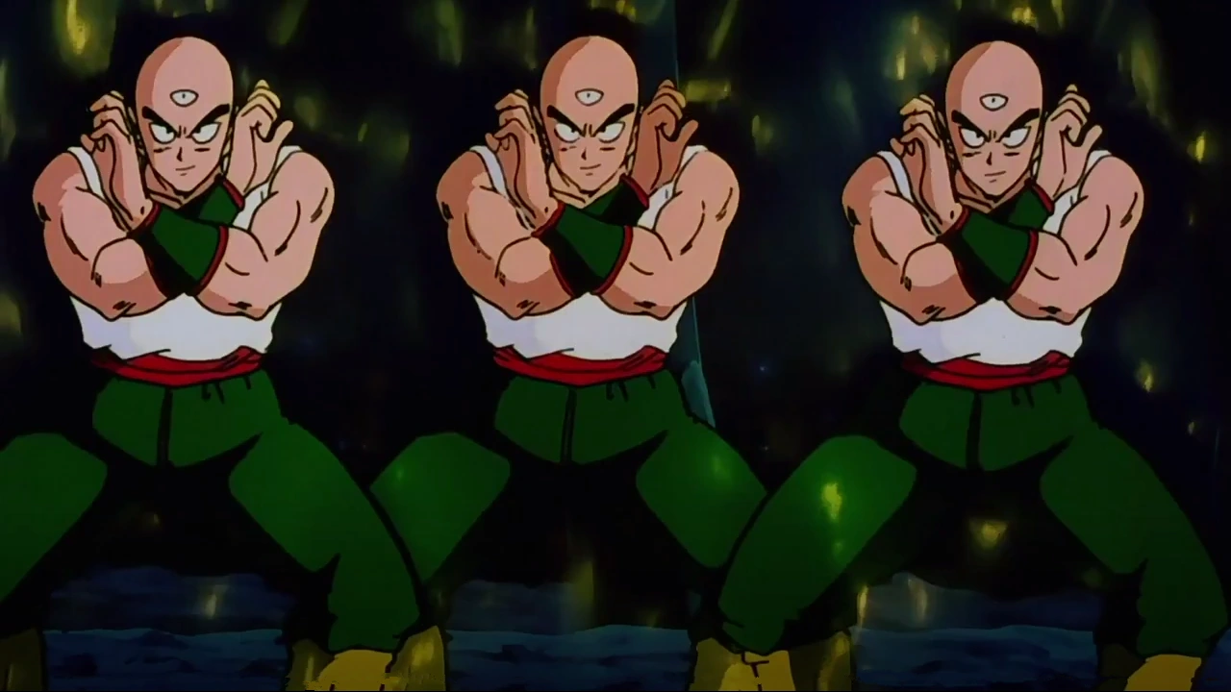 | Describe what Hannah does in the play. | Compare and contrast where the characters live with where you are living right now. | What is an example of repetition in the play?
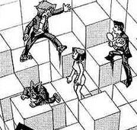 | Draw, design and label your own game which you would like to play. | Describe what you would have done if you were in the same situation as Ravi. | List the ways that the author prepares us for the ending of the play.

