The Beauty at the Heart of a ‘Spooky’ Mystery | A | B | C
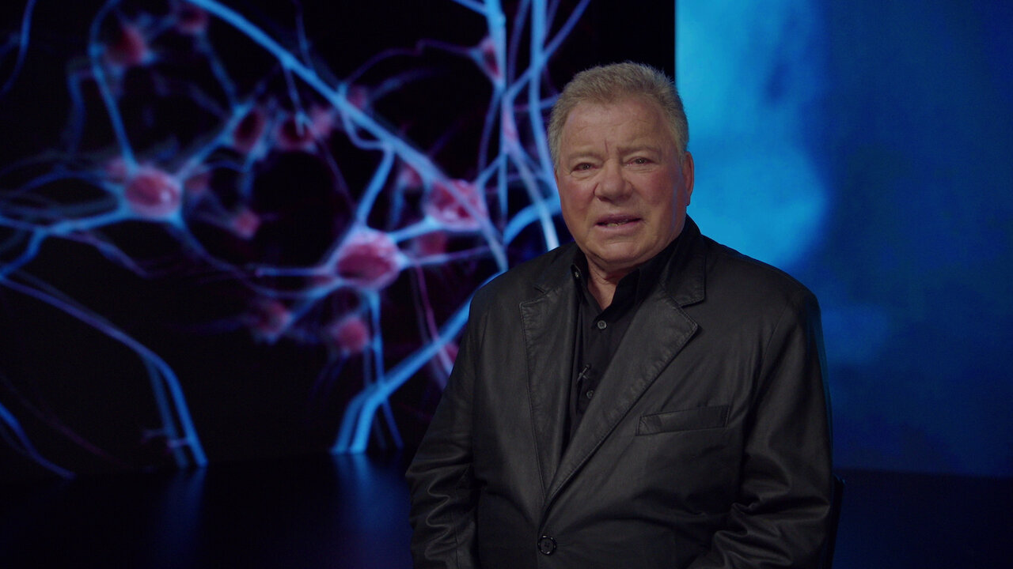 | Explain why the article focuses on what cannot be explained and if it reminds you of anything else important like that. | Definition finder:  - Propagate  - Entanglement  - Realism | Write about the personalities of the different people throughout the article.
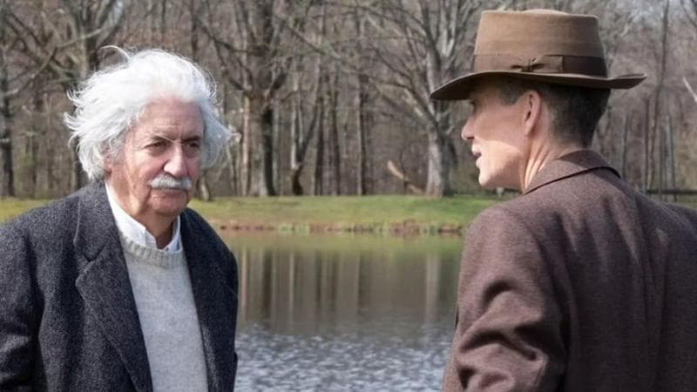 | Describe what Einstein mentions throughout the article. | Compare and contrast what the characters are doing with what you are doing right now. | What is an example of a metaphor in the article?
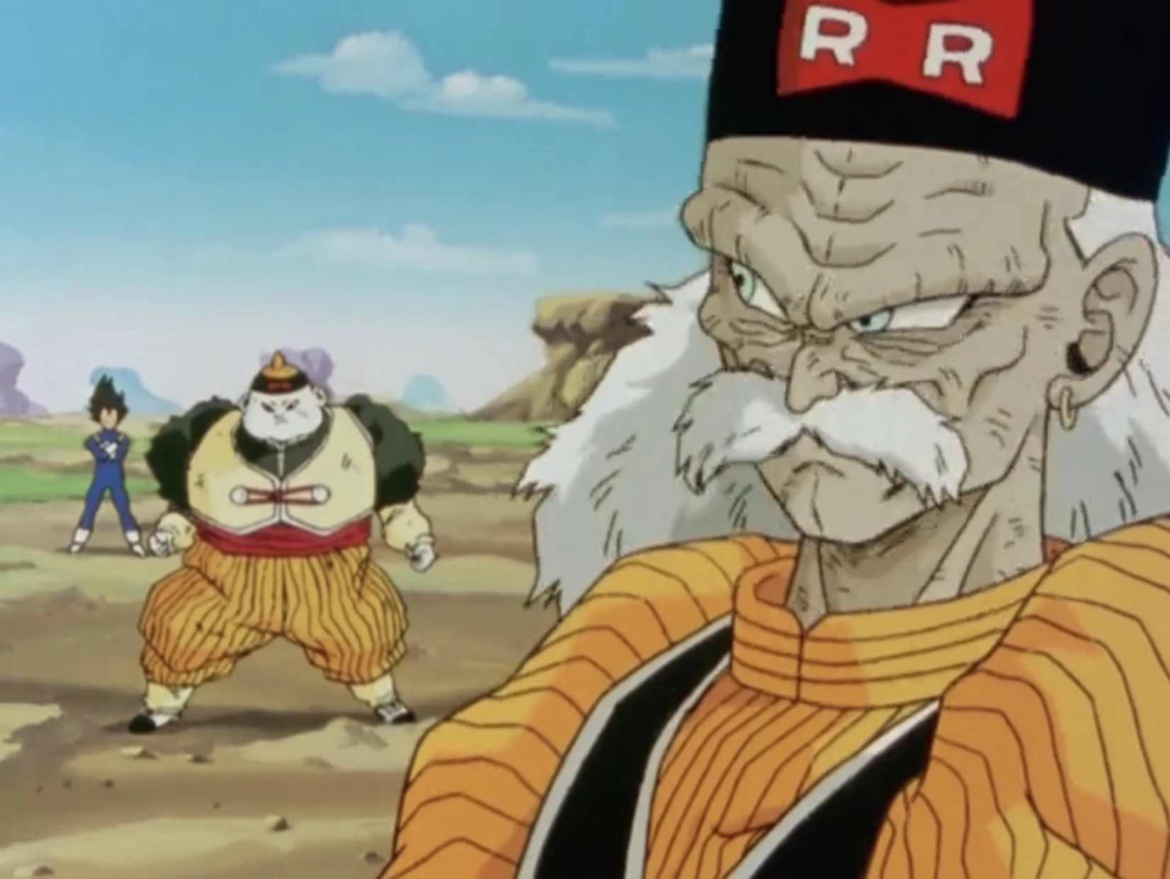 | Draw, design and label your own type of spooky scientific experiment. | Describe what you would have done if you were in the same situation as the scientists. | List the ways that the author prepares us for the ending of the article.

