Week 3: Human Rights
Forced to be Fat
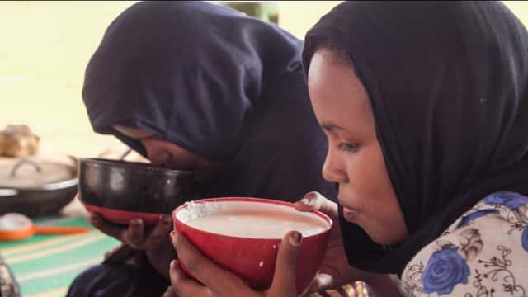
Success Criteria:

Students will be able to describe the forced feeding and forced marriage of young girls in North Africa, explain why these practices are considered human rights violations, and be able to identify at least two human rights that are being violated.

Class Discussion:
What are human rights?
Task 1: Beak up into groups of 4 to 6 and see how many human rights you can come up with. List as many as you can. After 10-minutes I will call on each group to list them on the whiteboard.
Task 2:

Watch the video on the United Nations Universal Declaration of Human Rights: https://www.youtube.com/watch?v=hTlrSYbCbHE

Forced to be Fat: A Case Study from North Africa

This week we are going to look at cultural practices that reinforce inequality. One occurs in North Africa in the country of Mauritania where young girls are force fed to be fat: Some Mauritania communities believe that the fatter girls look the wealthier and more attractive they appear to men. Families force feed their young girls a 9,000 calorie-a-day diet during a brutal "feeding season" in Mauritania. Growing up in a poor country, that's going through a devastating drought, means that marrying well is crucial and mothers believe getting fat will increase the chances of a happy union.
Task 2: Read the article below – and write down at least 5 key dot-points in your Red Books under the heading: Forced to be Fat: A Case Study from North Africa

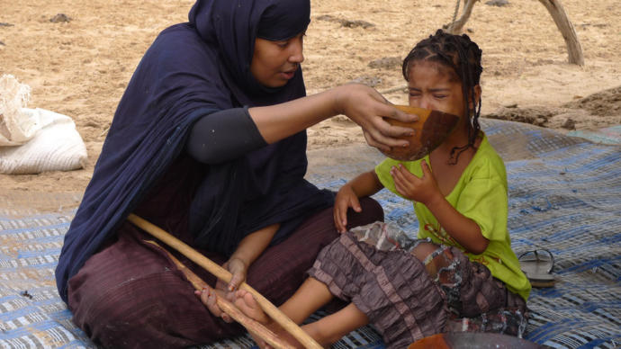

This Country Force-Feeds Young Girls

to Fatten Them For Marriage
Jasmine Osby
Yahoo News, September 16, 2022·

For as long as I can remember, I’ve felt pressure to be thin. From early years playing with Barbie dolls to the unavoidable advertisement parading slim bodies at every turn, it was clear that skinny was in.
Being fat was definitely not in style. Although my mom was overweight, I watched the torment obese kids endured on the playground. They were taunted, bullied, and name-called. They were exiles who sat alone isolated from the crowd. Other kids called them losers all because of their size.
As an adult, life outside of the playground didn’t get much better for my larger friends. I’ve watched them struggle in dating, the workforce, and in intimate relationships because their physical weight is frowned upon. While fat-phobic and fat-shaming culture seems to have improved, a lot of my plus-size friends and family still feel an overwhelming pressure to be thin to fit in.
However, while the West may identify being skinny with being beautiful, the locals in Mauritania disagree.
Located in Northwest Africa, Mauritania customs believe that being obese is a symbol of great wealth and status. Due to this tradition, families begin force-feeding girls at a young age. Their hope is that by 12 years old the girl will weigh at least 200 pounds. This will enhance her chances of getting a suitable husband.
After feeling the pressures of being slim and fit since birth as an American girl, I found the situation in Mauritania unusual. A different culture all the way on the other side of the world, this country praised a figure shunned by the Western world. However, while the tradition is embedded into the fabric of their society, it comes at the detriment of the women who live there.

An Age Old Tradition
Known as leblouh, the age-old tradition of fattening young girls has been a Mauritanian custom for centuries. The complete opposite of US culture, women in Mauritania begin feeling the pressure to be overweight at an extremely young age.
The people in Mauritania have long felt that having larger wives meant they were wealthier and more capable of feeding their families. Living in desert terrain, wealth and status were important in ancient culture.
Now, young girls are groomed for marriage as infants to ensure they are a perfect image of wealth. In an RT Documentary posted on Facebook, filmmakers interviewed multiple families in the countryside of Mauritania who still practice the ancient custom of leblouh. Elders can be seen encouraging girls as young as 3 years old to drink copious amounts of goat’s milk and gruel so they can gain weight faster.
Slimmer women are frowned upon and considered impoverished. Families in the country believe their daughters will not attract decent, wealthy husbands if they are not at least 220 pounds by marriageable age. Fatimetou Lelhamel, a grandmother and leblouh expert, described to the filmmakers how they force-feed female children early.
“This is how we fatten up women,” Lelhamel said. “She drinks milk until the afternoon. We prepare couscous and she eats it, too. For breakfast, we prepare special milk, called ‘amzik.’ We churn the milk until butter starts to appear. Then we mix that with fresh milk.”
Based on US standards, the National Institutes of Health suggest a girl between the age of 9 and 13 consumes 1,6000 to 2,000 calories each day. For those who practice leblouh in Mauritania, young girls are forced to consume 14,000 to 16,000 per day. Many follow this custom while sacrificing the health of their daughters. However, an entire industry built around fattening young girls has emerged in the country due to the need to be obese for marriage.
Although leblouh is becoming less appealing to younger people, some women in rural areas are resorting to desperate measures to gain weight. With recent food droughts in the country, some have started taking animal hormones and steroids to be bigger.

Lessons 2 & 3

Watch the video: “Young girls in Mauritania are force fed to look older and wealthier for marriage.” From SBS Australia at:
https://www.youtube.com/watch?v=N24CZ_Gf0uw

Task 4: Based on the reading and video, what are the health problems associated with force-feeding children? List them below:
Consult the following websites to help you:
1. https://rightforeducation.org/2022/05/23/the-human-right-to-dignity/
2. https://parenting.firstcry.com/articles/harmful-effects-of-force-feeding-children/?ref=interlink
List of Health Problems Associated with Force-Feeding:
1.
2.
3.
4.
5.
6
7.
8.
Task 5: Now look at the List of Human Rights under the United Nations Declaration:

https://www.un.org/en/about-us/universal-declaration-of-human-rights

List those rights that are being violated in Mauritania when young girls are forced into marriage and forced to be overweight as it is seen as attractive in their culture. Summarize each Article that is being violated in a single sentence, and in a second sentence, tell me why it is a violation.

For example:

1. Article 5: “No one shall be subjected to torture or to cruel, inhuman or degrading treatment or punishment.” This is a violation because it is a form of torture to force-feed a child.

List at least 4 more articles here -------------------------

