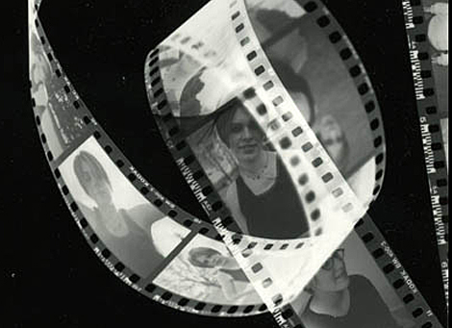

The Language of Film

General Terminology
- Exposition → the exposition is the beginning of the film. Its purpose is to introduce the basic information that must be supplied to an audience at the bginning of a film – the setting, the main characters and the themes, so they can follow the film and feel involved with it.
- Denouement → the denouement is the ending of the film. Its purpose it to wrap and perhaps make a final statement or judgement about the main characters and the themes.
- Turning Point → a point in the film where something new in the form of a complication or a choice is introduced to the plot. This often leads to a development in the character in some way.

Technique | Example | Effect
Extreme long shot / establishing shot |  | This shot types shows a lot of landscape and is often used at the __________ of a film. It helps to develop important _____________ about the place where the film is set.
Long shot |  | This shot types shows a lot of landscape, but we also see people who are _____________. It helps us to see their _______________ to the landscape.
Close Up |  | This shot contains little background and _____________ the audience on a person's _______________ and expressions.
Point of View Shot |  | In this shot the camera becomes the ________ of the of the characters and sees things from their point of view. This helps the audience feel like they are ___________ to the film.
High angle |  | This angle has the camera looking _________ from ____________ the subject. This helps suggest the character is __________ and ___________.
Low angle |  | This angle has the camer looking _______ from ________ the subject. This helps suggest the character is ____________ and ____________.
Bird's Eye View / Ariel |  | This angle has the camera directly ____________, like a bird. This helps suggest the characters are being _______________.
Tracking Shot |  | This is where the camera ____________ the subject. It helps make the audience feel like they are taking part in the ______________.
Zoom in or out |  | This is where the lens of the camera moves ____________ or ________ from the subject. It helps the audience focus on a specific detail or see the subject in a wider setting.
Cut |  | The most ______________ used type of editing, where one shot is replaced by another. When ___________, cuts help create _________.

