**Week 7: Current Event Analysis #1**

**The Strange Case of the Japanese KFC Christmas**

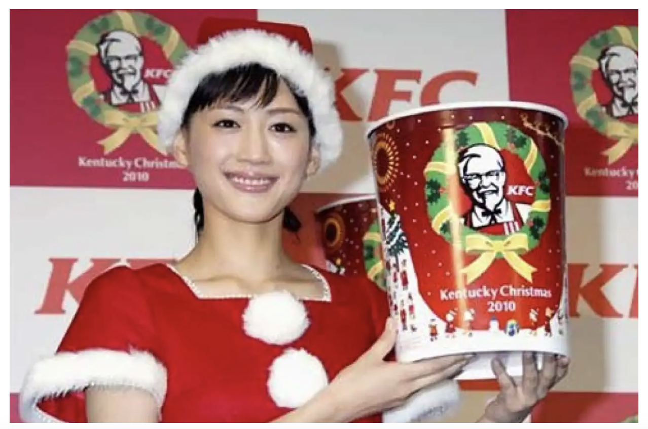

**Success Criteria:** By the end of the week students will be able to recount in detail the 3 current events under analysis and their significance.

Believe it or not – and do believe it because it’s true – in Japan there is a tradition of eating Kentucky Fried Chicken at Christmas!

**Task 1:**  Watch the video ‘How KFC became a Japanese Tradition.’ <https://www.youtube.com/watch?v=DYDDxfpV-WE>

**Task 2:** Read the article on Great Waikato Crocodile Hunt of 1886 at: https://www.timeout.com/tokyo/things-to-do/whats-the-deal-with-kfc-and-christmas-in-japan

1. Who is the Japanese man who is credited with starting the tradition of KFC at Christmas?

2. What year is the tradition believed to have started?

3. What two factors made birthing this new tradition rather easy?

4. How big is the tradition in terms of sales?

5. How has KFC gotten even more customers?

6. Based on watching the video clip, create at least six key dot-points.

a.

b.

c.

d.

e.

f.

**Current Event Analysis # 2**

**The Havana Syndrome Mystery Solved**

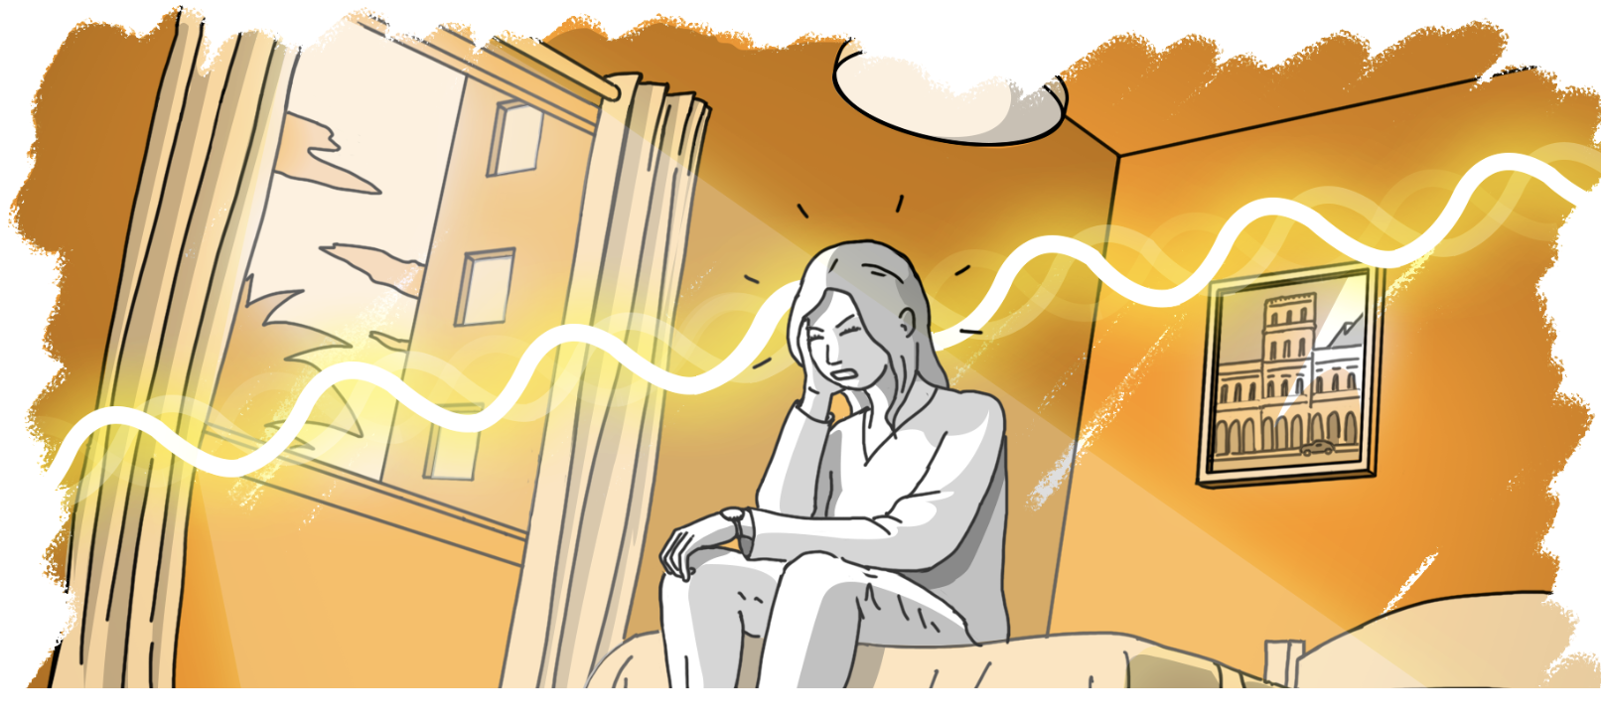

In late 2016 several American and Canadian Embassy staff reported feeling unwell after hearing mysterious sounds while they were stationed in Havana, Cuba. Some people have suggested that they were targeted with a Russian secret weapon. While we explored this Current Event last year – new information has since come to light.

**Task 1:**  Watch the new 60 Minutes report on Havana Syndrome. https://www.youtube.com/watch?v=DYDDxfpV-WE

Write a half-page summary of the position held by the skeptical scientist from the University of Auckland. Why is he reluctant to believe in Havana Syndrome?

**Task 2:** Read the article ‘Havana Syndrome: The Story that Refuses to Die’ at: <https://www.psychologytoday.com/nz/blog/its-catching/202404/havana-syndrome-a-story-that-refuses-to-die>

Answer the following questions:

1. What has the United States intelligence community (the CIA & FBI) concluded about Havana Syndrome?

2. List the 5 different reasons why the author of the article believes is keeping the Havana Syndrome myth alive. Write a summary of each reason in at least 3 sentences – and in your own words – DO NOT COPY word for word from the article.

1. Current Fears & the Power of Moral Panics

2. Ego

3. The Prevalence of AHIs

4. Excitement

5. The Search for Confirmation

**Current Event Analysis #3**

**Auckland’s Volcanic Hazards – What would you did in the event of an Eruption?**

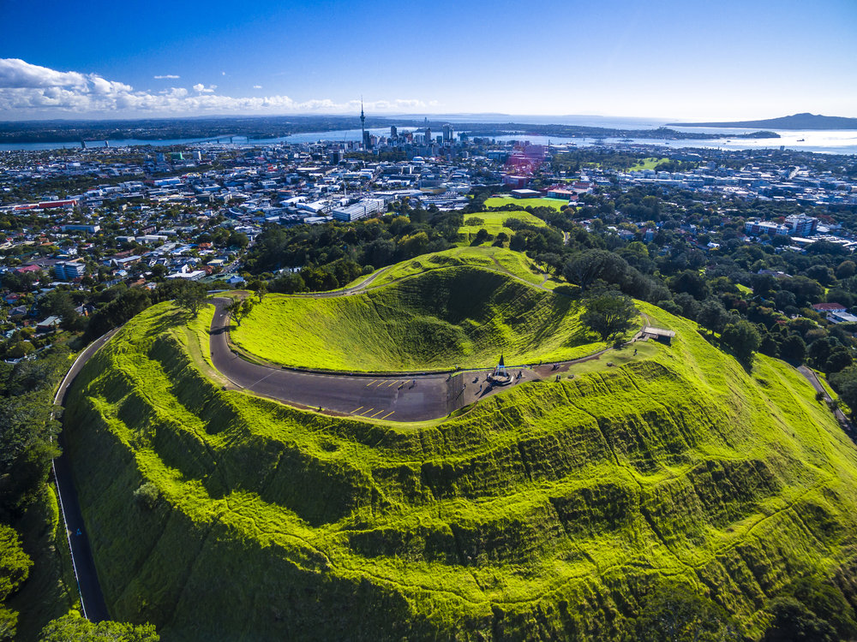

Just 600 years ago there was a major volcanic eruption in Auckland. What would happen if a similar event occurred today? The Emergency Services branch of the New Zealand Government has created a video explaining what actions we can do and how we can prepare for such an event.

**Task 1:**  Watch the video ‘Auckland’s Volcanic Hazards.’ <https://www.youtube.com/watch?v=wRVvYsg33yg&t=473s> (10:42 sec.)

Based on the video, answer the following questions:

1. At least how many volcanic cones have been identified in the Auckland volcanic field over the past 200,000 years?

2. Auckland is the only large city in the world that is built directly on a ________ ______.

3. What is the name of the largest volcanic cone in Auckland? How long ago did it eript?

4. Auckland’s volcanos produce a very fluid form of magma (hot melted rock) called _______.

5. If there is another volcanic eruption in Auckland, how will scientists know days or weeks ahead of time?

6. In the event of an Auckland eruption, what would be the exclusion zone where people have to be evacuated from?

7. How hot is volcanic magma?

8. What problems are caused by volcanic ash. List each of the problems caused by volcanic ash?

a.

b.

c

d.

e.

f.

g.

9. How long could a volcanic eruption last in Auckland?

10. What can you do to prepare for a volcanic eruption in Auckland. List each of the things you need to do to be ready – as listed in the video clip.