**Week 2: Lesson 1**

**Listening to the Voices of Maori Ancestors –**

**‘How a Matarunga Māori Changed My Life’**

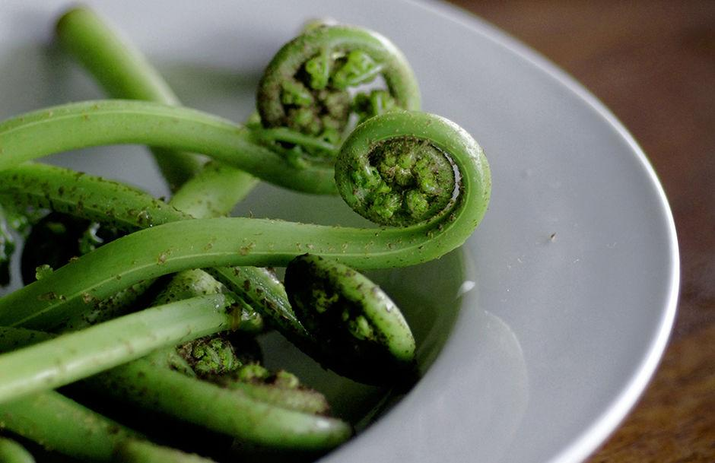

**Success Criteria**

Students will gain a better understanding of traditional Māori foods, how Māori view food, and be able to recount the best times to eat and to fast according to Māori tradition.

**Task 1:** Watch the video **– ‘TUPUNA KAI: A Māori diet based on what ancestors ate.’**

<https://www.youtube.com/watch?v=ziCKhZRqHXk>

This video shows how a Maori man who was overweight and searching for meaning in his life, lost weight and changed his life by turning to traditional Māori kai (food).

1. What plants did he find in the forest to eat?

2. What fruits did he eat?

3. What does he believe you should do during a full moon?

4. What does he do when there is very little moon (‘the moon is dark’)?

After Watching

5. What alternatives are there for people wanting to try this way of eating if they do not have access to, or the knowledge to safely gather foods from, the forest and sea?

6. Select one idea from the video and give your opinion on it.

**Class Discussion:** How did this man turn his life around by embracing his cultural traditions? Why is a person’s culture important? (Remember Term 1 and our unit on Culture).

**Working in small groups –**

**Task 2:** Research Skills – The man in the video talks about fasting. Go online and look up which major religions engage in fasting. Name some of the religions. When do they fast? Why? Look up the health benefits of fasting. Many doctors believe that there are several benefits. Name some. Write a summary under the heading – ‘Research Skills & Fasting.’

**Key words** you could type into Google: ‘fasting and health,’ ‘fasting and religion,’ ‘fasting and Māori.’

**At your table – you will have 10-minutes to research this – then I will call on each group and I will write key information on the board in dot-points that you have written into your books.**

**Week 2: Lesson 2 – A Look at Traditional Māori Kai (Food)**

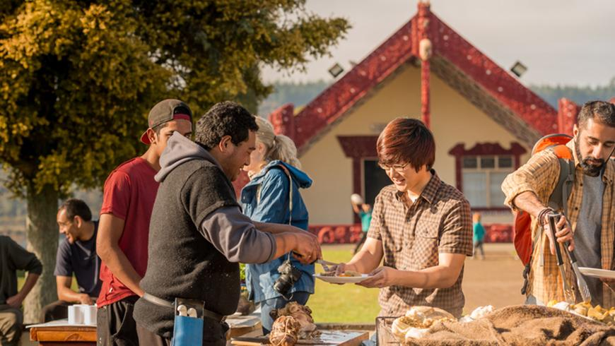

**Success Criteria**

Students will gain a better understanding of traditional foods that were eaten by Māori long ago and more recently and will be able to recount where food was typically grown, why kumara only grew well in certain places, and several key Māori words for popular foods.

**Activities:**

1. Reading

2. Writing

3. Drawing

Read pages 9 and 10 of the book **Food and Culture in New Zealand** (these pages appear at the end of this lesson), and answer the following questions:

1. Why did early Māori locate villages near and along coastal areas?

2. In which parts of New Zealand does kumara not grow and why?

3. Early Māori ate a variety of foods. Write down the definition of the following foods with their European names. Draw a picture of the food next to it. For example:

**a. ika moana = sea fish**

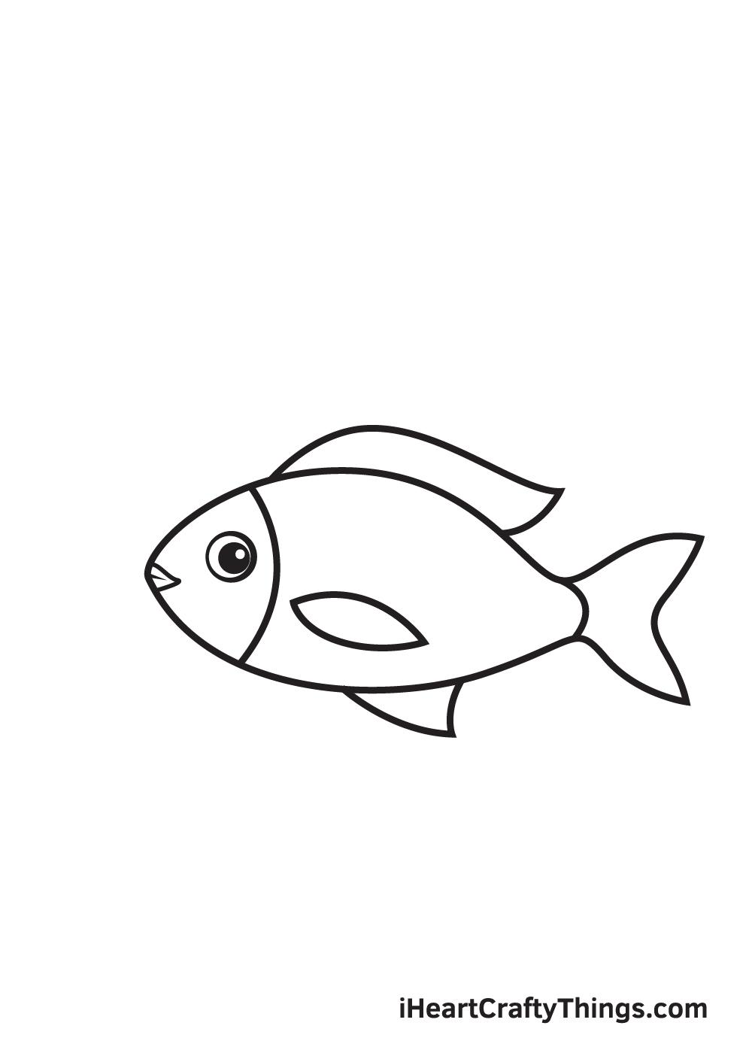

**b. manu =**

**c. kiori =**

**d. aruhu =**

**e. karaka =**

**f. karengo =**

4. On the top of page 10, it mentions that the early European visitors noted that Māori survived by eating one particular food that was in abundance. What was it?

5. They also ate fish. How did they cook it?

6. How did Māori prepare fern root before it was eaten?

**Homework:** What you do not complete in class is homework.

**The Reading for lesson 2 appears below – pages 9 & 10.**

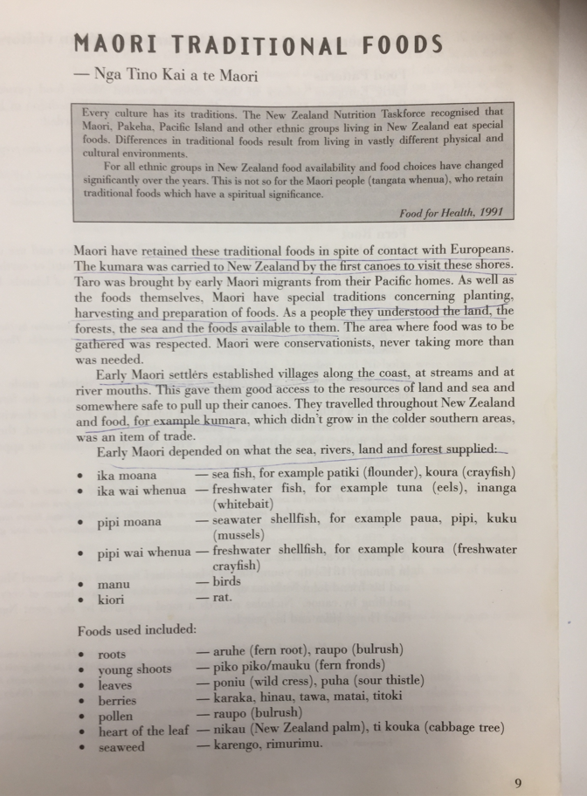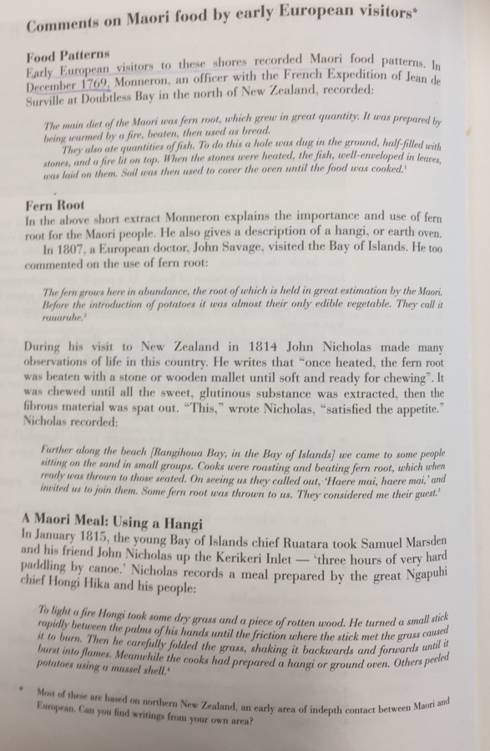**Week 2: Lesson 3 – Māori Food Tourism**

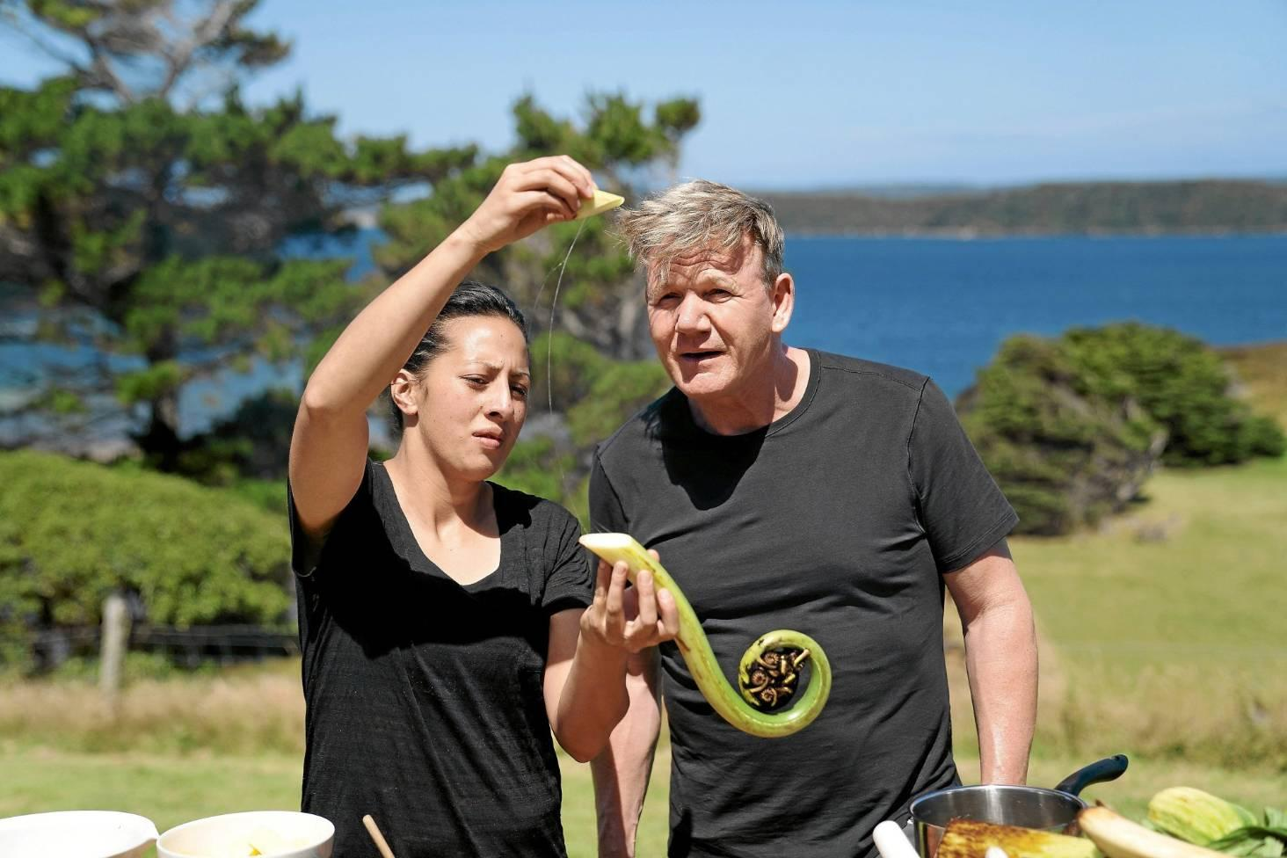

British Chef Gordon Ramsey on his recent visit to Aotearoa New Zealand.

**Success Criteria**

Students will gain an understanding of how traditional Māori would forage for food and how elders are attempting to keep the ancient traditions alive by foraging for traditional foods, so the knowledge does not become lost.

Task 1: Watch the video on Māori Food Tourism

# <https://www.youtube.com/watch?v=B8sKQeLmax0>

# (12:07 sec.)

1. The words of the plants they gather are shown on the video and what they are used for, their qualities (e.g., taste, colour), and how is it beneficial for your health? For each of the plants listed below, list their qualities and how they are beneficial to human health.

2. Kawakawa

3. Why do they harvest the Kawakawa on the north side of the tree?

4. Pirita vine:

5. Piko Piko:

6. Ear Mushroom:

7. Puti Puti:

8. White bait:

9. Kamo Kamo

10. What do they do to sweeten the salmon?

11. Koa Koa Pavolva

**Homework:** What you do not complete in class is homework.