Drownings in 2022 highest in a decade, more than 80 per cent are men | A | B | C
 | Explain why men have drowned more in 2022 than others and if it reminds you of anything else where men are overrepresented. | Definition finder:  - Hull  - Waterways  - Appealing | Write about the different types of actions that men do which lead to their drowning throughout the article.
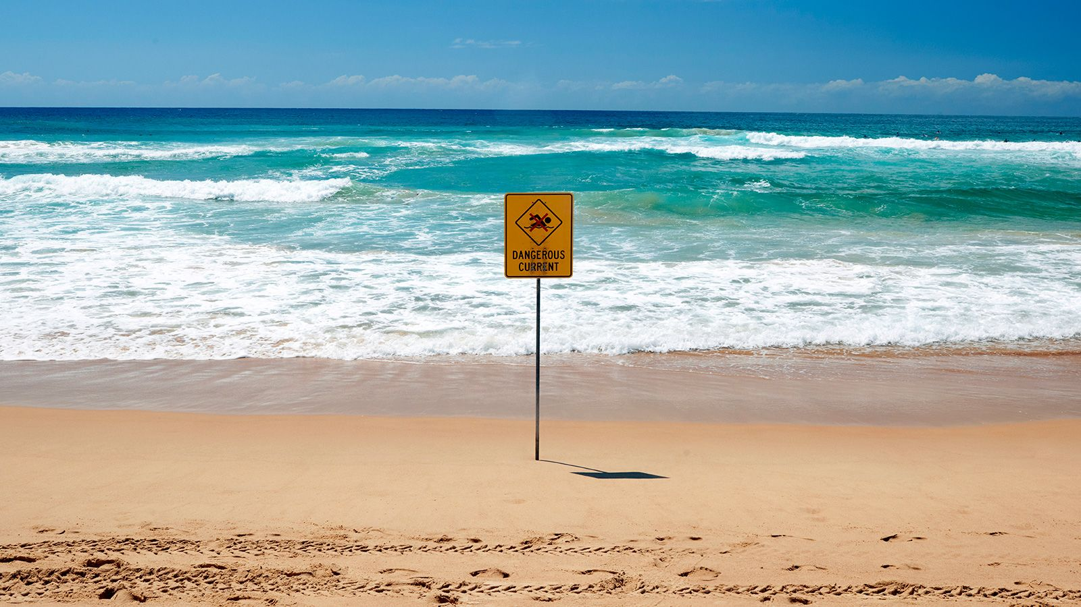 | Describe what the people working for “Water Safety NZ” do throughout the article. | Compare and contrast the people in the article with the people you know. | What is an example of alliteration in the article?
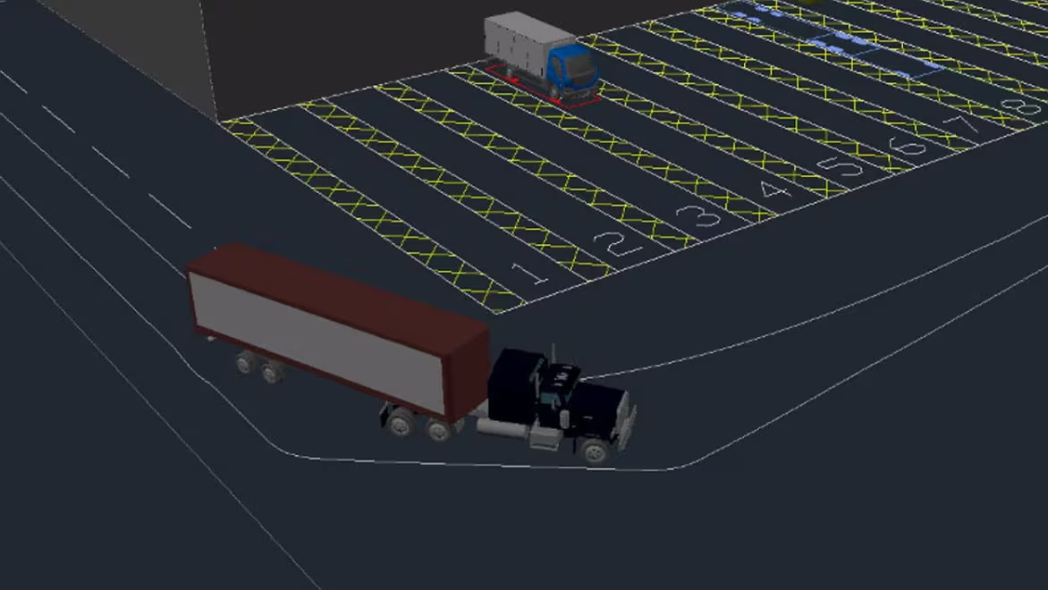 | Draw, design and label your own type of vehicle which prevents people from drowning in waters. | Describe what you would have done if you were in the same situation as the people working for “Water Safety NZ.” | List the keywords which are related to water confidence in the article.

