**Murder mystery at MHJC - forensics investigation**

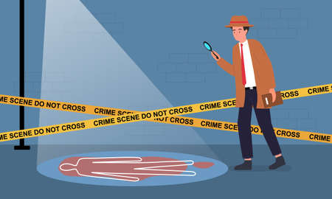

**A crime has been committed in the science lab! A man has been murdered, and Miss R-B’s model mummy sarcophagus has been stolen. We need your investigative skills and knowledge of forensic science testing (trace analysis & fingerprints) and to help solve the crime...**

In class you will be provided with background information about the situation, the victim and the suspects, as well as a box of evidence handed over by the detective team. As investigators, you will need to scientifically process the evidence and conduct interviews with the suspects.

You will create a detailed **evidence book** **(google slides or doc).** The book will be very important to the trial where you attempt to charge your suspect(s) with the crime.

***Your evidence book should contain the following information:***

* A description of the situation
* A description of the victim
* A list and description of suspects
* Descriptions of the pieces of evidence
* Interview transcripts
* Methods, tables and results from processing the evidence
* A conclusion, using your results to narrow down the suspects, present and explain who you believe to be the guilty suspect

This Science/English Assessment will be due to be submitted on Mission Heights Online at the end of week 9 (Friday 2pm).

| **Science** | **TOWARDS** | **AT** | **ABOVE** | **BEYOND** |
| --- | --- | --- | --- | --- |
| Investigation/procedure | You have processed the evidence appropriately. | You have processed evidence appropriately, drawing simple conclusions. | You have accurately processed and interpreted the evidence accurately, drawing science based conclusions. | You have accurately processed and interpreted the evidence accurately, drawing clear science based conclusions linked to the evidence. |
| Communicating in Science | You have used several scientific symbols, conventions, and/or vocabulary | You have used at least two of: relevant scientific terms, symbols, simple representations, or simple models to communicate effectively | You have used a range of relevant scientific terms, symbols, simple representations, and simple models to communicate effectively | You have used a range of relevant scientific terms, symbols, representations, and models to communicate effectively |

| **English** | **TOWARDS** | **AT** | **ABOVE** | **BEYOND** |
| --- | --- | --- | --- | --- |
| Understanding text conventions (incl Purpose and audience) | You are working towards  creating a text that is relevant to the task, **often** including  appropriate and deliberately selected structures and  conventions which support the text’s purpose and ideas  (Structures and conventions include visual techniques,  verbal techniques, tone and register) | You have created a text that is relevant to the task,  **consistently** including  appropriate and deliberately selected structures and  conventions which are linked to the text’s purpose and ideas  (Structures and conventions include visual techniques,  verbal techniques, tone and register) | You have created an effective text which conveys ideas and purpose through deliberate use of structures and conventions.  (Structures and conventions include visual techniques,  verbal techniques, tone and register) | You have constructed a  compelling text which draws together deliberately selected structures and conventions to enhance the reader’s  understanding of your intended ideas and purpose  (Structures and conventions include visual techniques,  verbal techniques, tone and register) |
| Language Use [Vocabulary and Language Devices] | You are working towards using interesting language (including some language techniques) and a writing style which is appropriate to your audience | You have started to control your use of interesting language/ language techniques relevant to your topic, as well as a writing style appropriate to your  audience | You have deliberately used a wide range of language  features effectively while  sustaining a writing style which is appropriate to your audience | You have consistently and deliberately used a wide range of language features effectively while sustaining a writing style which is appropriate to your audience |
| Accuracy in Writing | You have made errors in  grammar, spelling and/or  punctuation which are intrusive and affect meaning. | You have made errors in  grammar, spelling and/or  punctuation which are intrusive at times, but readers can infer meaning. | You have made minor errors. Meaning is consistently clear. | You have made few to no  intrusive errors.  Meaning is consistently clear. |
| **Time management** | You have yet to complete and submit your assessment | You have submitted your assessment late | You have submitted your assessment by the due date Friday Week 9 | You have submitted your assessment before the due date Friday Week 9 |