**The Nazi Party**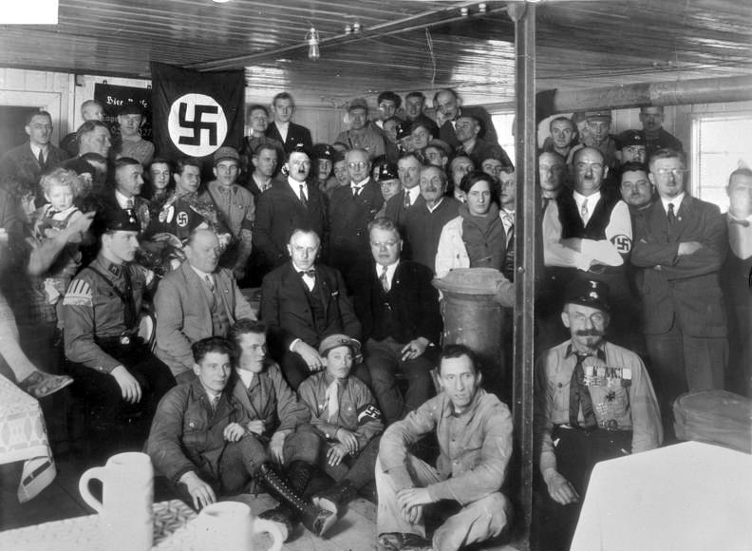

The Nazi Party (Nationalsozialistische Deutsche Arbeiterpartei - National Socialist German Worker, usually referred to at the time as **NSDAP**) was founded in 1919, one of many political parties that sprung up in response to the political chaos engulfing Germany after its defeat in World War One. Its original members were mainly concerned with preventing communists from taking over Germany, but in time the party’s 55th member - Adolf Hitler - began exercising much more influence on the party's policies and direction. On 28 July 1921, Hiter became the leader of the Nazi party, a position he held for the rest of his life.

Under Hitler, the Nazi Party developed a number of political policies based on **nationalism** (believing that your country [and usually your ethnicity] is better than others), **expansionism** (making your country bigger), and **anti-semitism** (hatred of Jews). To the Nazis, Germany's enemies - mainly Britain, France, and the Soviet Union - were all controlled by Jews, and German Jews had betrayed Germany by starting the First World War and forcing Germany to deliberately lose the war by accepting the "diktat” (dictated peace) at Versailles. While none of this was actually true, many Germans believed it because of historical anti-Semitic beliefs; the Nazis believed that the Jews were an inferior race of people who were weakening the pure German, or Aryan, race. In the book *Mein Kampf* (My Struggle - written by Hitler while he was in prison for a failed attempt by the Nazi Party to overthrow the government by force) - Hitler outlined his ideas of a Jewish conspiracy to take over the world, and his plan to expel Jews from Germany.

Anti-semitism, the fear or hatred of Jews, existed in Europe for centuries before the Holocaust. In the late 19th century, eugenics became popular. Eugenics was the theory that humans can be categorized in specific races. Each “race” had its own unchangeable traits. Some “races” were biologically, culturally, and morally superior to others. Eugenics has now been proven false, but it was popular enough at the time that the Nazi Party could tap into people’s beliefs there & with anti-semitism.

However, the Nazi Party's anti-semitic beliefs did **not** influence much of the support which it won - that came later. Instead, the Nazis tended to win more votes when the German economy was failing, and lose votes when the economy improved. Many Germans voted for Hitler and the Nazis primarily because of the party's **promise** to revive the economy and provide employment, to **restore** German greatness and national pride, to overturn the hated Treaty of Versailles, and to save Germany from the communist threat; the KPD (*Kommunistische Partei Deutschlands* - the Communist Party of Germany) was one of the strongest political parties in Germany, and many middle-class Germans were scared that they would lose their property if the KPD was elected.

In Germany's presidential elections in April 1932, Hitler won 36.8% of the vote, losing to the war hero Paul von Hindenburg (53%). In the German federal election of July 1932, the Nazis won more votes than any other political party, but not enough to govern alone. Another election was held in November 1932; the Nazis won only 33% of the vote but were still the largest party in the *Reichstag* (Germany's parliament). Hitler formed a coalition (political alliance) with the *Deutschnationale Volkspartei* (German National People's Party, or DNVP) which had won 8.9% of the vote, and was appointed Chancellor of Germany by President von Hindenburg on 30 January 1933. He called for another election in March 1933; the Nazis won 43.9% of the vote (288 seats) and the DNVP won almost 8% of the vote (52 seats), giving Hitler a majority of the 647 seats in the *Reichstag*. At the end of March 1933, with the support of the 74 seats won by the *Zentrum* (Centre Party), the Nazis pushed the Enabling Act through the Reichstag, giving Hitler the power to make laws without consulting parliament. The KPD was banned; in time, all other political parties in Germany were also forbidden. In August 1934, President von Hindenburg died; Hitler made himself Germany's President as well as Chancellor, and created the new title Fürher (leader). Hitler held this title until his death in April 1945.

**Answer the following questions:**

1. Who was the main leader of the Nazi Party, and for how long?
2. What were the Nazi Party’s main political aims?
3. According to the text, why did the Nazi’s hate the Jewish people so much?
4. Was the Nazi hatred of the Jews the main reason that many German people voted for the Nazi party? If not, why did the Nazi’s win so many votes?
5. How did the Nazi’s come to form the government of Germany in 1932?
6. At this point in time (1933/1934), do you think the German people were aware of who they were voting for? Why or why not?
7. How do you **think** the wider world outside Germany responded to Hitler’s rise to power? Acceptance? Support? Fear?