Drownings in 2022 highest in a decade, more than 80 per cent are men

The year is set to end on a grim note as the death of a scuba diver north of Auckland yesterday meant New Zealand’s water-related tragedy tally surpassed its highest level in a decade.

With three days to go and some of the hottest days of summer to come, the Water Safety NZ chief executive is appealing for the most at-risk group to make better decisions.

Three unconscious people were pulled from the water yesterday afternoon near Marine Pde in Raglan.

A police spokesperson said the trio were flown to hospital, all in a serious condition.

Water Safety NZ has recorded a total of 91 preventable drowning deaths this year, 77 of them males, which is the first time the statistic has passed 90 since 2011.

Over the past 10 years, 89 percent of beach drownings in New Zealand have been male.

“We want people to get out and enjoy our beautiful waterways and beaches but don’t want them, mainly men, making bad choices and taking big risks,” Water Safety New Zealand chief executive Daniel Gerrard said.

In a heartfelt open letter to Kiwi men in November, Gerrard pleaded with them to take better care in the water.

“To Pākehā males in power boats, Māori men gathering kai underwater, Asian men fishing from rocks, Pasifika men fishing from boats: you guys are consistently over-represented in our drowning tragedies.

“It’s common sense, apparently not so common anymore. By knowing the conditions, supervising the kids, wearing a life jacket and remembering you’re not as good as you were when you were 20, you will make it home at the end of the day,” Gerrard said.

This time last year, 86 drownings had been recorded and the overall total for 2021 was 90, making it the highest in a decade at the time.

The 10-year average of water-related tragedies is 80.

A total of five drownings have been reported so far during the holiday period this year, which began on Friday, December 23 at 4pm and ends on Wednesday, January 4 at 4pm.

Father-of-three Varun Chand died on Christmas Day [after his canoe capsized in Lake Roto Kohatu](https://www.nzherald.co.nz/nz/body-recovered-in-search-for-missing-canoeist-in-christchurch/3FJNFDK7ZZHHZJWSPXN6E6DUQI/), north of Christchurch city.

His 7-year-old daughter was on board.

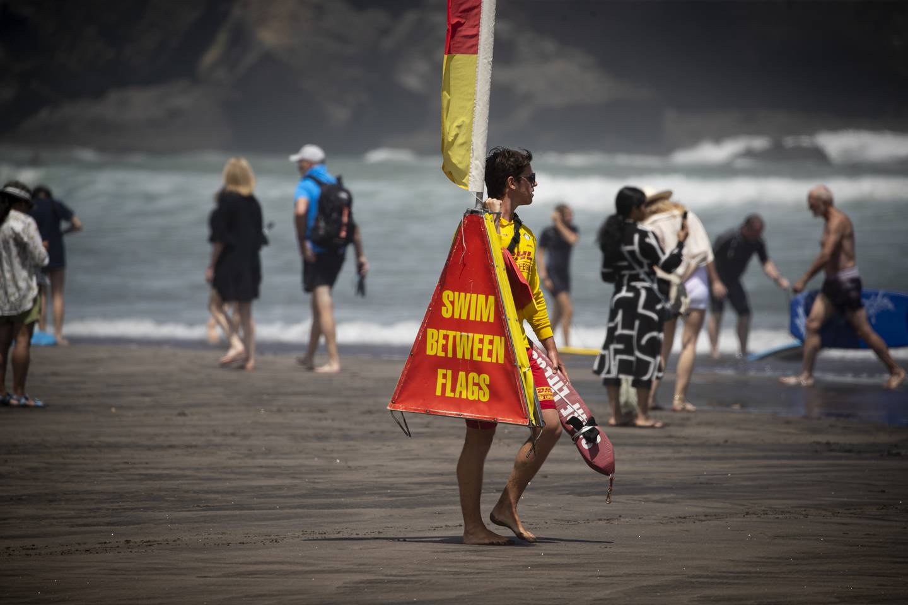

Chand was not wearing a lifejacket, [according to his wife Sheron Shoma Dutt](https://www.nzherald.co.nz/nz/man-killed-in-christmas-day-canoe-accident-bought-the-boat-as-a-surprise-gift/2BRNFEQ66JEHXOL543NLVVIZTE/).

Ōpōtiki man Jim Kemp was pulled from the water at Cape Runaway about 7pm on Boxing Day and given medical attention but died at the scene, police said.

[Kemp was a lifetime member of the Waihau Bay Sport Fishing Club](https://www.nzherald.co.nz/nz/opotiki-drowning-victim-was-lifetime-member-of-local-fishing-club/LU6HWI6UZBCVLLGBK634AUKN4M/) and was listed as the club’s vice president.

A friend of Kemp’s told the ***Herald*** he would be greatly missed.

“He was one hell of a nice guy and would always go out of his way to help someone if he could.”

His death was the first in a tragic 12 hours in which three people died in the water on Boxing Day night.

Emergency responders arrived at a Pukekohe, South Auckland, address around 9.30pm on Boxing Day where a person was pulled from the water and provided medical attention.

“However, the person sadly died at the scene,” police said.

And a swimmer died at Kaitoke Regional Park in Upper Hutt early on December 27 after failing to resurface.

The person was pronounced dead at the scene after being pulled from the water.

Yesterday, [a man died after being found unresponsive](https://www.nzherald.co.nz/nz/man-found-unresponsive-on-aucklands-goat-island-beach-pronounced-dead/VRY4PCKJW5HPNEYVZVBADO4MBU/) on Auckland’s Goat Island beach.

Gerrard said more has to be done to ensure people’s safety.

“Things are trending in the wrong direction. We clearly need better resources to make an impact and change people’s behaviour.”

During the last holiday period, 16 drownings were reported, which was the worst in 40 years.

Surf Lifesaving New Zealand chief executive Paul Dalton said it was extremely frustrating to continually see the water-related tragedy statistics so high.

“It is clear the messaging is not getting through to the level that we need it to. Some of that is partly the audience of people who think they know better and don’t believe it applies to them.”

Dalton said the older generation tend not to listen because they have got away with “bad water behaviour” since they were young.

“All we can do is keep putting out safety messages and find ways to influence those people to make better decisions,” Dalton said.

At least three boating tragedies contributed greatly to the year’s large number of water-related deaths.

Five died in March when [a fishing charter carrying 10 people sank amid rough seas](https://www.nzherald.co.nz/nz/fishing-boat-tragedy-new-footage-shows-wreck-of-sunken-charter-vessel-enchanter/542GMQVV2GJB4HCCNEU3FVTWPM/).

Enchanter, a charter vessel operating out of Mangonui, sank just before midnight on March 20 off North Cape in rough conditions.

Cambridge men Richard Bright, 63, Mike Lovett, 72, Geoffrey Allen, 72, Mark Walker, 41, and Mark Sanders, 43, from Te Awamutu, died.

Five more people died in September when a [sperm whale was understood to have flipped an 8.5m Fish Kaikōura charter boat](https://www.nzherald.co.nz/nz/kaikoura-tragedy-five-dead-after-boat-capsizes-off-goose-bay-in-calm-flat-conditions/FSBKRJ4FMEFNN7C3PUVTGUIKQI/) at Goose Bay, near Kaikōura.

The boat, which was carrying 11 people, capsized on September 10, throwing six people overboard, including the skipper and trapping five others underneath the upturned hull, who didn’t survive.

They were Catherine Margaret Haddock, 65, of Lower Hutt, Susan Jane Cade, 63, also of Lower Hutt, Diana Ruby Stewart, 68, Peter Charles Hockley, 76, and Maureen Patricia Pierre, 75, all of Christchurch.

More recently, Gemma Ferregel, 39, and her 10-year-old son Ryder died after [a boat carrying five people capsized](https://www.nzherald.co.nz/nz/clarks-beach-boating-tragedy-mother-gemma-ferregel-and-son-ryder-ferregel-named-as-victims/UVII7I7TFVCD3PYWX3GP44B3EE/) on November 6 in the Manukau Harbour off Clarks Beach.

has not yet been recovered since after police suspended their search more than two weeks after the tragedy.

Three others on the boat survived, two of them swimming to shore, freezing and exhausted, to raise the alarm.