Democracy & Leadership in
New Zealand &
Around the World

Week 1: Lessons 1 to 3

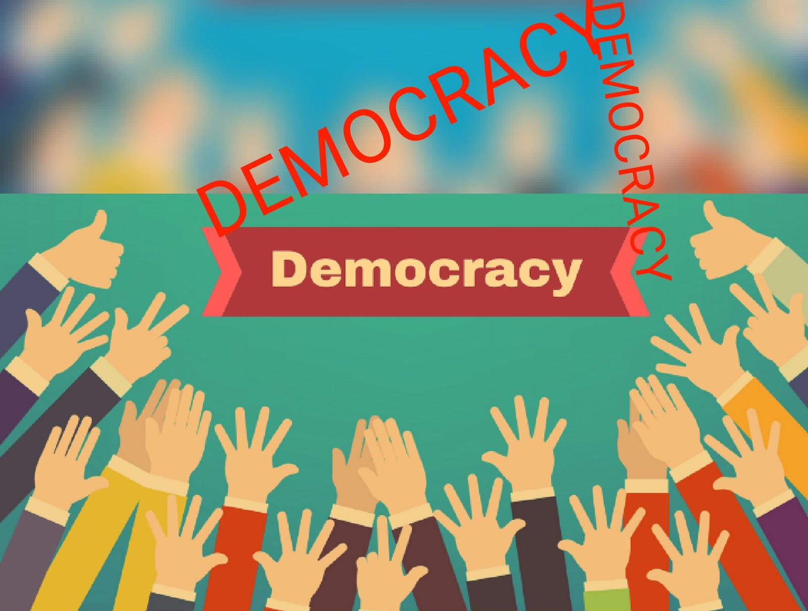

Success Criteria: To be able to identify and recount the need for rules, laws and order in society. By the end of the week students will be able to define rules versus laws, and key aspects of Communism, Capitalism, Monarchies and Dictatorships.

Task 1: Open your Red Books to 2 blank pages. One the first page draw a line across the page about a third of the way down. Above the line write the Unit Title. Below the line write down the lesson heading (An introduction to Democracy) and today’s date.

Task 2: Why We Need Rules

We have many sets of rules:
  - School rules
  - Road rules
  - Sports rules

Rules are made for a reason.

As New Zealanders our Parliament makes rules that make it easier for us all to live together. We call these rules laws.

Task: Rules Exercise – Create the following grid in your books and list the different rules you have to follow in any given week:
Why we need Rules?

Watch the video clips –

India – importance of rules (crazy driving)
https://www.youtube.com/watch?v=pLUm3Q-7iZA

Ukraine Parliament (importance of rules)
https://www.youtube.com/watch?v=emKIIv2_cNI

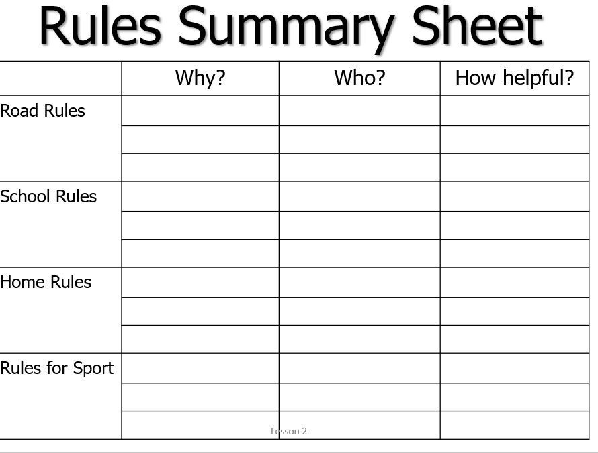
Week 1 Lesson 2:

Task 1: Write the following into your books:

What is a Government?

Government involves a group of people who are in charge, who have the authority to sets the rules for a society.

Governments –
- Make laws
- Keep order
- Protect people and property
- Make rules
- Enforce laws

Class Discussion: Did you know that your parents pay money to the government – it’s called taxes. So, what do our tax dollars pay for?

Task: Write down key dot-points about Democracy:

Different Types of Governments

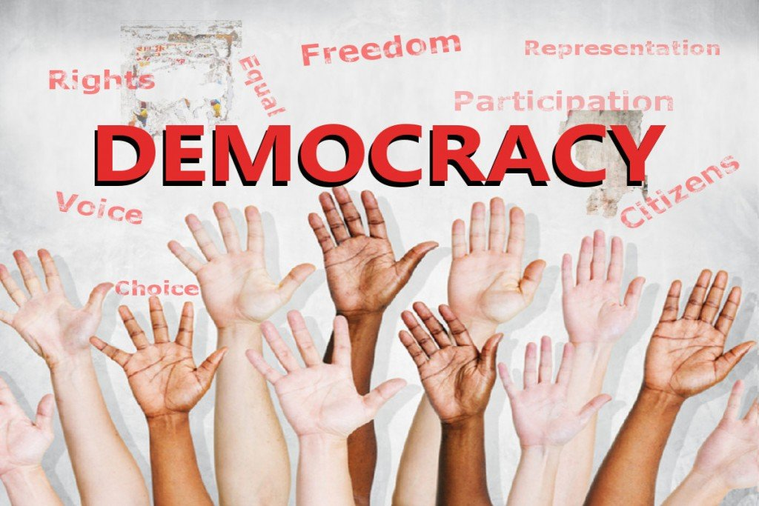

1. What is a Democracy?

- The government is elected by the people.
- Everyone who is eligible to vote has a chance to have their say over who runs the country.
- A democracy is determined either directly or through elected representatives.

Examples:
- New Zealand
- Australia
- United States
Capitalism

- Most democracies practice capitalism where people can own their own businesses and property. People can also buy services for private use, such as healthcare.

- But most capitalist governments also provide their own education, health and welfare services.

Watch the clip:

The Profit Motive: Going Places | Pro-Capitalism Propaganda Cartoon | 1948
https://www.youtube.com/watch?v=eFvOPpBVff0

Class Discussion: The pros and cons of capitalism

Students break up into small groups and discuss the benefits and drawbacks of Communism for 10-minutes.

Teacher to call on each group and write their key points on the board

Week 1 Lesson 3:

Write the following key information into your books in the form of dot-points:

Communism

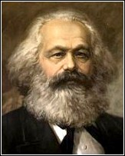
Karl Mark founder of Communism

- Communism - a government where people share work fairly and are paid equally (on paper)
- The word “Communism” comes from the Latin word “Communis” which means common or belonging to all.

- In a communist country, the government owns property such as businesses and farms.
- It provides its people's healthcare, education and welfare.
- Problems with Communism

- Lack of individuality
- Lack of choice
- Equal treatment for all, even if you work harder than all the rest (a doctor could make the same money as a farmer or janitor) – so where is the incentive to work hard and get ahead?

During the 1940s and 1950s, many people living in New Zealand and other Western countries like the United States, had a fear of Communists. The fear was that Communists were going to try and take over the world. Watch the short clip as an example. This was once shown on American TV:
https://www.youtube.com/watch?v=SkYl_AH-qyk

Now watch the short clip on an overview of Communist beliefs:
Video clip: What is Communism
https://www.youtube.com/watch?v=qElx_EyTTKA
Class Discussion: The pros and cons of Communism

Students break up into small groups and discuss the benefits and drawbacks of Communism for 10-minutes.

Teacher to call on each group and write their key points on the board.

