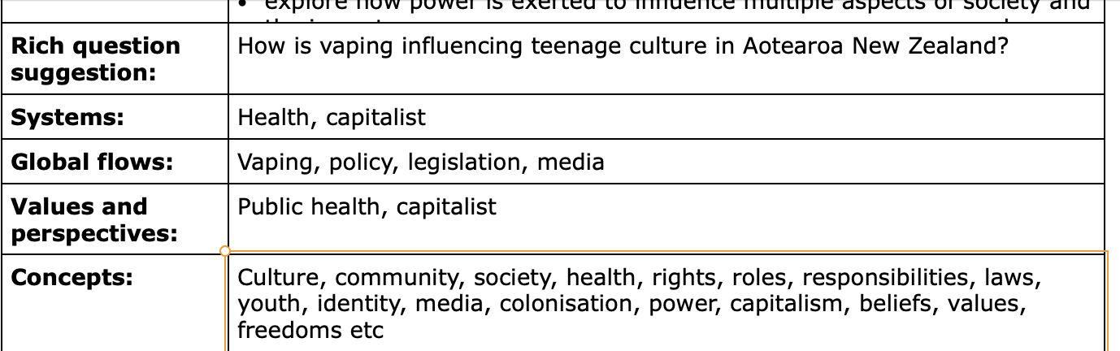

**Exploring Perspectives on a Contemporary Issue**

Complete all the tasks below for your assessment:

* **FOCUS:** You need to identify your human rights issue, identify your stakeholders and key search terms
* **EXPLORE:** Using your search terms, find a range of relevant resources to help answer your focus questions
* **REFLECT:** Answer your focus questions comprehensively

| **DATE: Monday Week 9 24th June** |
| --- |

| **FOCUS** | |
| --- | --- |
| **Highlight your contemporary issue** | * Teens vaping in Aotearoa |
| **What are different groups or individuals involved/impacted?**  Highlight 3 stakeholders with different roles and perspectives - you will focus your assessment on unpacking their POV | * … * … * … * … * … * … * … |
| **Key search terms**  What are your keywords from your contemporary issue?  What are some synonyms of those keywords? | * … * … * … * … * … * … |
| **EXPLORE** | |
| **Task 1: Find your sources**  You need to use your research terms and keywords to help you collect resources. These resources need to help you answer your focus questions. You should try to obtain information from a range of different resources:   * EPIC database * Books * Websites * News articles * Blogs and opinion articles * Video resources * Podcasts   When you are finding out whether or not a resource is relevant to you, you shouldn’t waste your time reading the whole resource. Read the description/abstract (if there is one), the introduction and conclusion. If it sounds useful then you should read through it, taking notes as you go.  You also need to do the **CRAAP** test to find out if this is a reliable resource and to be aware of the kinds of biases it might include.    **Task 2: Analyse your sources**  Analyse each of your sources by following the technique outlined below:   1. **Identify** relevant chapters/sections 2. Skim & Scan - **gather** relevant information and summarise in your words the key information 3. **Select** evidence - relevant to Key Questions 4. **Referencing (Bibliography)**   **Use the space below to record your sources and take notes from them.**  **\*\*\* Make sure these notes are in your own words OR it has quotation marks around it if it is an important quote.**   | **Part One - Outline of the issue** | | | | | | | --- | --- | --- | --- | --- | --- | | **What is the issue?**   * … * … * … | | | **Why is it relevant today?**   * … * … * … | | | | **Part Two - Perspectives, viewpoints, and responses** | | | | | | | **Name of individual or group** | **The perspective(s) they hold on the issue is…** | **Their viewpoint on the issue is…** | **Values they hold are…** | **They responded by…** | **Examples or evidence that support this are…** | |  |  |  |  |  |  | |  |  |  |  |  |  | |  |  |  |  |  |  | | **Part Three - Look at the bigger issue** | | | | | | | Explain impacts of these responses to the contemporary issue.  What are the direct effects on individuals, groups, or places? These could be short or long term, positive or negative.   * … * … * … * … * … | | | Examine implications of the differing perspectives and related responses to the contemporary issue. What are the wider consequences for society that have arisen from the differing perspectives and responses to this issue? These may be real or potential implications.   * … * … * … * … * … | | | | | |
| **REFLECT** | |
| Write a 750-800 word report answering the following focus questions. Ensure you are including multiple pieces of evidence in each paragraph (at least 3). Make sure you leave enough time for proofreading. | |
| **Part One — The issue (150 words)**   * Outline your chosen contemporary human rights issue   + What is the issue?   + Why is it relevant today? | |
| **Part Two — Perspectives, viewpoints, and responses (400 words)**   * Identify and describe the differing perspectives of each of the people or groups you have selected, in relation to the contemporary social issue.   + You might consider liberal, conservative, social, environmental, indigenous, political, or economic perspectives that are held by your chosen people or groups. * Describe how the differing perspectives of these people or groups influence their viewpoints on the contemporary social issue. * Discuss how these differing perspectives have influenced responses to the contemporary social issue.   + What are the different responses of each of the people or groups in relation to the contemporary human rights issue?   + Consider why the people or groups have responded this way. | |
| **Part Three — Look at the bigger picture Human Rights violations (250 words)**   * Explain the impacts of these responses to the contemporary social issue and how this social issue is a violations of the Universal Declaration of human rights * Specific human rights articles that could be violating within the vaping industry. * Examine the implications of the differing perspectives and related responses to the contemporary social issue.   + What are the wider consequences for society that have arisen from the differing perspectives and responses to this issue? These may be real or potential implications. | |
| **Bibliography**  Include your references here using the following format. Your bibliography should be in alphabetical order.  Name of author or institution. (date published). *Title of article/video.* URL link to website  **For Example:**  World Vision New Zealand. (unknown). *Change Everything with Water.* [https://www.worldvision.org.nz/connect/40-hour-famine/](https://www.youtube.com/watch?v=Tb2a4nPBgUY&ab_channel=CanadianMuseumforHumanRights) | |