**Pre-Assessment Question:  
The Judgement of the Nazis**

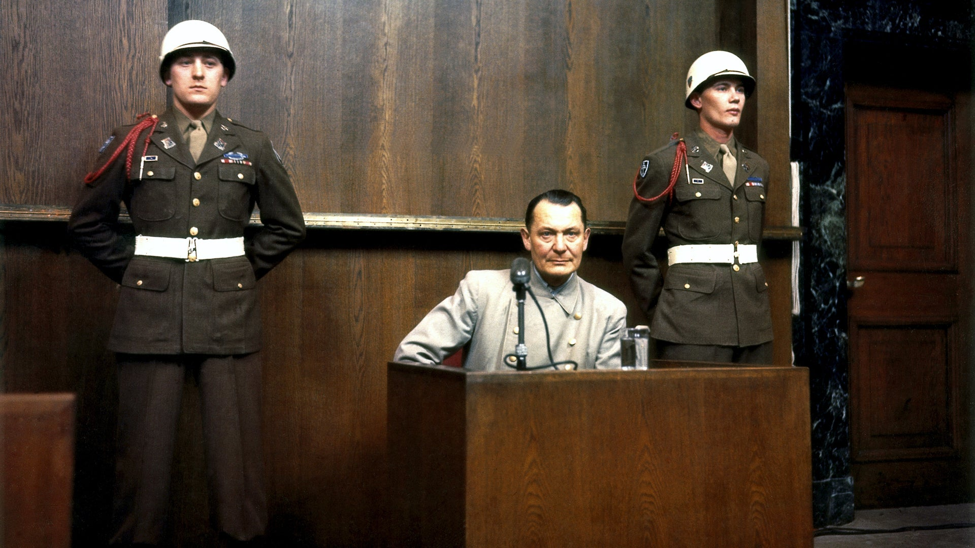

*Hermann Göring, the most high-profile Nazi at the Nuremberg Trials*

You have spent two sessions getting a broad understanding of Nazi Germany and how it operated, and how the Holocaust was carried out and for what purpose. You also spent a week looking at the concept of universal human rights and how they have been applied and should have been applied. You now have enough understanding of a **key human rights issue** to develop an **opinion** on its resolution. You have looked at different perspectives across a tough topic, and now you must develop your **own** perspective.

**You will now answer this prompt to the best of your ability.**  
  
*It is the end of WW2. You are the leader of an organisation charged with figuring out the following question, and all world leaders will listen to your findings. How should the leaders of Nazi Germany, and the soldiers who listened to them and carried out their orders, be punished for their crimes against humanity?*

**Some examples that did take place at the end of WW2:  
  
-** The Nuremberg Trials, where many nations took the most important Nazi leaders to court and eventually hanged or imprisoned them.  
- Public executions, where Nazis of varying levels of involvement (from none to total) in war crimes were executed on the streets. Members of the public, soldiers and powerful Nazi leaders were shot this way.

- Immediate imprisonment without trial, sometimes doing hard labour for years. This mostly took place in the USSR.

- Some individuals were taken to the USA to work for important government or scientific goals, such as Werner von Braun being a key Nazi in the development of NASA.  
- Many places in Germany took a blind eye to the actions of the people in their town, and did not punish them in any meaningful way. Some soldiers were socially excluded, but many were not. **Resources**  
On top of our previous work with human rights - available on Google Classroom - and the work on Nazi Germany we have done this week, you have some resources you can read to help inform your opinion.   
  
<https://www.nationalww2museum.org/war/topics/nuremberg-trials>  
  
<https://www.theholocaustexplained.org/survival-and-legacy/postwar-trials-and-denazification/>

<https://www.alliiertenmuseum.de/en/thema/denazification/>

**Requirements/Suggestions**  
**1.** You must write 175-200 words, with full sentences and correct spelling and paragraph structure. Introduction, explanation, conclusion. If you require support, I will make allowances for you.

**2.** You must clearly state an answer as to how you believe the leaders of Nazi Germany - give examples as to who you mean - and the soldiers responsible for war crimes should have been ‘dealt with’ at the end of the war. You can say different answers for different people, such as the commanders of the camps vs. regular soldiers.

**3.** You must clearly give a **PERSPECTIVE** - meaning **why** do you believe this? Why do you believe this is the correct form of justice? You must clearly explain your reasoning and use statements to back up your beliefs.   
**For example:** if you agree with the Nuremberg Trials and what happened to Nazi leaders there, you must explain why.

4. You must not be vulgar. This **is** a tough topic and I will accept answers that recognise the violence in the topic, but you must be sure to be respectful in your writing. I will not accept work that is disrespectful.  
  
You will have one session & time at home to answer this question. You have until Monday next week, as that is when our assessment begins.  
You **MUST** submit once you have completed the question.

| Answer here: |
| --- |