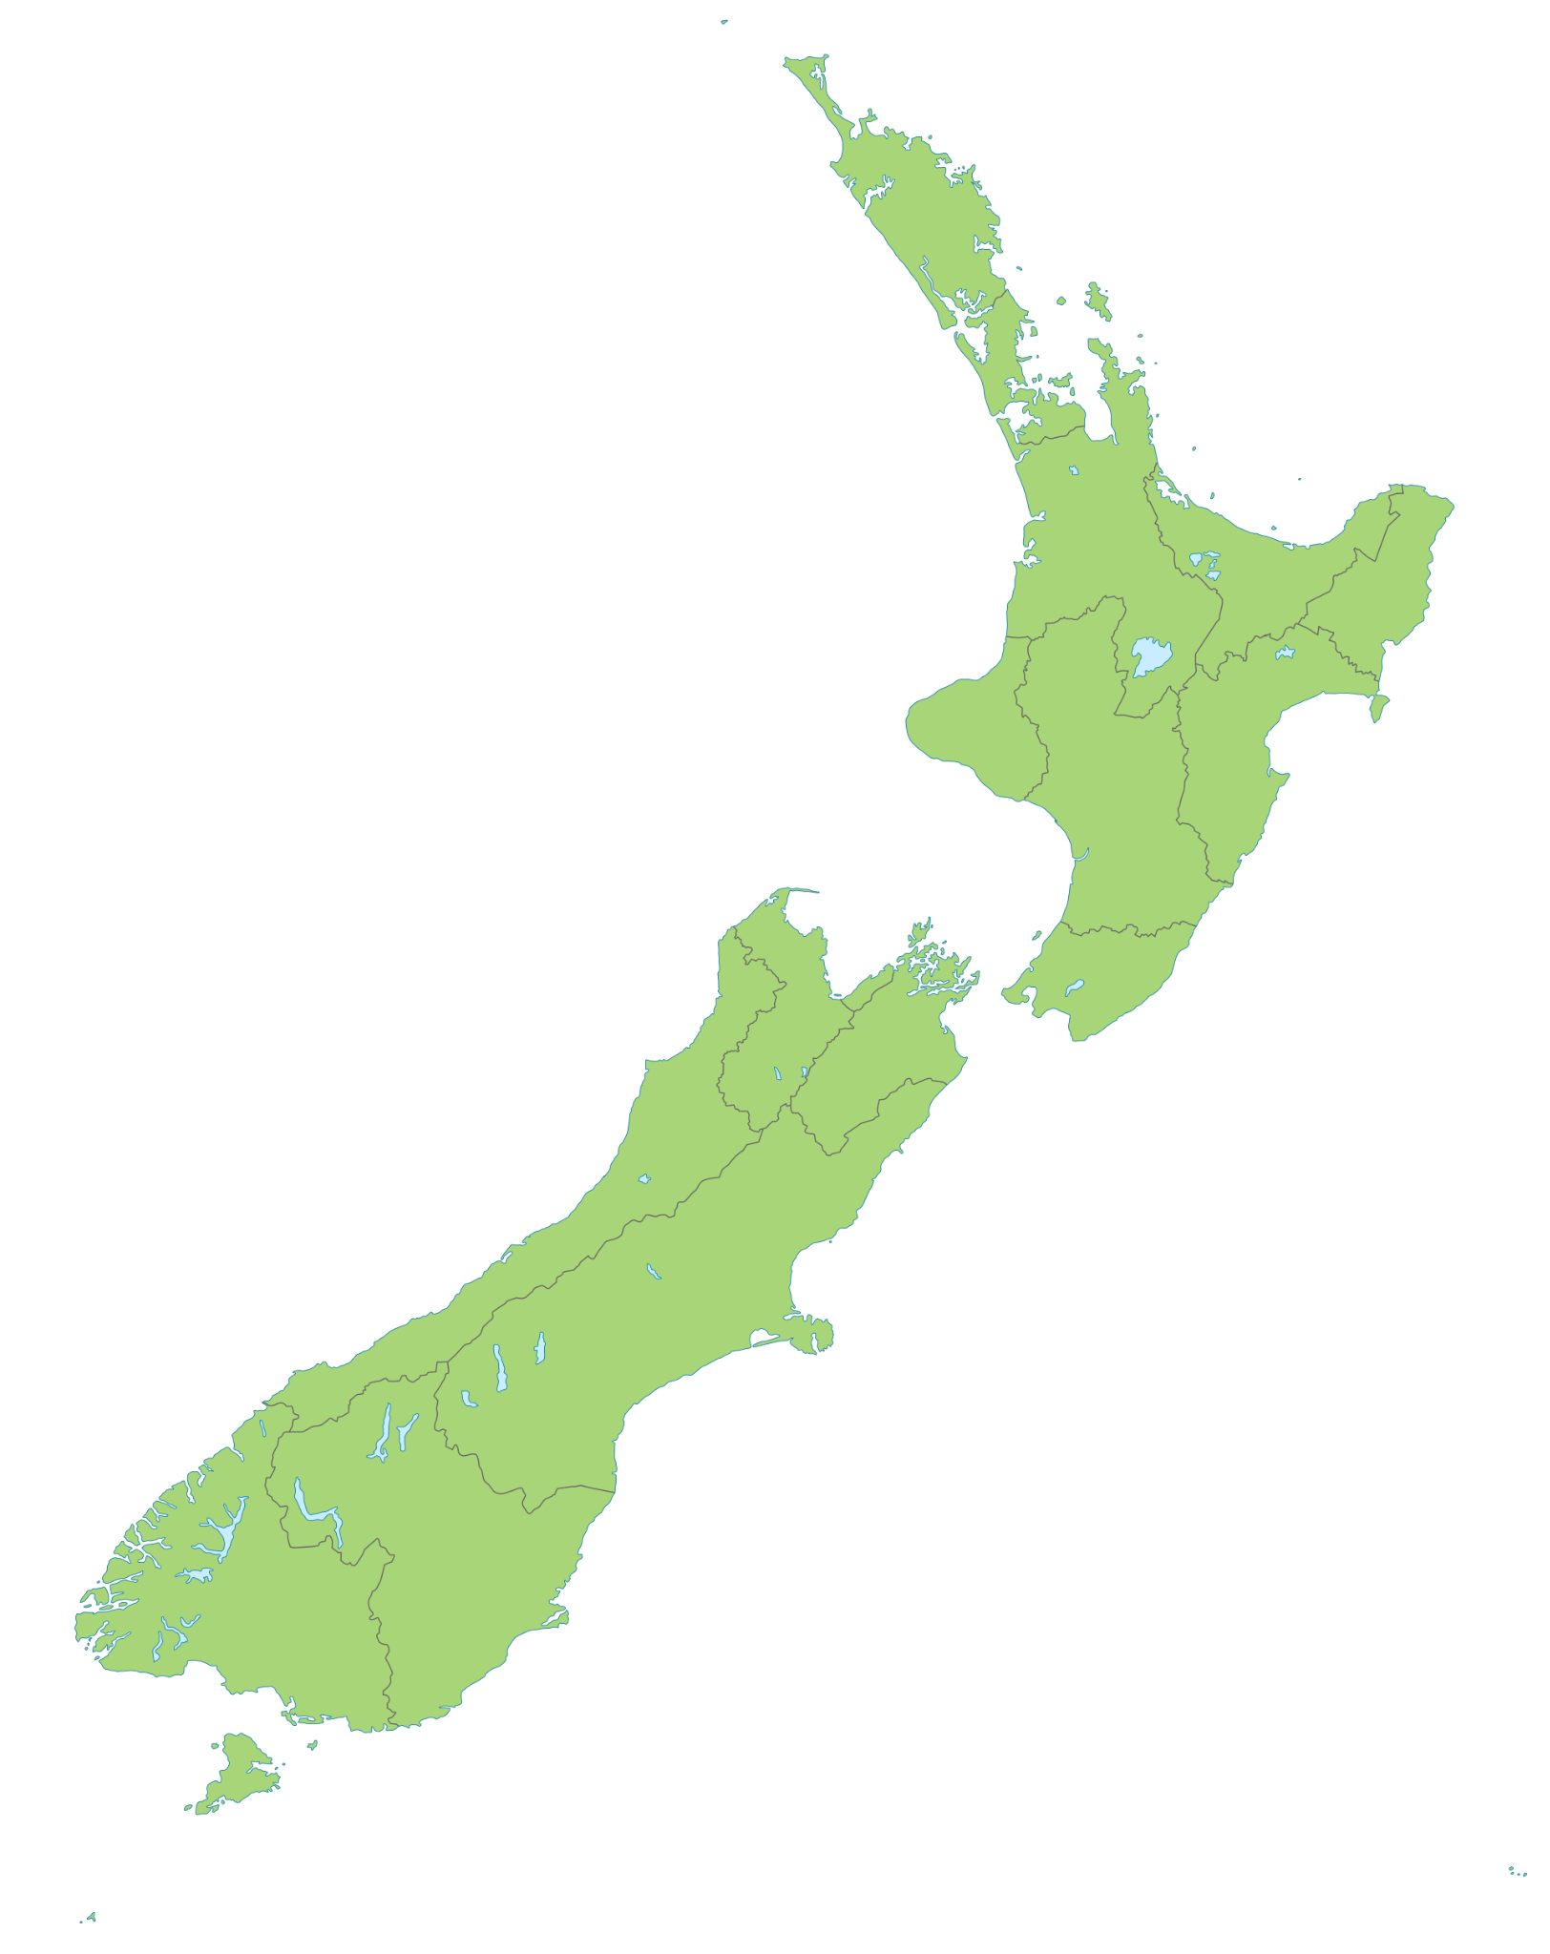

| Te Waipounamu | Ōtepoti | Rakiura |
| --- | --- | --- |
| Te Whanganui-a-Tara | Te Ika-a-Māui | Rotorua |
| Te Papaioea | Kirikiriroa | Whakatū |
| Wanaka | Taupō | Tamaki-makau-rau |
| Māwhera | Ahuriri | Kaikōura |
| Te Tihi-o-Maru | Waihōpai | Ōtautahi |
| Tauranga | Whangarei | Whanganui |
| Kaitaia |  |  |