**Global Studies May 2021**

**Year 8**

**Week 3 Lesson 1: Current Event –**

**The Week of May 17 to 21**

**Due Friday May 21 at 3:00 pm**

**Bug Threatens New Zealand**



Have you seen this bug?

**Because Week 2 was a short week and we had limited class time, we are going to use Lesson 1 to catch up on all of our work, including the last lesson. If you are up to date and have completed Article #1, then you can do the poster extension exercise.**

**Article #1: Google the link below and read the article on the Brown Stink Bug that is a threat to the country.**

https://www.mpi.govt.nz/biosecurity/major-pest-and-disease-threats/brown-marmorated-stink-bug-threat-to-nz-and-identification/

**1. According to the article, where has the bug come from and where has it spread t0?**

**2. Why is it considered to be a ‘sneaky bug?’**

**3. What is the easiest way to identify the bug?**

**4. What do its eggs look like?**

**5. What should you do if you find the bug in New Zealand?**

**6. How can you stop the bug from coming here?**

**7. What does MPI stand for, and how is it stopping the bugs from coming here?**

**8. Look at the world map. Look at a political map of the world and identify the different countries where the bugs are currently found.**

**Extension Exercise:** Create your own poster designed to make people aware of the Brown Stick Bug, the threat it poses to the country, and how someone who sees one can help.

**Week 3: Lesson 2**

**“Nothing to Declare”**

**New Zealand’s Border Security**

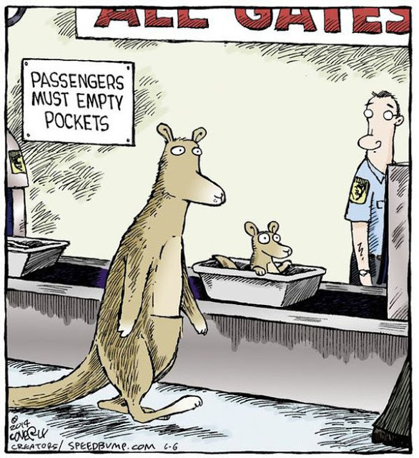

**We are going to watch a clip from a TV program on New Zealand Border Security. In it, several people are suspected of bringing illegal items into the country. On a blank page in your Red Book, write at the top of the page in large letters – “Nothing to Declare” – New Zealand Airport Security. For each illegal item uncovered in the program, list:**

**1. How was it detected?**

**2. How much is it worth?**

**3. Penalty in dollars**

**4. Penalty in possible prison time**

**You can Google the clip at:**

**https://www.youtube.com/watch?v=a4VSY_07sQU**

**Week 3: Lesson 3**

**“Nothing to Declare”**

**New Zealand’s Border Security**



**A. Watch the video, “Biosecurity New Zealand In-flight video.” Click the link:**

<https://www.youtube.com/watch?v=gU_kcbVOwsM>

This video is meant to remind international travellers to New Zealand, about the importance of protecting the country from unwanted pests and diseases. It tries to be positive and to get people to do the right thing.

1. Do you think the video is effective? Why or why not?

2. What could you add to improve the video?

**B. Watch the video, “What it's like to be a New Zealand Customs Officer.”**

<https://www.youtube.com/watch?v=dwFXz-gQCi0>

1. What is the most important job of a customs officer?

2. List key qualities of a customs officer and why they would need those qualities?

**C. Watch the video on the New Zealand airport Passenger Arrival Card.**

“What is the Arrival Process in a New Zealand Airport?”

Here is the link: <https://www.youtube.com/watch?v=ylXS81xpz2g>

1. What are the key messages in the video.

For the questions below, refer to the attached New Zealand Customs Card.

D. **A Real New Zealand landing Card Form.** Could you fill one out? Imagine your backpack is your luggage and you are passing through Auckland Airport after a trip overseas.

When you arrive in an airport, you need to fill in a LANDING CARD form.

What is a landing card for?

Why are you completing the form?

**See the attached Form (Resource C).**  Could you fill in in?