The Game | A | B | C
 | Explain why the play focuses on agreeing and if it reminds you of anything else important like that. | Definition finder:  - Apartheid  - Symbolic  - Embassy | Write about the personalities of all the different characters throughout the play.
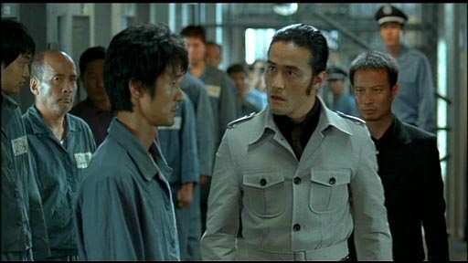 | Describe what the voiceover is saying throughout the play. | Compare and contrast when the characters are living with when you are living right now. | What is an example of alliteration in the play?
 | Draw, design and label your own television show. | Describe what you would have done if you were in the same situation as the protesters to racism. | List the ways that the author prepares us for the ending of the play.

