The Park | A | B | C
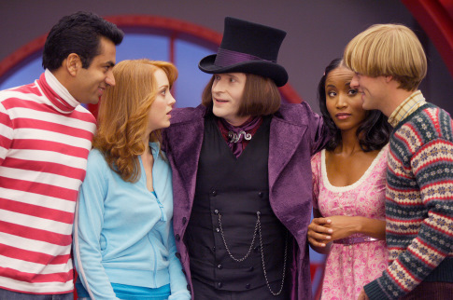 | Explain why the story focuses on bias and if it reminds you of anything else important like that. | Definition finder:  - Reprimands  - Proprietor  - Rand | Write about the personalities of all the different characters throughout the story.
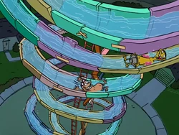 | Describe what the main character does in the story. | Compare and contrast where the main character lives with where you are living right now. | What is an example of alliteration in the short story?
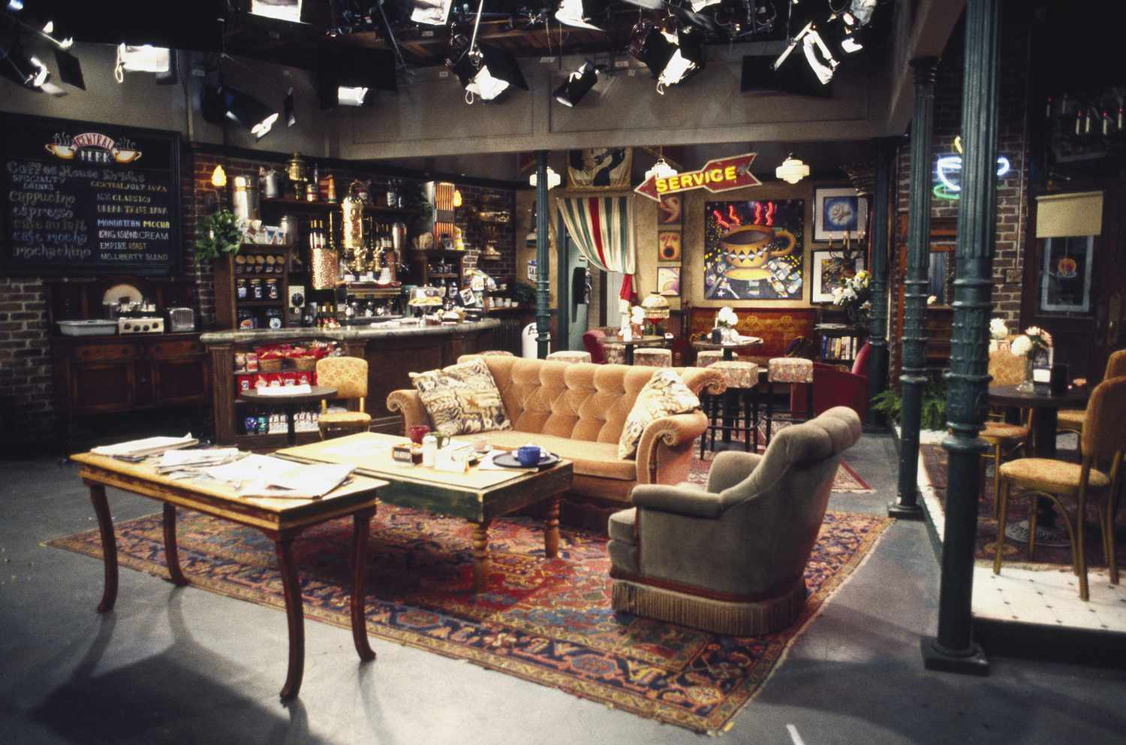 | Draw, design and label your own park which you would like to spend time in. | Describe what you would have done if you were in the same situation as the main character. | List the ways that the author prepares us for the ending of the short story.

