**Week 2**

**The Nuremberg Laws**

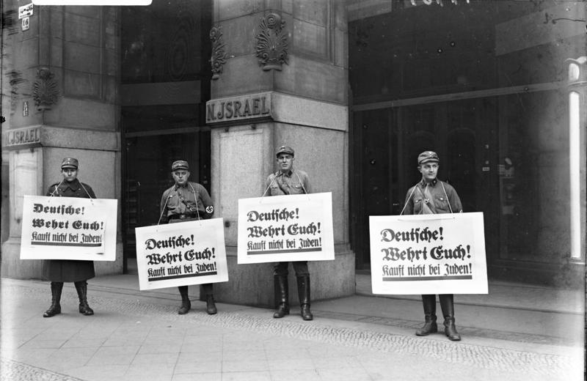Members of the [SA](https://en.wikipedia.org/wiki/Sturmabteilung)picketing in front of a Jewish place of business with placards saying "Germans! Defend yourselves! Don't buy from Jews!" during the [Nazi boycott of Jewish businesses](https://en.wikipedia.org/wiki/Nazi_boycott_of_Jewish_businesses), 1 April 1933.

**Success Criteria:** By the end of the week, students will be familiar with The Nuremberg Laws and be able to recite in detail at least three key laws.

**Task 1:**  Watch video on the Nuremberg Laws:

<https://www.youtube.com/watch?v=RtM38eIOxIk>

**Task 2:**  Access the Powerpoint on the Nuremberg Laws and create an annotated timeline on each of the major Laws. This will take you two full class periods to do an adequate job. You will write this into your Red books. Your teacher will help model this for you during the first lesson.

<https://www.ushmm.org/m/pdfs/20180228_3_Laws_and_Decrees_Timeline.pptx.pdf>

**1. Example:**  **Slide No. 1**

NATIONWIDE BOYCOTT OF JEWISH-OWNED BUSINESSES

During the anti-Jewish boycott, an SA man stands outside a Jewish-owned store with a sign demanding that Germans not buy from Jews. Berlin, Germany, April 1, 1933. At 10:00 a.m., SA and SS members stand in front of Jewish-owned businesses throughout Germany to inform the public that the proprietors of these establishments are Jewish. The word "Jude," German for "Jew," is often smeared on store display windows, with a Star of David painted in yellow and black across the doors. Anti-Jewish signs accompany these slogans. The official boycott ends at midnight.

***Example:***

***BOYCOTT OF JEWISH SHOPS***

***APRIL 1, 1933: Germans stand in front of Jewish Shops and ask their fellow Germans not to shop there and support the Jews. Sometimes they write the word ‘Jude’ on shop windows to identify the shop as Jewish-owned.***

A look ahead to next week.

Nuremberg Laws Video Project

You will work in groups of 2 to 5 and create a video clip of between 3-4 minutes long recreating at least one Nuremberg Law.