**Week 10: Current Events**

**Lesson 1:**

**The Coming Solar Tsunami**

**& the Kiwi Scientists Trying to Understand It**



**Success Criteria: By the end of the lesson students will be able to describe the Carrington Effect and why we need to prepare for it.**

**Class Discussion: How many students have ever seen the Northern or Southern Light? What did it look like? Has anyone ever heard of The Carrington Effect?**

# Task 1: Watch the video clip titled, “The Most Powerful Solar Storm in History and Why It Matters for Our Civilization” at: <https://www.youtube.com/watch?v=CwUND3V74ew>

# Answer the following questions in your Red Book:

# 1. What is a solar storm?

# 2. How did scientists discover that a giant solar storm hit earth thousands of years ago – and what does Carbon 14 have to do with it?

# 3. What are the consequences of a solar Tsunami hitting earth?

# 4. What can be done to prepare for the next event?

# 5. What are the odds that a major event will happen in he next 50 years? To answer this question, read the article below from TV NZ:

**Scientists Preparing New Zealand's Defences Against Solar Tsunami Threat**

**August 20, 2022 by Kaysha Brownlie NewsHub**

[A group of Dunedin scientists is already stepping up New Zealand's defence for when one happens.](https://www.newshub.co.nz/home/travel/2021/10/passenger-captures-stunning-aurora-photo-from-aircraft-window.html)

['A rather pretty display': Stunning Aurora Australis lights up New Zealand's skies](https://www.newshub.co.nz/home/new-zealand/2021/03/stunning-aurora-australis-lights-up-new-zealand-skies.html)

[We see the sun every day but what most of us don't realise is it's currently moving into a phase of high activity. During this time it produces more solar flares, as well as solar tsunamis.](https://www.newshub.co.nz/home/new-zealand/2021/03/stunning-aurora-australis-lights-up-new-zealand-skies.html)

"Solar flares are the biggest explosion in the solar system inside the atmosphere. They throw billions of tonnes of material out into space and that's a solar tsunami," explained Professor Craig Rodger, from the Otago University physics department.

There's roughly a 25 percent chance of an extreme event reaching Earth in the next 50 years.

"That's pretty high, much higher than us winning Lotto even in 50 years," Prof Rodger warned. It could cause an electrical blackout which is why he will travel to the Chatham Islands as part of a team installing a magnetometer.

"We need to better understand how magnetic fields vary across the country," he told Newshub.

"We put a magnetic instrument up in Awarua near Invercargill, one in King Country, now we're putting one in the Chathams. That will give us good north, south, east, west coverage."

Unlike other natural disasters, we will know when a solar tsunami is coming. It takes 12 hours to reach Earth from the sun.

"If it's a very very big event, you could imagine the safest thing to do would be to turn the power grid off for a day or two and then we'd turn it back on - we'd have a power grid," Prof Rodger said.

A previous solar tsunami has proven planning is key.

"The Carrington event was the largest solar storm ever recorded in history in 1859, it affected electrical infrastructure everywhere around the world including New Zealand," warned Otago Museum science engagement co-ordinator Toni Hoeta.

There wasn't a lot of electricity back then but today the world relies on it. It's worth stopping at this point to think about the number of electrical devices you rely upon as do hospitals, schools, businesses, laptops and phones.

"It can even affect GPS so imagine you're in the sky on an aeroplane and the GPS goes out of whack," Hoeta said.

That being said, work is already underway to prepare for it.

"The good thing is that we're doing science with Transpower to prepare for this eventuality so we can mitigate and have contingency plans so it won't be as bad for New Zealand," Prof Rodger said.

"Don't prepare for it in the sense the world is ending, just know we might have limited power for a certain amount of time," added Hoeta.

So best keep those batteries to hand.

**Lesson 2: Current Event**

**Is Video Game Addiction a Real Thing? Yes**

**Do you Probably have it? No says an Auckland University Expert**

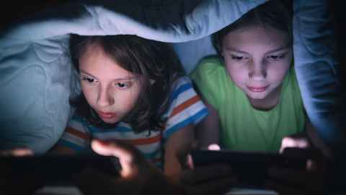

**Success Criteria: By the end of the lesson students will be able to describe to define what video game addiction is, whether they have a problem, and both positive and negative impacts of playing video games.**

**Task: Watch the short video clip on gaming addiction:**

[**https://www.youtube.com/watch?v=kpjhPK3zLAE**](https://www.youtube.com/watch?v=kpjhPK3zLAE)

**Class Discussion: How many students think they know someone who is addicted to video games? How would you define video game addiction? How many students have ever played a video game for more than 12 hours in a single day? How many hours do you average playing video games on any given day? (We will create a chart on the board). *Optional – you can create a bar graph or percentage bar graph based on the class responses**

**Break up into groups of 3 to 6 students. Take turns reading the article below, then discuss and answer the following questions. The article is by Auckland University video game researcher Alison Sims. She is a world authority on the impact of video games and addictive behaviour.**

# On Addiction & Video Games

**23 June 2021 by Alison Sims**

**Auckland University,** [**Faculty of Creative Arts and Industries**](https://www.auckland.ac.nz/en/news/list.html?tag=news:faculty-of-creative-arts-and-industries)**,**[**Education and Society**](https://www.auckland.ac.nz/en/news/list.html?tag=news:communications-team/education-society)

Opinion: Despite extensive research, scientists still aren’t sure if video games are addictive. But, as Allan Fowler asks, if they were, would that be a bad thing?

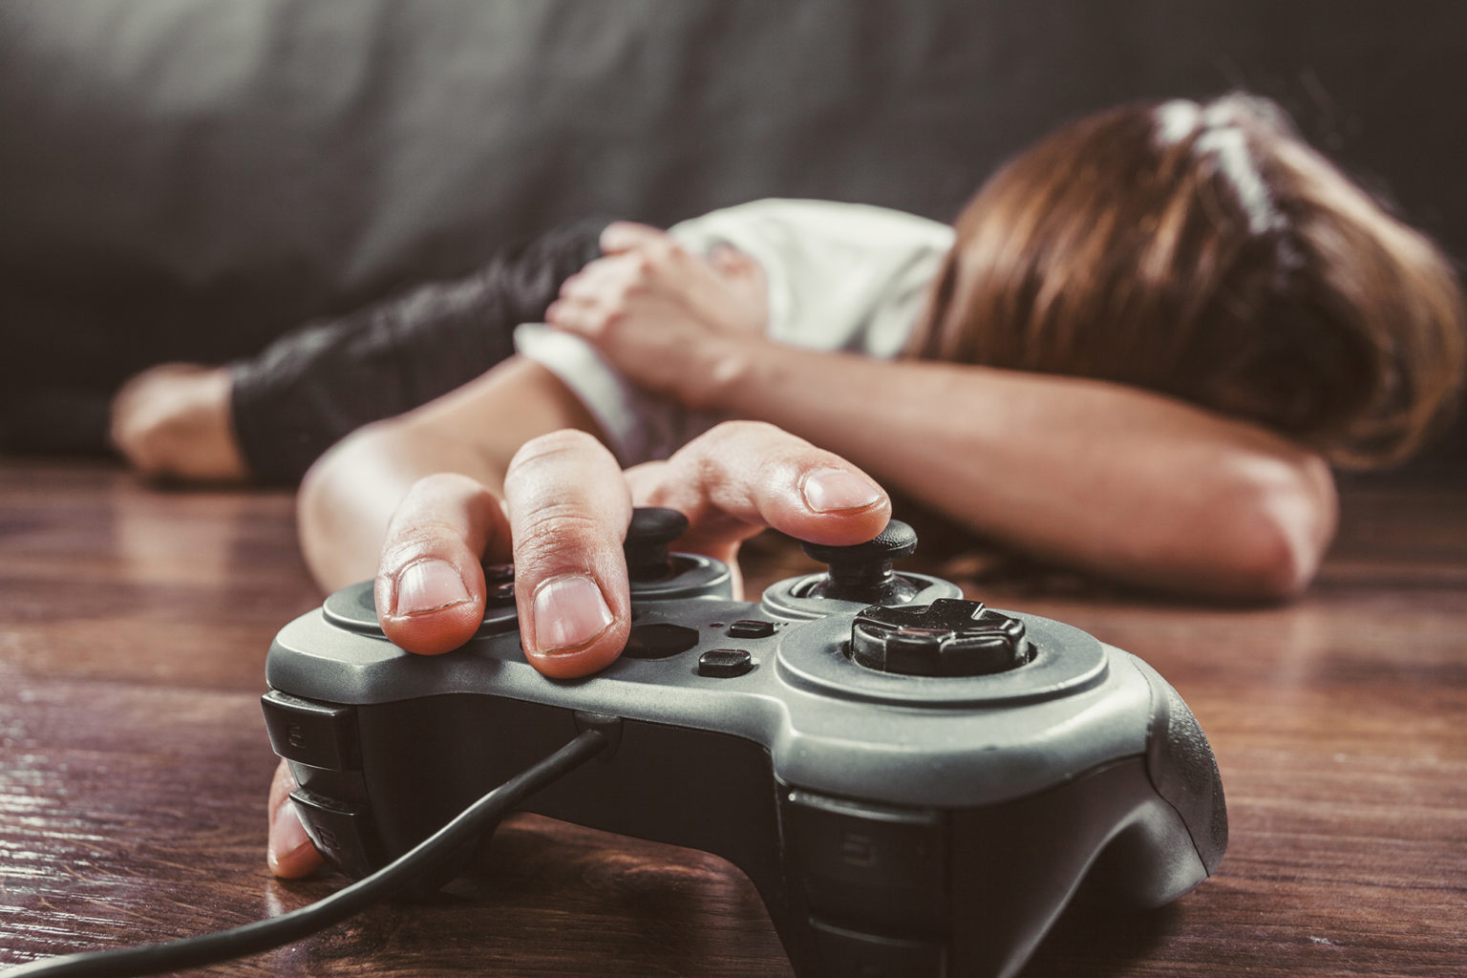Above photo: Is this you?

The American Psychiatric Association 2013 defines Internet Gaming Disorder as “a persistent and recurrent use of the Internet to engage in games”.

In a recent article in the [*Washington Post*](https://www.washingtonpost.com/lifestyle/2021/05/25/roblox-addiction-advice/)*,* US writer and producer Amy Brill expressed concerns about how much her children, and her friend’s children, were playing Roblox, the online gaming platform that allows players to create their own games, enables masses of multi players and has its own virtual currency for in-game purchases.

Valued at US$29.4 billion, the platform now has more than 32 million daily users, two-thirds under the age of 16.

In her article, Brill worries about the addictive potential of such gaming and cites the American Psychiatric Association 2013 definition of the Internet Gaming Disorder, which defined it as “a persistent and recurrent use of the Internet to engage in games”.

What the article doesn’t mention is a more recent study published in the American Journal of Psychiatry in March 2017. This study concluded that among those who played games, most did not report any symptoms of internet gaming disorder and the percentage of people who might qualify for internet gaming disorder was extremely small.

So, are games addictive? Judging by the mass of literature being produced on the topic, scientists don’t actually know. But if they are, is that necessarily a bad thing?

Many games are designed to motivate the player to continue playing, to get gamers hooked. Game developers use status symbols like leaderboards, high scores, badges, or rewards to keep the player playing. Playing electronic games has been shown to release chemicals like dopamine and hormones like testosterone. It might sound like some developers are encouraging addictive-like behaviour, and they might not be wrong.

Is anyone confused? That’s no surprise. Video games can definitely be used in a positive way. Several studies show that games can help with learning, social awareness, environmental awareness, and stress management. Games have been shown to help with spatial awareness, hand-eye coordination, spelling, mathematics, and physics.

I have undertaken several studies to evaluate the effectiveness of commercial video games, and in several cases, games have been shown to be an effective tool for learning. In a recent study, I asked a group of students to play the video game Gran Turismo (a car racing simulation) for 30 minutes each night for a month.

At the end of the month, I asked this group to race a performance go-cart around a controlled racetrack. I also asked a group of students who had not played the game to race the same go-carts around the same track. While the students who had played the game (the treatment group) took time getting used to the elements that weren’t part of the game (gravity, feedback, and physics), in all aspects, these students outperformed the group of students who had never played the game.

The treatment group showed an understanding of the principles of racing, they understood and used the vocabulary and could apply racing principles in practice. The treatment group looked for the best racing line, accelerating instead of braking into a curve. They used the terminology of racing when talking to each other. The treatment group achieved superior track times than the control group, and made fewer mistakes.

If we agree that games can effect change positively, then surely we need to accept that games can also cause harm?

There is considerable research into the negative aspects of excess gaming, particularly of those games that involve violence. It is no surprise that, after news of mass shootings in the US, politicians, and some media blame video games.

Many researchers and psychologists would agree that mass shootings rarely have one cause, there are usually numerous complex reasons and motivations given in attempts to explain these heinous crimes. There is anecdotal evidence that suggests, in some cases, video games helped the perpetrators of these crimes learn what to do. But while games may have been one of the influencing factors, it would be hard to argue that they are were the only factor.

Of course, this association is extreme and there are other less deadly reasons parents would have concerns about too much video gaming. For some parents there are concerns about not spending enough time engaging and relating to people offline, not doing enough physical activity, eye strain, or not spending enough time on homework.

So, while games can be good for us, like most things in life, excessive consumption can be bad for us. As a game developer, researcher, and parent, I am very cognisant of the potential effect of games or violent media on my own children.

Although it is often hard for my children to hear, they must follow the ESA ratings. For those readers who don’t know what the ESA ratings are, they are established by the Entertainment Software Association, which classifies games in a similar way to how movies are classified with their G, PG, and M labels. While many parents (and their children) may not fully understand the ESA rating system, it does provide some useful guidance.

We also limit what violent media our children can consume at home (not much). We also only let our children play video games on the weekend and only after completing their homework. We limit what games our children play. They play video games in the family room so we can keep an eye on what they’re playing and when. Many parents might think this is a bit tough, and they might be right.

So, is your child really addicted to Roblox? Probably not, but it might pay to manage the amount of time spent staring at a screen and get them to play, read, talk, bake a cake, or any other beneficial activity.

**Questions:**

1. Define video game addiction according to the American Psychiatric Association.

2. List some of the benefits of playing video games.

3. List some of the negative impacts.

4. Summarize the Gran Turismo (a car racing simulation game) study conducted by Sims. What were the findings of the study?

5. How young are the majority of video gamers who use the platform Roblox?

6. What are does ESA stand for in the video gaming world?

7. Near the end of the article, name some of the restrictions under the Entertainment Software Association guidelines, that students your age should have to adhere to.

8. Based on the research by Alison Sims, what is her conclusion about the addictive

**Lesson 3: Current Event**

**What is Islam?**

**A Class Discussion & Assignment**

**Success Criteria: By the end of the lesson students will be able to describe the five pillars of Islam and be able to recount other basic tenets of this major religion.**

**Islam is one of the major religions in the world with over a billion people who identify as Muslim. Many news stories involve Muslims and religious beliefs. As so many people identify as Muslims, we are going to devote a class period to better understanding what Islam is. It is also important to note that there are many different beliefs within Islam – not everyone believes the same thing.**

**Class Discussion: What do students know about Islam? What are some common stereotypes? Are there any Muslim students in class who would like to contribute to the discussion?**

**Task:** Write down the word ‘stereotype’ into your Red Books along with the definition below from the Oxford Dictionary:

**Stereotype:** “a widely held but fixed and oversimplified image or idea of a particular type of person or thing.”

**Read the following article: “What is Islam” by the BBC (British Broadcasting Corporation) at:**

<https://www.bbc.co.uk/bitesize/topics/zpdtsbk/articles/zrxxgwx>

**Assignment:** After reading it, create a one-page poster in your Red Book titled: “This is Islam.” The purpose of the poster is to introduce Islam to people who know little about it. Include 1 image (hand drawn) and many key dot-points. DO NOT COPY WORD FOR WORD – re-word the information. Place you dot-points under the following headings: be sure to include the following words – The Qur'an, Imam. Mosque, Makkah, the Five pillars of Islam.

**What is Islam?**

The word 'Islam' in Arabic means submission to the will of God.

Followers of Islam are called Muslims. Muslims believe there is one true God Allah (the Arabic word for God).



## **What do Muslims believe?**

Muslims believe that Islam was revealed over 1,400 years ago in Mekkah, Arabia through a man called Muhammad.

Muhammad is so respected that it is usual for Muslims to say 'peace be upon him' whenever they mention his name.

Muhammad is believed by Muslims to be the last prophet sent by God (Allah). They believe God sent prophets to mankind to teach them how to live according to His law.

Jesus (Isa), Moses (Musa) and Abraham (Ibrahim) are other respected prophets.

### **Five Pillars of Islam**

The **Five Pillars of Islam** are an important part of Muslim life. They are five things that a Muslim must do so they can live a good and responsible life. They include:

* The **declaration of faith** (Shahada)
* **Praying** five times a day (Salat)
* Giving money to **charity** (Zakah)
* **Fasting** during the month of Ramadan (Sawm)
* A pilgrimage to **Makkah** at least once in a lifetime (Hajj)

## **What is the holy book of Islam**

The Muslim holy book is called the Qur'an. Muslims believe this to be the word of Allah as dictated to Muhammad.

They also have the **Sunnah**, which Muslims believe to be the practical example of Prophet Muhammad.

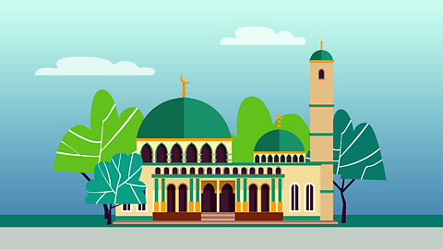

## Where do Muslims worship?

Muslims worship in a building called a **mosque**. On Friday at noon, the most important of the weekly services is held. When Muslims pray, they must always face **Makkah** in Saudi Arabia. Many Muslim men will wear a small cap called a **taqiyah** when they pray.

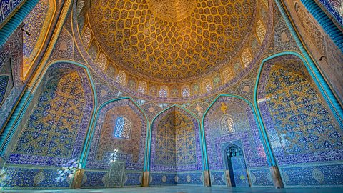

**Mosque**

Mosques are places of worship for Muslims all over the world. Mosques usually have rules like leaving shoes outside and dressing modestly.



**Imam**

Imams lead worship in a mosque and are important community figures. They are there to offer spiritual guidance and life advice for the Muslims in their community.

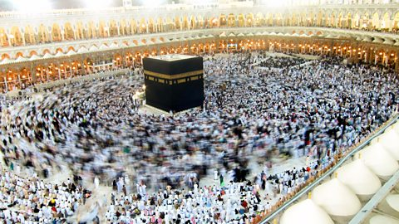

**Makkah**

Makkah is the holiest city in Islam. It is Muhammad’s birthplace and also the place the Qur'an was revealed. Hajj is a huge yearly pilgrimage to Makkah, attracting several million Muslims from all over the world. All Muslims (as long as they are healthy and able to travel) try to do Hajj at least once in their life.



**The Qur'an**

The Qur'an is the most important book in Islam. Muslims believe it was revealed to Muhammad by Allah through the Angel Jibreel. It has details on the existence of Allah, morality and historical events.

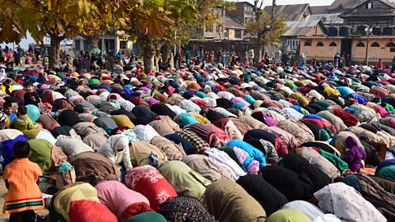

**Salah (prayer)**

Salah (or prayer) is very important to Muslims. Muslims pray five times a day and they must be facing the direction of Makkah.