BIOGRAPHY LEARNING GRID | A | B | C
 | List 5 true and false facts from the text. | Create a secret code revealing an important fact from the biography (1=A). | Design a mini timeline of four key events from the text in the right order.
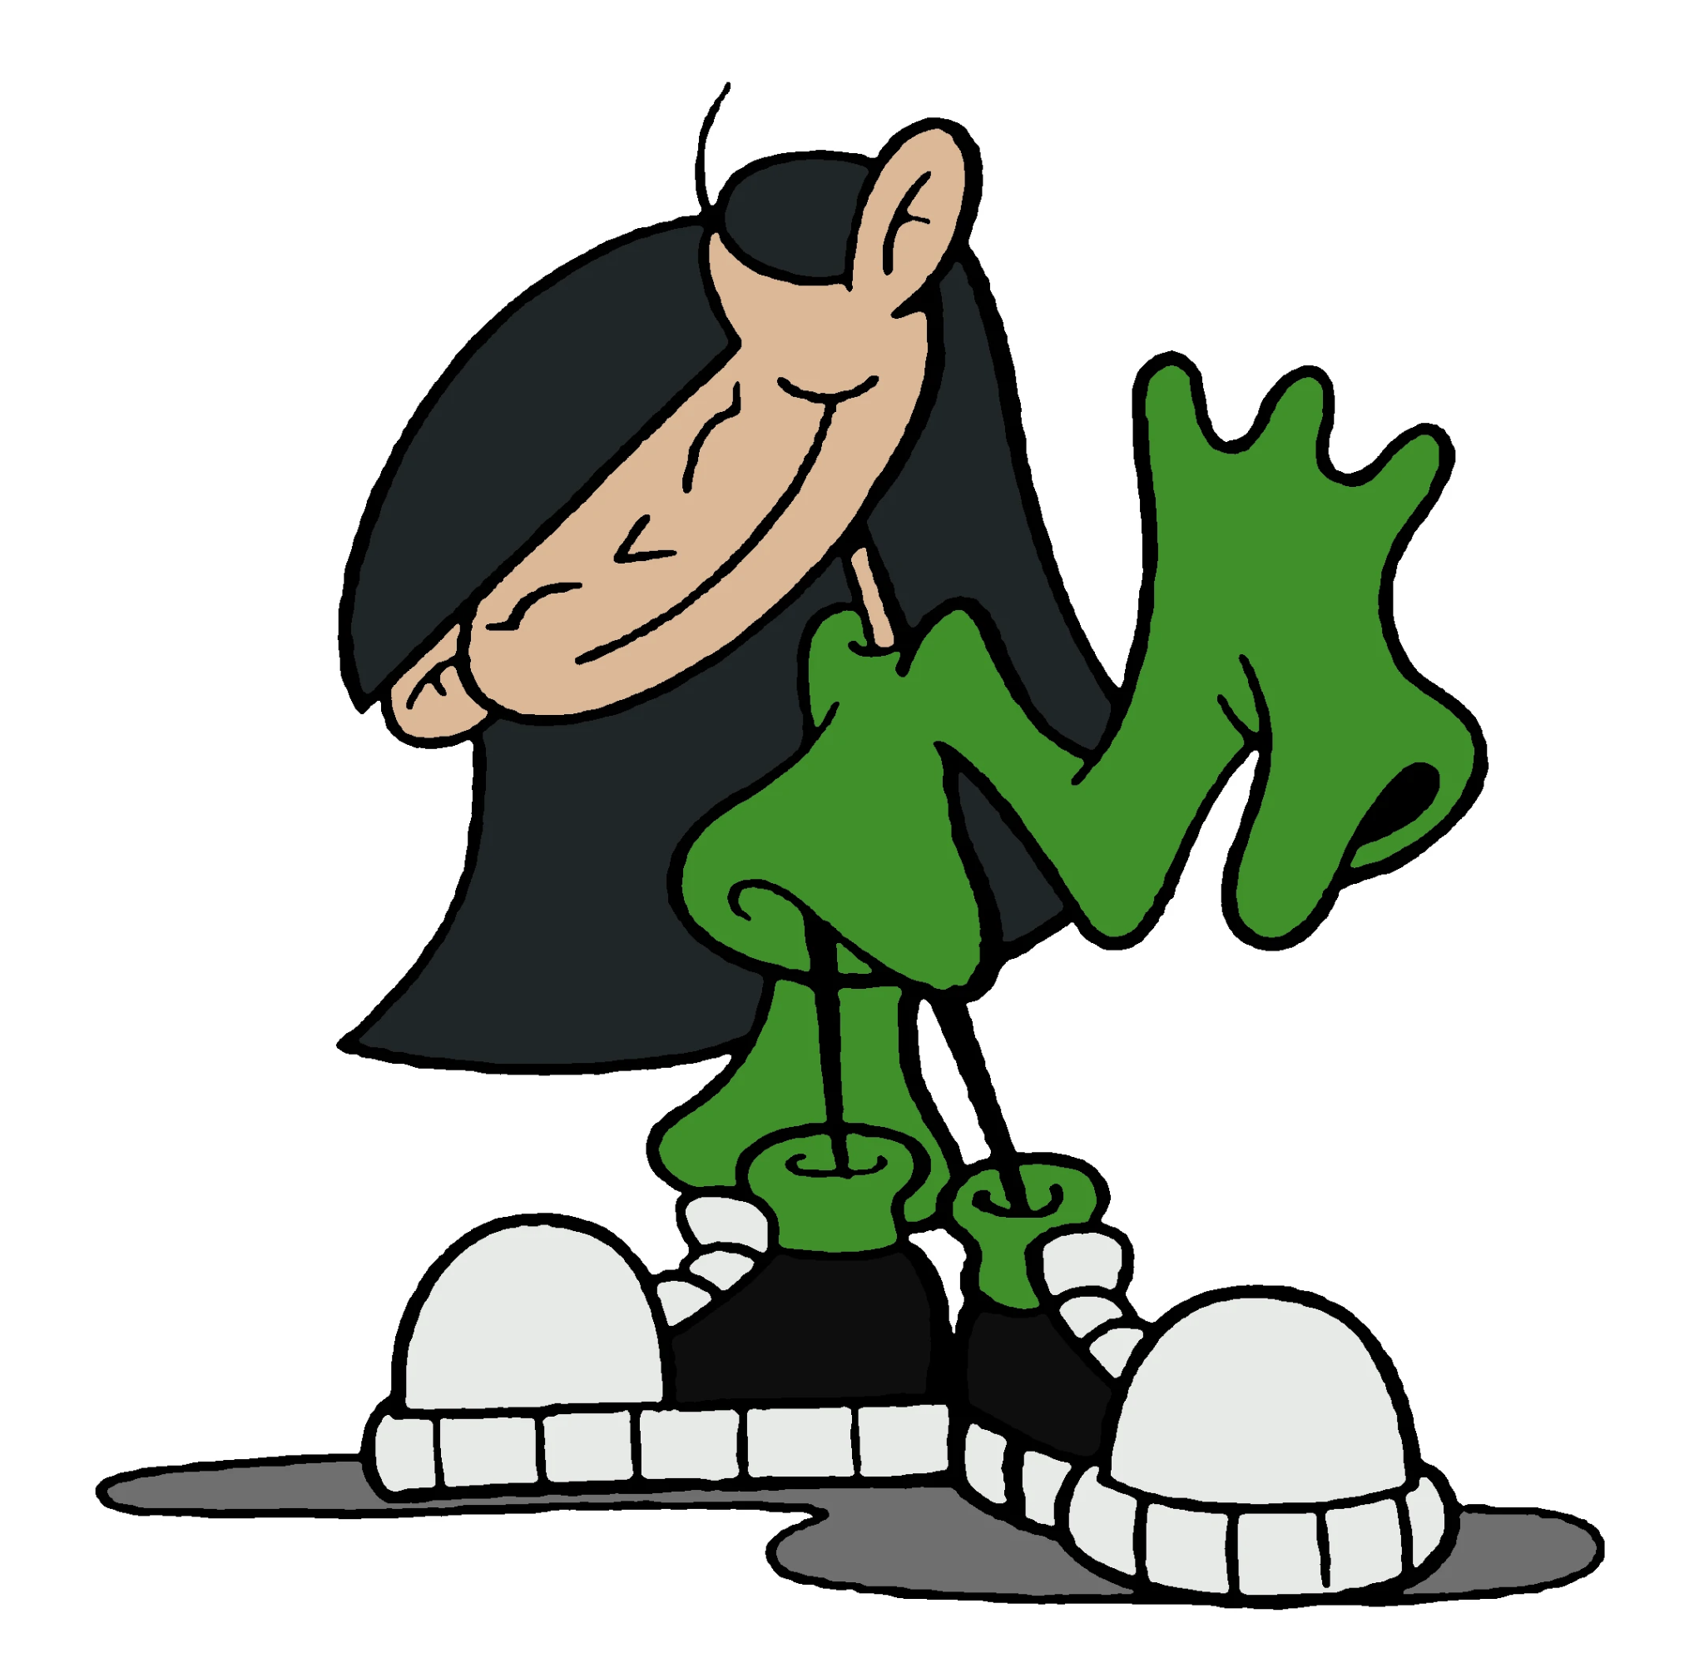 | Write 4 key facts, 3 keywords, 2 key people and 1 key date from the text. | Write 3 facts you learnt and one question you have about your biography. | Draw a grid just like this one in your English books and write facts from the biography in it.
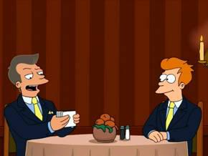 | Find out about a person who has made a difference in the world just like the person in the biography you read. Write a biography about that person. | Write 5 statements about the person whose biography you read with missing key terms. Give to your neighbour to fill in. | Draw, label and colour a picture of what the person did with their life.

