Week 6 Lessons 1 to 3
The Week of August 29 to September 4, 2022

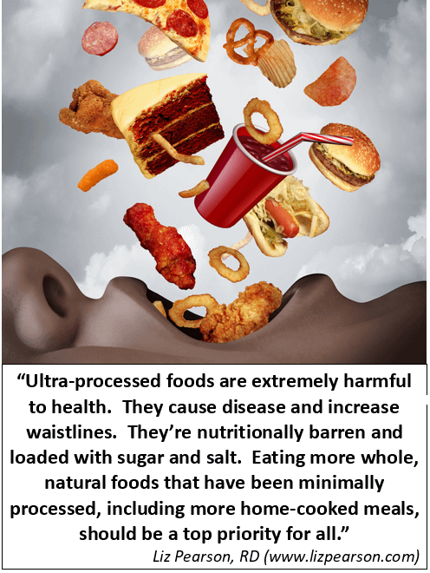
– Liz Pearson, Dietitian

How the Food Industry Get Us to Eat More

Success Criteria: By the end of the week, students will be able to describe 3 substances that are used by the food industry to get us to consume more food than we need, the impacts on our health, and possible solutions. We will also look at the French documentary, ‘Tricked not Eating More’ and we will examine the question – ‘How do some major corporations get us to consume so much processed food and why are we so hooked on it?’

Task: Watch the documentary “Tricked Into Eating More…”
https://www.youtube.com/watch?v=l0B1xMu-uow

We will do this as a class, occasionally stopping and discussing.
In this documentary, Remi, a French-American reporter, finds the answers to the questions we all ask about fast food: How do major corporations get us to consume so much processed food and why are we so hooked on it?
Please write each question out in your Red Books, and either filling in the missing word(s) or writing out the answer.

1. Only a small number of large Corporations supply ___% of what we eat. (1:20 sec. mark)

2. Our ancestors ate to __________. We on the other hand eat to satisfy our ___________. We no longer eat what we need, we eat what we ______. (3:34 sec.)

3. Why do so many people like sugar? (5:45 sec.)

4. There is an innate (genetic) tendency to like sugar, in part because it has natural __________ properties. (6:30 sec.)

5. From the time we are born, babies have a natural preference for ________.

6. It is natural for people to not only like sugar, but also fat and _____ (7:31 sec)

7. Go to the 10-minute mark where the program describes several ways that supermarkets get us to buy more food when we enter the store.

a. Which is more likely to stop us from buying products we don’t want – carrying a basket or pushing a trolley? Explain why.

b. Why do supermarkets place fully prepared meals right next to the fresh fruits and vegetables section?

c. The Oreo Cookie is one of the best-selling cookies in the world. What makes it so attractive to us? (16:30 sec)

8. Among the many different substances that are commonly added to our foods to get us to like it, there is one that stands out above all others. It is ___________. (20:00 sec.)

9. Over the past 30 years the worldwide consumption of _____ has tripled.

10. The food expert says that we should definitely eat less _________, _________, and _________. (22:00 sec.)

11. It’s not just eating fat that makes us overweight, it’s also eating __________,

12. In 1830, the average person ate 5 kilos of sugar each year. Today it’s closer to ____ kilos per person!

13. Baby foods and children’s yogurt often contain ________.

14. When we get hooked on sugar from an early ago, how does this affect us later in life? (24:00 sec.)

15. A research team in France recently stumbled upon something unexpected while studying a group of animals who were offered cocaine or a sugar drink. Explain. (26:30 sec.)

16. What happened to the man in the MRI machine who drank a milkshake while inside the chamber of the machine? (28:00 sec.)

17. When Remi asked the major food corporations for an interview about how they make foods addictive, they refused. What are 2 of the main diseases that are caused by people overeating? (33:00 sec.)

18. What is the plan to create a traffic light system? Explain what it means? (37:00 sec.)

19. Out of 2,000 requests from Companies to put on their product – claims that it was good for your health, how many were rejected? (40:00 sec.)

20. What is the health benefit that has been claimed from drinking green tea? What about Royal Jelly? Are these claims true?

21. Several years ago a lawsuit was filed by some mothers against the product Nutella. Did they win? What was the problem with Nutella?

22. France is experiencing a big rise in chronic diseases that some experts link to eating junk food. Look up the definition of ‘chronic disease’ and write it down. (43:00 sec.)

23. What do the initials L.T.I. mean?

24. List some of the possible solutions to combat food filled with sugar, fat and salt from making us sick (46:00 sec.)

Extension Exercise:

Create a poster in one page of your Red Book that will highlight one way that big corporations get us to eat more than we should. Include a catchy title and an image (a hand-drawn stick figure will do if you are not good at drawing!).

