CAMERA ANGLES

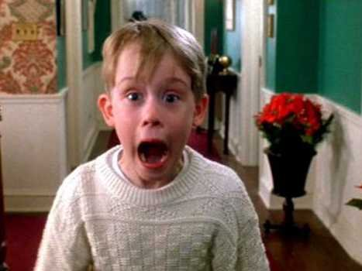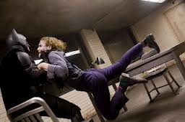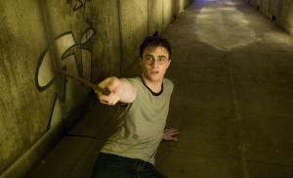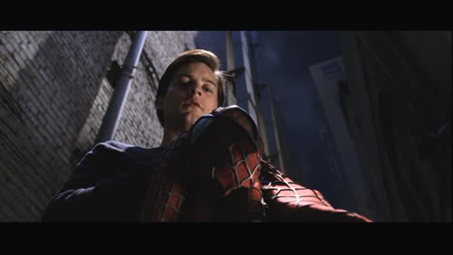

This is the most commonly used angle in film. It accounts for 90-95% of shots in films. What is it?

__________________________________

Why do you think it is commonly used?

This angle, also called a canted angle, adds tension to a frame and create a sinister or distorted view of a character. What else is it called?

__________________________________

Why is this angle used in this scene with Batman and the Joker?

This angle shoots the subject from above. What is it?

__________________________________

What does this angle show Harry is feeling?

This angle shoots the subject from below. What is it?

__________________________________

What does this angle show Peter is feeling?

CAMERA SHOTS

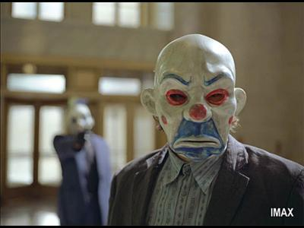

This shot is the most natural: subjects are shot from the middle up. What is it called?

__________________________________

Why makes this shot natural?

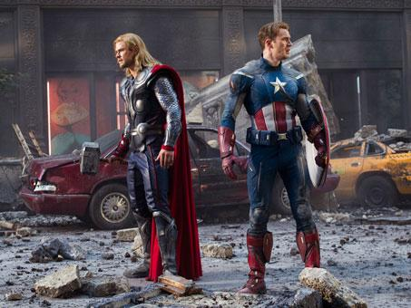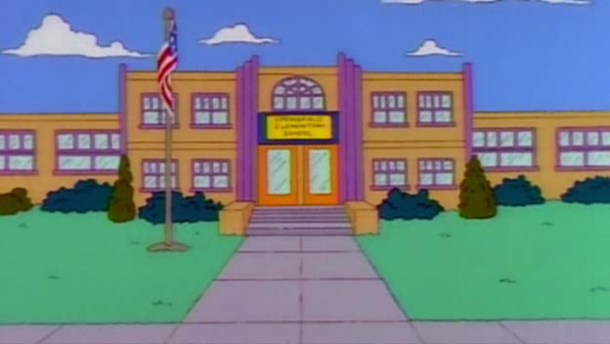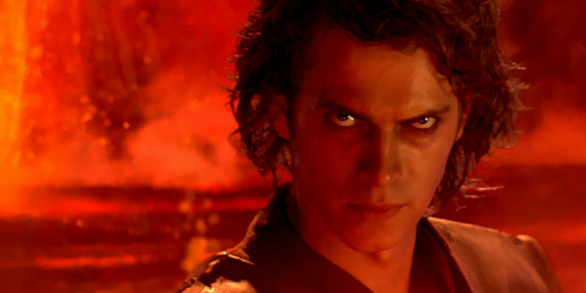

This shot is used to set the scene. What is it called?

__________________________________

What would be the benefit of a new scene or the start of a film beginning with this shot?

This image takes up at least 80% of the frame and therefore appears to be quite large. What is it called?

__________________________________

Why would a director choose to use this shot?

This is a shot, taken from some distance, which shows the full subject and some of the background as well. What is it called?

__________________________________

What is the purpose of this shot?

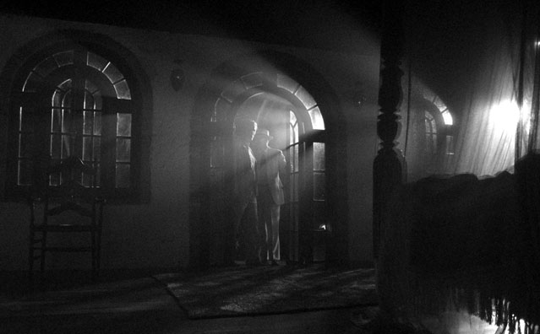LIGHTING TECHNIQUES

This type of lighting makes the most of dark tones and shadows. What is it called?

__________________________________

What type of mood does this style of lighting create?

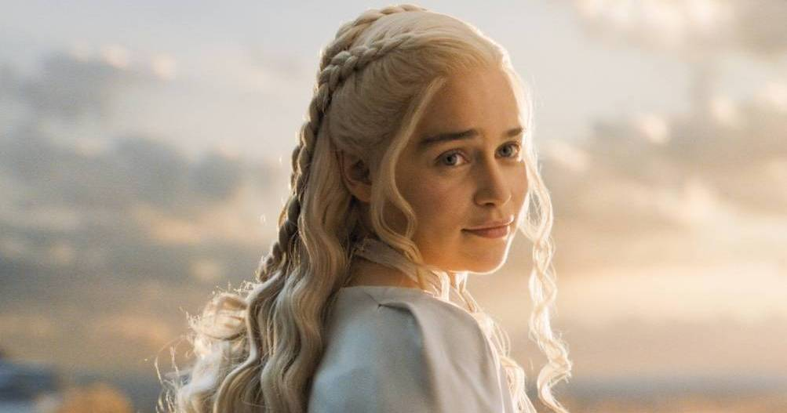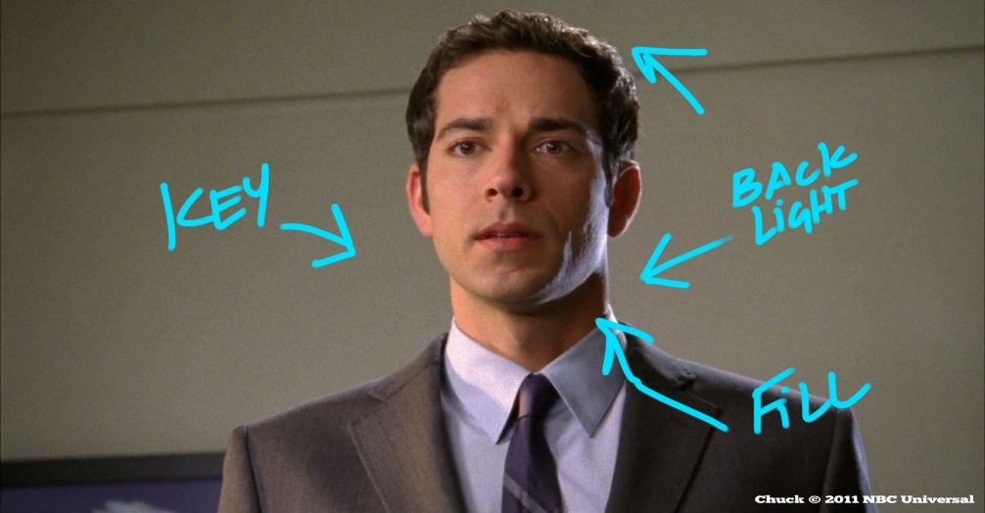

This lighting is usually bright and free from dark shadows, highlighting certain parts more prominently than others.

__________________________________

What type of mood does this lighting suggest?

In what type of scene could you choose to use this lighting?

This type of lighting is commonly used, even throughout the shot and uses the standard three-point lighting technique (key light, back light, fill light). What is it called?

__________________________________

Why is this lighting technique commonly used?

Where in particular do we often see it used?

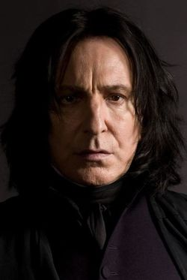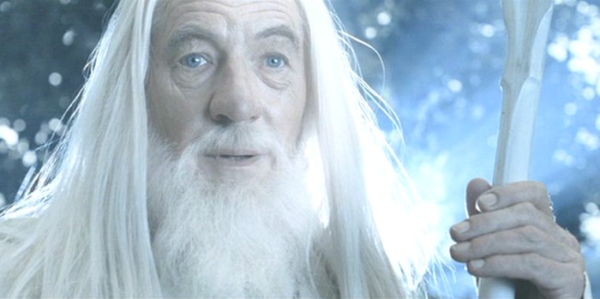

LEFT: Front/rear lighting.

What can this suggest about a character?

RIGHT: Bottom/side lighting.

What can this suggest about a character?

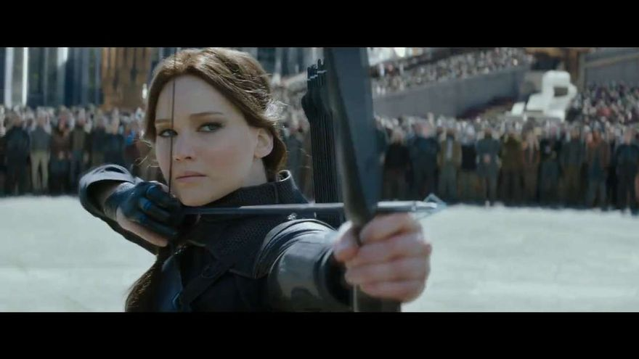CAMERA FOCUS

When one subject or object is in focus and the rest of the shot is out of focus. What is this called?

__________________________________

Sometimes the director shifts the focus from one object to another during a shot. What is the name of this technique?

__________________________________

Why would a director want to have only one object in focus?

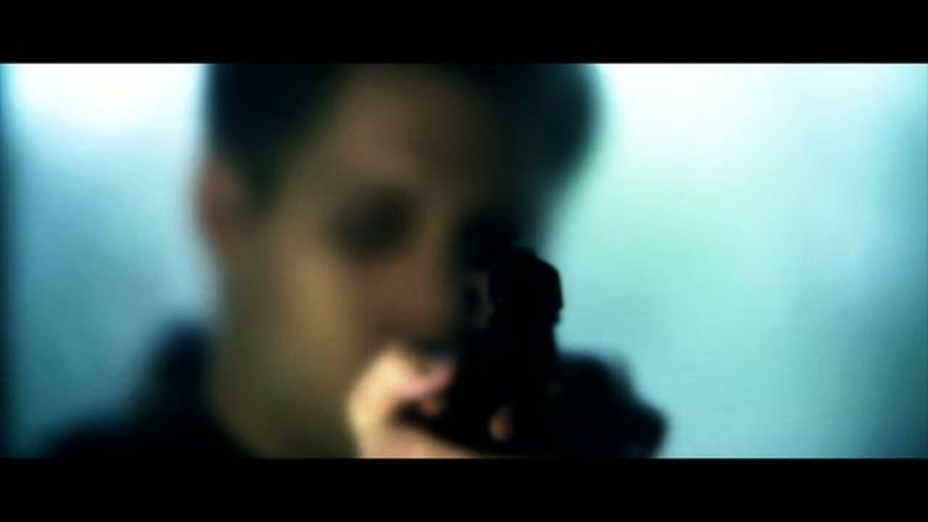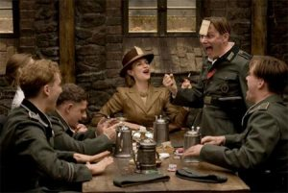

This is when a director intentionally puts an object/subject/setting slightly out of focus to make the image look unclear. What is it called?

__________________________________

What might the director’s intention be when using this technique?

This is a shot where the foreground and background are both in focus. What is it called?

__________________________________

How common do you think this shot is and why?