**Human Rights**

**Week 2: Lessons 1 to 3 –**

The Garment Industry –

The True Cost of Fast Fashion

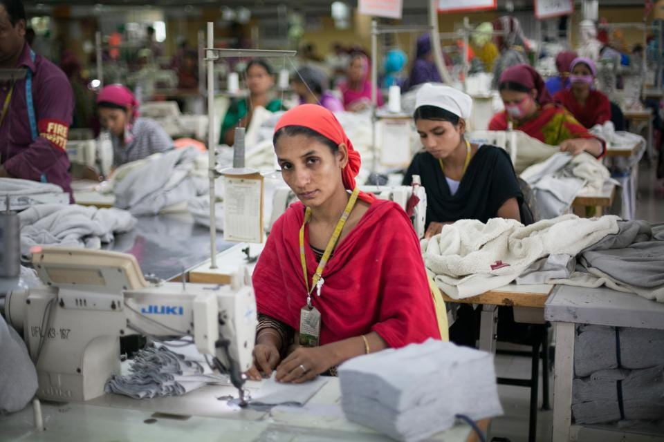

Garment workers in Bangladesh

**Success Criteria:** By the end of the week students will be able to recount several different ways that garment workers in Bangladesh are being exploited to make cheap clothing, and how fast fashion harms the environment.

This week we are going to our look at the garment industry and how it exploits (misuses/takes advantage of) workers. Let’s begin with the issue of ‘fast fashion’ which is driving the industry.

Lesson 1, Task 1: Write the following definition of ‘fast fashion’ in your books.

**Fast fashion has three main components: it's cheap, trendy and disposable. It makes purchasing clothes on impulse easy and affordable. Shoppers are encouraged to update their wardrobes regularly throughout the year to keep up with ever-changing trends.**

It could also be summarized this way:

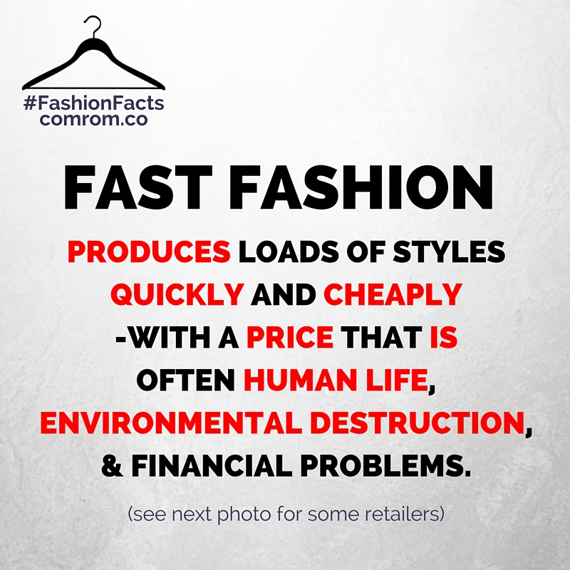

**Class Discussion:**

**Look at the photo of the clothes that have been thrown away. In the not too recent past, people kept their clothes for much of their lifetime and would often mend them when they became ripped or torn. Today clothes are overall of poorer quality and if there is a problem – most people simply throw them away and buy another.**

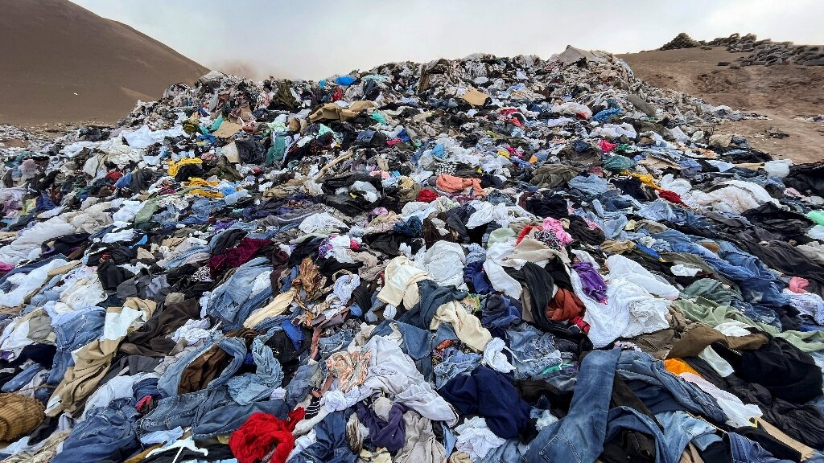

We are going to watch part of the documentary, ‘The True Cost’ at: <https://www.youtube.com/watch?v=5-0zHqYGnlo&t=126s>

**About ‘The True Cost.’**

**The documentary ‘The True Cost:** Who Pays the Real Price for your Clothes’ is a film exploring the impact of fashion on people and the planet. This is a story about clothing. It's about the clothes we wear, the people who make them, and the impact the industry is having on our world. The film puts a human face on how the world's 40 million garment workers are feeling the squeeze as developing countries, desperate for economic opportunity the business provides, fail to enforce wage and labor laws, while big fashion brands keep their hands clean. The price of clothing has been decreasing for decades, while the human and environmental costs have grown dramatically. ‘The True Cost’ pulls back the curtain on the untold story and asks us to consider the question ‘Who really pays the price for our clothing?’

**As we watch the film this week, answer the following questions:**

In your Red Book write ‘Week 3 Lesson 1, The True Cost,’ then write down the first 5 questions and we will address them together in class. We will do this, 5 questions at a time. So, once we have answered the first 5, we will stop and write out the next 5, and we will go over them, and so on. Be sure to leave at least 3 spaces between questions.

**Questions:**

1. Obsola de Castro says that clothes communicate – what is it she says that they are communicating to others? (2:50 sec. mark)

2. In the 1960s, what percentage of clothing was made in America? What is that figure today? (4:00 sec.)

3. What is ‘Fast Fashion?’ (7:30 sec.)

4. Recently a major building collapse in Bangladesh killed many workers in the garment industry there. Why do journalists blame the factory owners for what happened?

5. At the 13:00-minute mark, the journalist asked an important question – Why is it that the garment industry is able to generate huge profits but at the same time they are unable to give their workers a safe work environment and higher wages? WRITE THIS OBSERVATION INTO YOUR BOOKS.

**Class Discussion:** What do you think about what we have seen so far. How can the system of fast fashion and exploiting female workers, be fixed?

**Week 3, Lesson 2:**

6. At the 16:00-minute mark it is said that a common justification for sweatshops is that “low wages, unsafe conditions and _______ _______are all excused because of the needed jobs that they create for people with no ____________. This story has become the narrative (the story) used to explain how the fashion industry operates all over the world.

7. What is the goal of Safia Minney, founder of the Money Tree?

8. At the 20:00-minute mark, Safia is critical of the current fashion system because

a) workers are not paid a living wage, and

b) the __________ is not looked after.

9. Define ‘living wage.’ Look it up online and write it down.

10. What percentage of garment workers in Bangladesh are female? What is their average income per day?

11. When some female garment workers in Bangladesh formed a union, what was the response? (22:00 sec.)

12. It is estimated that _____ in every ____ people alive today work in some part of the global fashion industry.

13. Each year people buy over 80 billion dollars worth of cloths – a ______% increase from two decades ago.

14. A key issue is that fashion is being used as dis_______ (26:00 sec.)

15. The average American throws away ___ pounds of textile waste each year. Most of this was non-biodegradable, meaning it sits in ________ for 200 years or ____ while releasing ________ ______ into the air (26:00 sec.)

16. Go to the 32-minute mark and watch – Don’t write anything down – just listen to the woman’s story!

**Lesson 3:**

**Create a poster in your book over 1 or 2 pages. Your poster should have:**

**1. A catchy, relevant title**

**2. Raise Awareness**

Explain to people what ‘fast fashion’ is & how garment (clothing) workers in Bangladesh are being taken advantage of (working long hours for low pay and poorly treated).

**3. Key Facts about the garment industry in Bangladesh**

Mention some key facts that will grab peoples’ attention and motivate them to take action to stop what is happening (working in buildings that could fall down, cramped spaces, few breaks, etc.).