Show understanding of oral/visual text(s) through close viewing and/or listening, using supporting evidence

This assessment activity requires you to select and view one or more scenes from the visual text RABBIT PROOF FENCE, and to demonstrate your understanding of it in a written discussion. You will be assessed on the perceptiveness of your understanding and your selection of supporting evidence.

Part A:
Film Name (s):
Director:
Summary of the whole text:
The film ‘.....’ directed by ….. is

Ideas/Themes explored in the film:

The film ‘.....’ directed by ….. explores the ideas of…..

Selected Scene:

The scene I have selected to analyse is….
Time Stamp:

Discuss the theme/ideas explored in this scene:

This scene reinforces the ideas that...
Bullet points

The Director’s Message in the selected scene:

The director’s message in this scene is that adults influence children and the choices they make. This is seen in this scene when…..

Part B.
For your identified frame, you need to:

- Identify the shots, angles, camera movement, sound, dialogue, light and use of colour or special effects.
- Explain exactly how each visual and/or verbal technique is used in each frame. Why has the technique been used?
- Remember that visual is everything you see and verbal, everything you hear.
- Comment on / interpret the use of the visual / verbal technique
- In the ‘commentary’ boxes, use the following guidelines
  - This frame/shot shows…
  - The effect of the use of …..is that………
  - The combination of ……………… and …………….has the effect of…………………
  - The Director’s intention here is to ……………………..
  - This positions the audience to……….
  - This makes the viewer feel that……..
  - This idea is evident in society………..
  - This is similar to the idea in (another text)

Screenshot | Technical Information (what information is given here? What can you see/hear? Which visual and/or verbal techniques are evident? | Commentary - interpret, discuss or comment on the technical information. What does it show? How is the audience manipulated to react to an idea? How does this clip relate the the overall idea in the scene? There MUST be a discussion of a combination of at least techniques.
- Screenshot 1 | Eg 1st visual language feature  - Name it  - Describe what we see / hear | Explain the effect of the visual language feature in this scene/shot  - at least 3 sentences  - begin with an interpreting phrase  - expand your answer to show you understand the way this language feature works  - Connect the effect to character or ideas in the film overall  Connect to another visual language feature in this scene  - how they work together  - do this thoroughly for ABOVE  You only need to do this box twice by pairing up your language features (2 + 2 = 4)  For BEYOND: What do the ideas and characters in these clips show us about our society, human experience or the wider world? Write this here:
- Screenshot 2
- Screenshot 3
- Screenshot 4

Assessment Schedule

TITLE: ENGLISH Year 10 Making Meaning /Ideas and Language Features

 | Working Towards | Achieved | Merit | Excellence
Understanding | You are still developing understanding and have attempted to use supporting evidence | You have demonstrated some understanding and used supporting evidence at times | You have demonstrated understanding and used supporting evidence consistently | You have demonstrated a convincing level of understanding and used supporting evidence consistently
Ideas | You are still developing the use of critical thinking skills to explore ideas, links and viewpoints within, across and beyond the text(s) | You have applied critical thinking skills to explore some ideas, links and viewpoints within, across and beyond the text | You have applied critical thinking skills to explore ideas, links and viewpoints within, across and beyond the text | You have applied critical thinking skills to convincingly explore ideas, links and viewpoints within, across and beyond the text
Language Features 1 | You are developing an understanding of language features and their effects | You have shown some understanding of language features and their effects in detail | You have shown understanding of language features and effects in detail with consistent awareness of author purpose in using these | You have shown convincing understanding of language features and effects in detail with consistent awareness of author purpose in using these
Language Features 2 | You are developing understanding of author’s purpose in using these language features | You have shown some understanding of author’s purpose in using these language features | You have shown understanding of author’s purpose in using these language features | You have shown convincing understanding of author’s purpose in using these language features

AOs

Ideas Show an understanding of ideas within, across, and beyond texts.

Language features Show an understanding of how language features are used for effect within and across texts.
- Processes and Strategies: thinks critically about texts with understanding and confidence; recognises, understands, and considers the connections between oral, written, and visual language

Please see exemplar below:

Screenshot | Technical Information (what information is given here? What can you see/hear? Which visual and/or verbal techniques are evident? | Commentary - interpret, discuss or comment on the technical information. What does it show? How is the audience manipulated to react to an idea? How does this clip relate to the overall idea in the scene? There MUST be a discussion of a combination of at least techniques.
52.47 - 52.54  Establishing shot  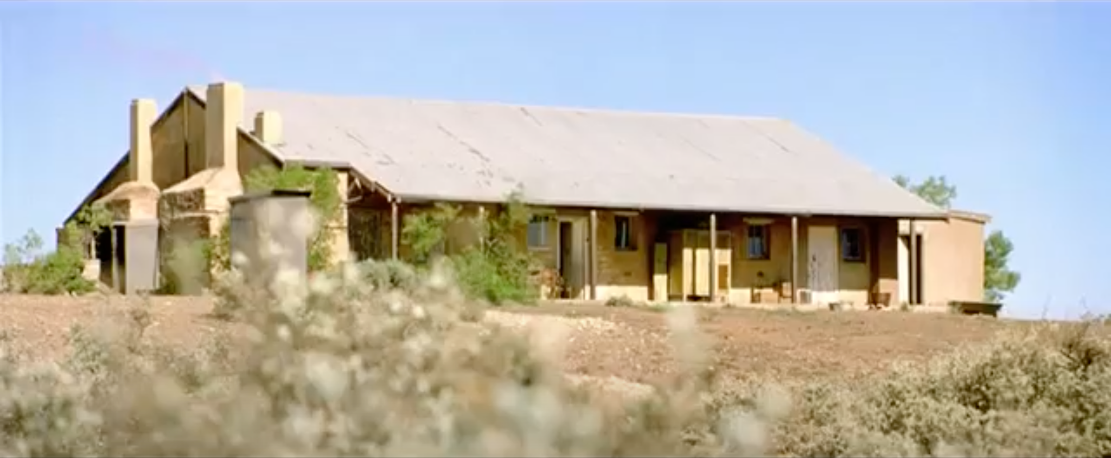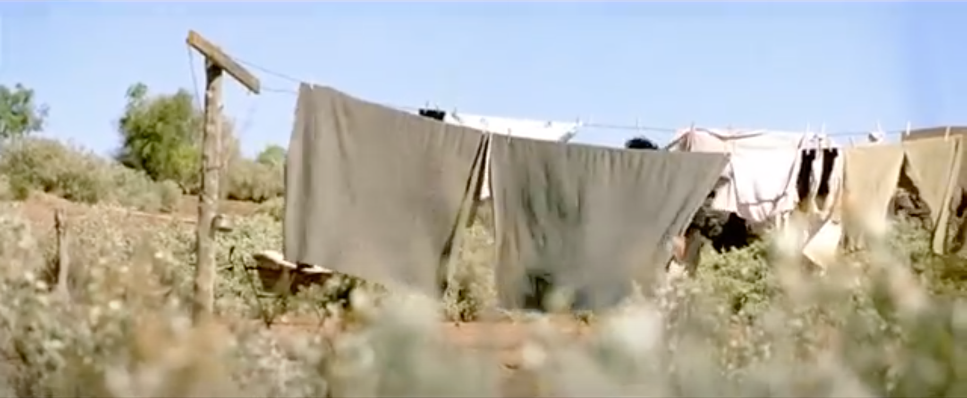 | Establishing shot - A run-down house is shown, with yellow walls and a tin roof. The raggedy house is surrounded by dirt similar to that of a desert and sand. A cloudless sky is shown above the house, showing how hot the country is.  Wide shot - shows the whole setting,  Panning - the camera moves from the scene of the building to a scene of a woman hanging her laundry out on a drying line.  Bird sounds - during the entirety of the scene the background sound is of birds chirping. | After the change in setting an establishing shot is required to set the scene. This shot is needed as it shows us where the following scenes will be taking place. The establishing shot is done in a wide shot; to capture the whole building a wide shot is necessary as it shows the whole setting, rather than only a portion. This is important as it gives the viewer a sound understanding of the setting that the characters are currently in. A panning shot is then used. A panning shot shows how two things are connected and in close proximity. In this scene, the panning shot shows how Molly is connecting the home with the lady working outside it. The background noise that is heard during this scene is of birds chirping, this gives the scene a nature-oriented feel whilst also showing that they are currently outside and if they don’t go inside they will have to spend the night outside with animals (that is why there are bird noises). The mood created in this scene is of realisation, and understanding this is shown by the panning shot use to connect the two wide shots which mimic Molly’s perspective. Her perspective being how her eyes move from the house to the woman, connecting the dots in her head that she is the girls’ way of getting into the house.  The effect of the use of the panning shot along in combination with an unsteady camera movement is that of a human perspective, with the camera moving from the house; somewhere where the girls can spend the nights, to the woman; showing how she is connected to the house and possibly their only way in. I suppose the Director’s intention here is to show how Molly’s mind is working and receives and conveys emotion. This technique forces the viewer to have a deeper understanding and connection to the girls as we see how similar they are to us, giving the movie a personalised connection to humans.  This idea is evident in society as we are more likely to show empathy towards someone when we see how alike they are to us. For example, we hear stories about children in Africa who are starving, but many people don’t see themselves in situations like these so they are less likely to help. The director using this technique better shows the conditions the girls were in and connects it to a modern human in the current age symbolising how someone whose mind worked just like us was treated.

Name of Technique
Describes what we see and hear
Purpose of the shot
Combination of techniques for impact
Effect on the audience - how does it make them feel and why does the director want to create this effect
Relevance to wider society
Link to our context

