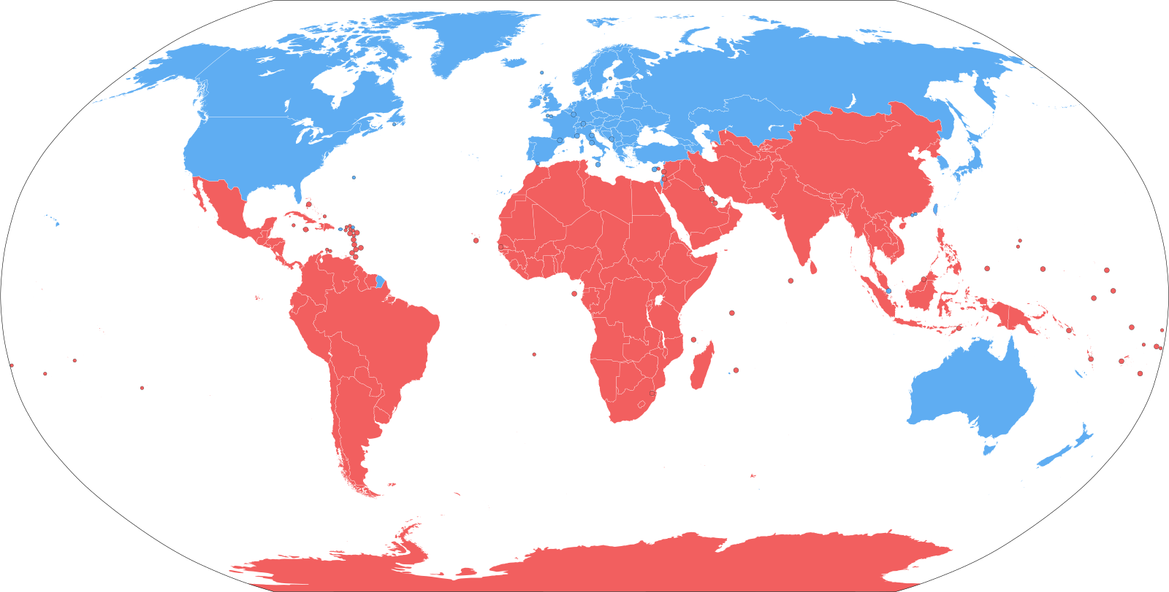
Classifying and measuring countries - whether rich ‘North’ or poor ‘South’

- While all countries continue to “develop”, a gap has been observed between the “rich North” (developed countries) and “poor South” (developing countries) in terms of economic wealth and living standards.
- See the image - Blue North, Red South
- Despite an overall reduction of absolute poverty, statistics show inequality is growing between the world’s richest and poorest countries.
- Absolute Poverty and Relative Poverty: inequality is not just growing between countries, but within them as well - between rural and urban, between states, between communities - the divide persists.

Instructions:
Working with a partner, analyse the most recent statistics from the HDI (Human Development Index) to answer the questions below. Work together - just write on this page who your partner is.

Follow this link:
https://hdr.undp.org/data-center/human-development-index#/indicies/HDI

- Look at the graph axis. What year/s are the statistics on the HDI you are using from?

- Which country is ranked as first on the HDI? What is their HDI value?

- Which country is last on the HDI? What number are they ranked?

- Where does Aotearoa NZ rank? Where does Australia rank?

- What four tiers exist in the HDI? Which tier is considered “developed”?

- Why do you think schooling is used as such a strong indicator of a country having high worth/high development? (1-2 sentences)
- If you filter by Arab States, you will see that Syria has an immense drop off from 2012 onwards. Why do you think Syria’s placement dropped? (Hint: What happened there in the 2010s?)

- How much more money does the first ranked country on the HDI have according to the GDP per capita compared with the last ranked country?
(Hint : First country’s GDP per capita MINUS last ranked country’s GDP per capita)

- Which hemisphere do MOST of the higher ranked countries on the HDI come from? Which hemisphere do MOST of the lower ranked countries on the HDI come from?

- Fill in the table below using the data from the page - remember, you find the info by hovering over the country’s line. When finished putting in Australia + China’s date, pick two countries from the Top 10/Bottom 10 Countries list we saw this week and fill in their data. You may have to use the Region Filter to locate them.

COUNTRY | HDI RANK 9/1750 | LIFE EXPECTANCY AT BIRTH (YRS) | ADULT LITERACY RATE (% age 15 and above) | GDP PER CAPITA  (PPP US $$)
NEW ZEALAND | 20/175 | 78./1 yrs | 99% | US$19,160
AUSTRALIA
CHINA
(Country 1)
_ _____
(Country 2)

______

Other resources
- Interactive map showing north & south etc https://worldpopulationreview.com/country-rankings/developing-countries
- Live population map https://worldpopulationhistory.org/map/1950/mercator/1/0/25/
- GDP by country https://www.worldometers.info/gdp/gdp-by-country/

