Getting Started, Robotics and Coding – Edison

This is a guide on how to get started using the Edison Programmable Robot

* You can access the Edison home page with this link to the Edison home page

<https://meetedison.com/why-edison-robot/>

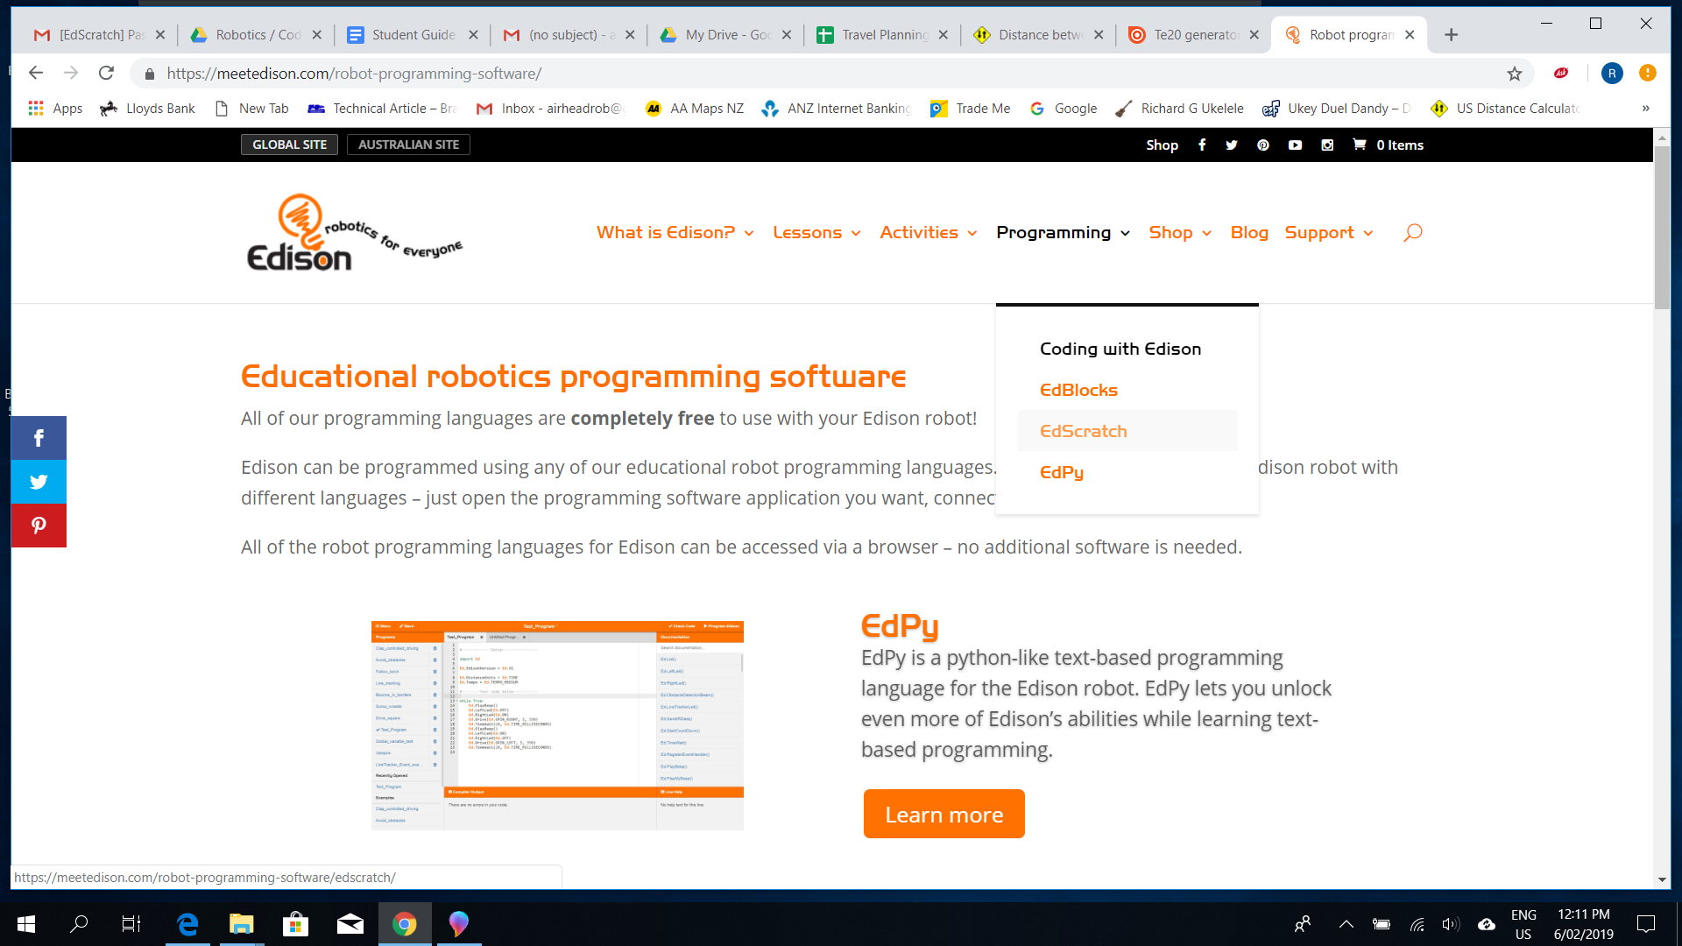

The home page contains a lot of information about Edison Robots, you could spend a few minutes and explore this. To begin programming and using Edison you need to open the programming software. Edison uses Scratch based programming, to access this either click on programming, select ‘edscratch’ and enter or use the link below;

<https://meetedison.com/robot-programming-software/edscratch/>

You will see this page which is the programming page for Edison, you will always need this page to use your Edison so bookmark it.

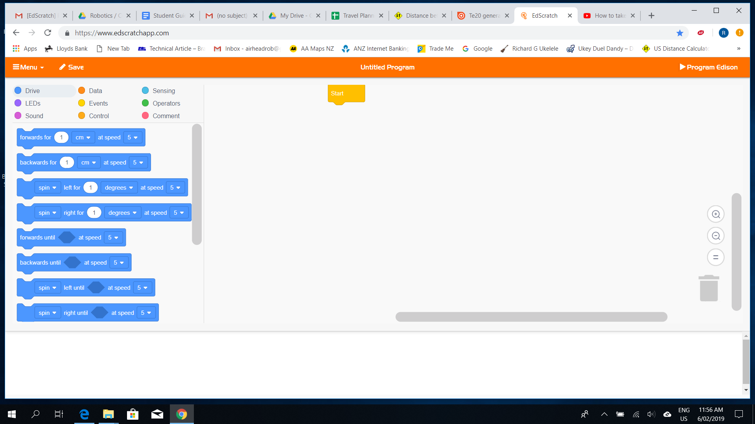

The screen shows the nine different parts of the Edison programming system, clicking on each coloured icon shows the various blocks of Scratch code used to build programmes. The area to the right of the blocks is where the programme is built.

The first thing to do is code a simple programme to drive Edison forward 10 centimetres then stop, this will test your computer can link to Edison, download the programme and that Edison carries out the programme as instructed.

First, set up your computer and connect Edison;

* Make sure no external devices are connected to the computer
* Turn the volume setting to max or 100%
* Plug the Edison connection lead into the headphone jack plug
  + Turn Edison on using the small slide switch underneath, Edison will automatically turn off after about 5 minutes, sliding right is on, if slide switch is to the right but edison is off then slide to the left then right, Edison’s LED lights with blink
* The two pin plug fits into the two matching holes near the on/off switch, it can fit either way around, Edison is now connected and ready to receive a programme
* Next, build a programme using the Edison Scratch software

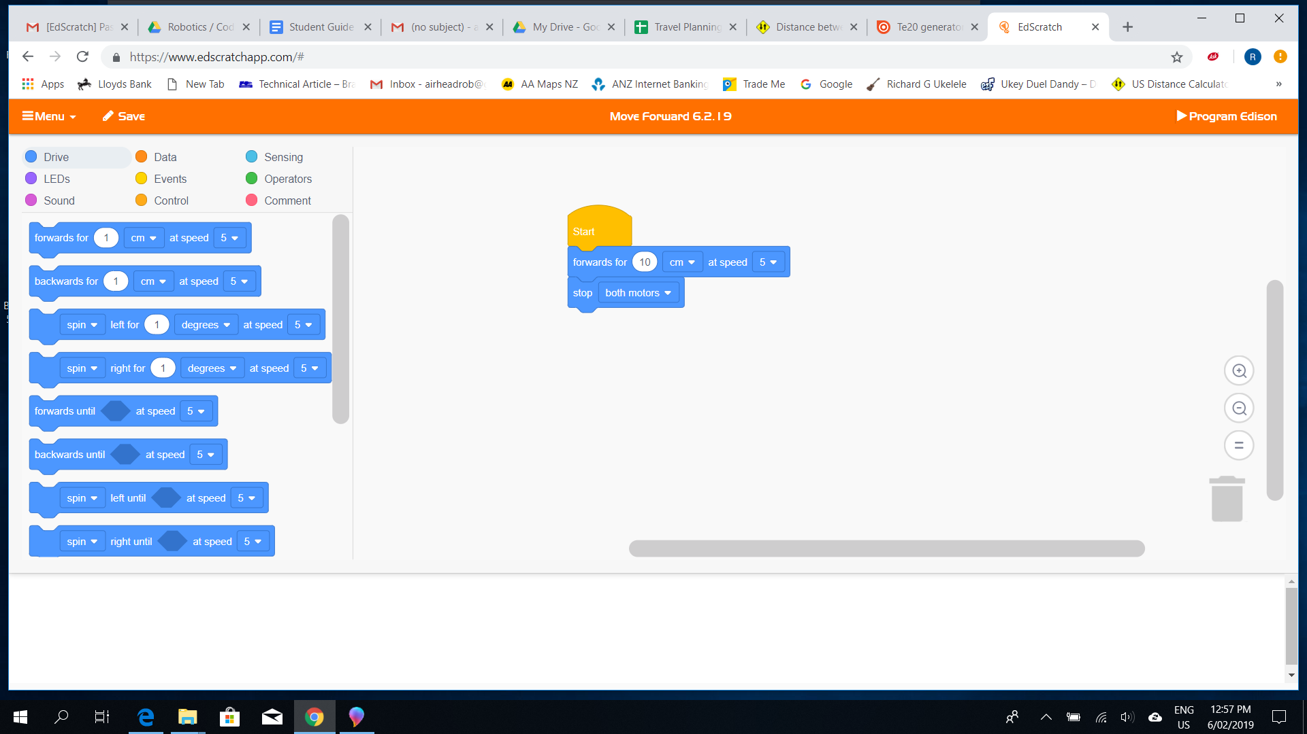

Use the ‘drive’ blocks to make this programme

Drag the ‘forwards for’ block on to the screen and attach it underneath the ‘start’ block ,edit the distance to 10 cm at speed 5 then scroll down the drive blocks, drag the ‘stop both motors’ block and attach it under the drive block, the programme is now complete.

Save the programme!

Your programmes will be saved so every time you login to Edison you can access all of the programmes you have made BUT, you must save each new programme with an identifiable name

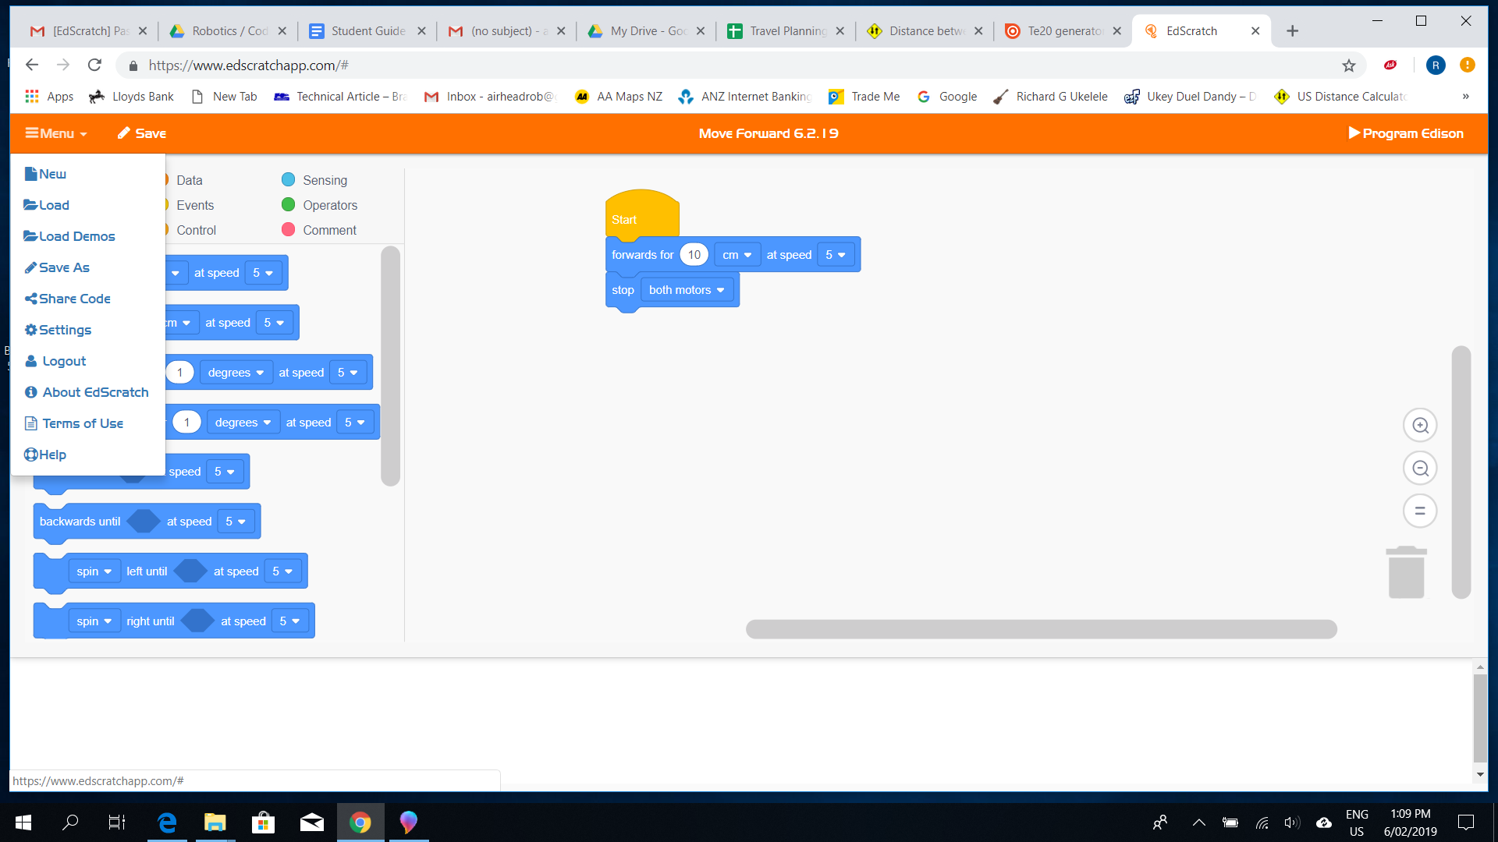

Click on the ‘menu’ icon

Click on ‘save as’

Type the name of the programme

Use a name that reflects the programme, such as Drive Forward it is a good idea to add a date so you know when the programme was written so this programme title is;

Drive Forward 6.2.19

Download the programme to Edison:

* Make sure Edison is turned on
* Press the round button once, this tells edison to expect a new programme
* On the programming screen, click on the ‘programme edison’ icon on the far right of the toolbar
* Edison’s LED lights will go out then blink to show the programme has been received
* Place Edison on a flat surface large enough so it will not run off the table
* Press the ‘triangle’ button once, Edison should move forward 10 cm then stop

Start a new programme to move backwards 10 cm then experiment with other movements, save all programmes, don’t just overwrite one programme. You can access existing programmes by the ‘menu’ and ‘load’ icons

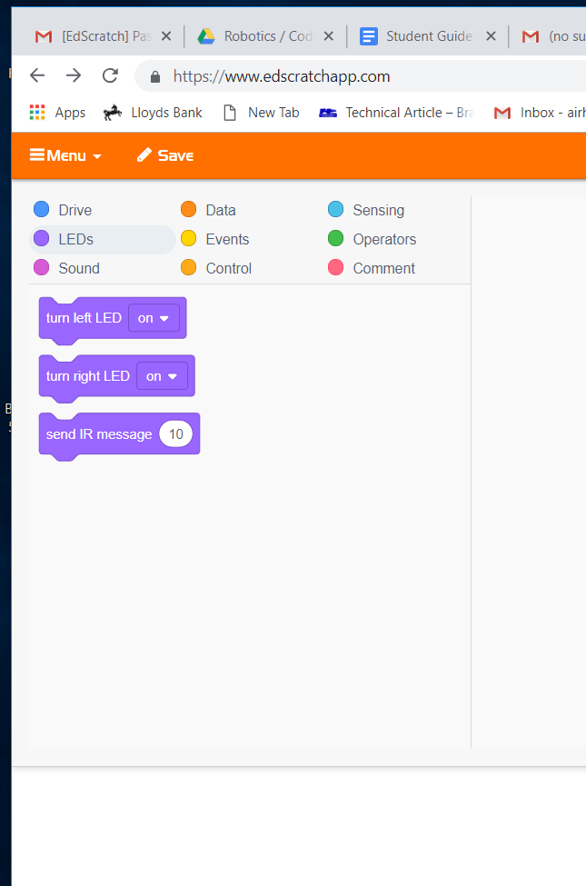

Next, make programmes to flash Edison’s LED’s using the LED’s blocks

You will continue to work through various programmes using Edison as instructed.