**Percentages**

**WALT convert percentages to fractions in its simplest form and decimals**

**Success Criteria: I know percentage means it’s out of 100%. I can simplify fractions by finding the highest common factor.**

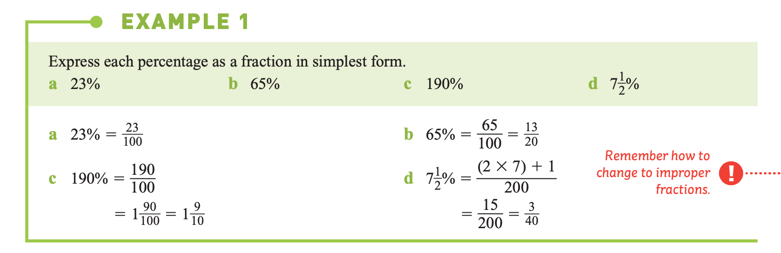

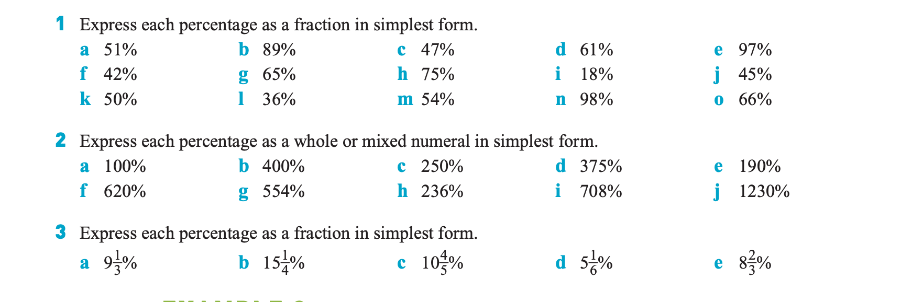

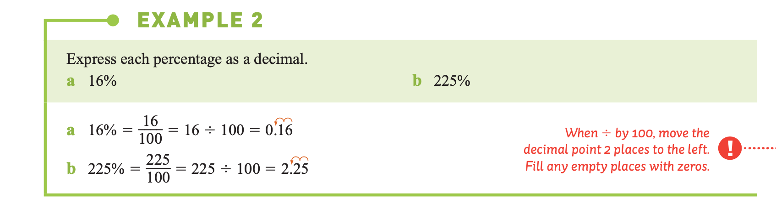

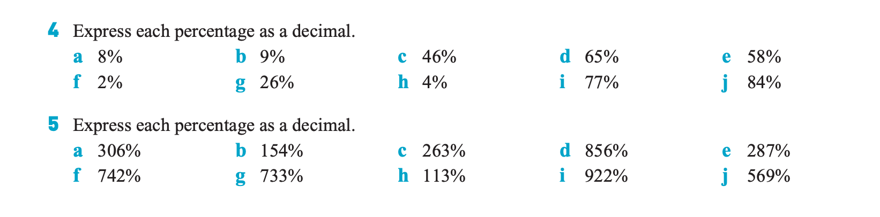

**Challenge** 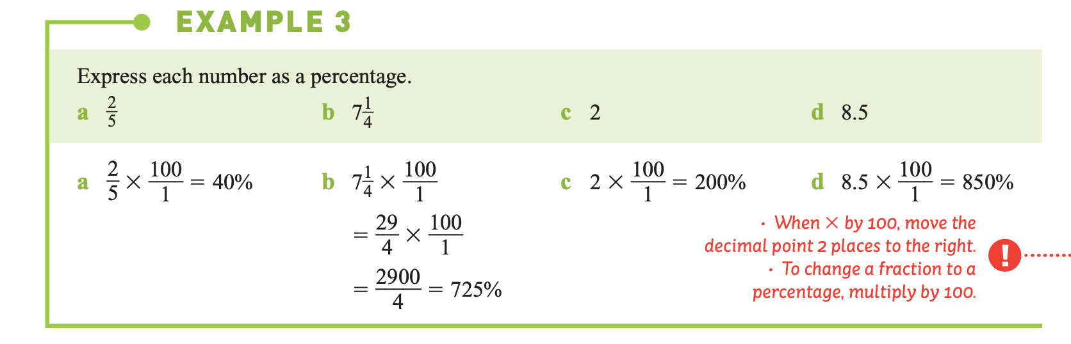

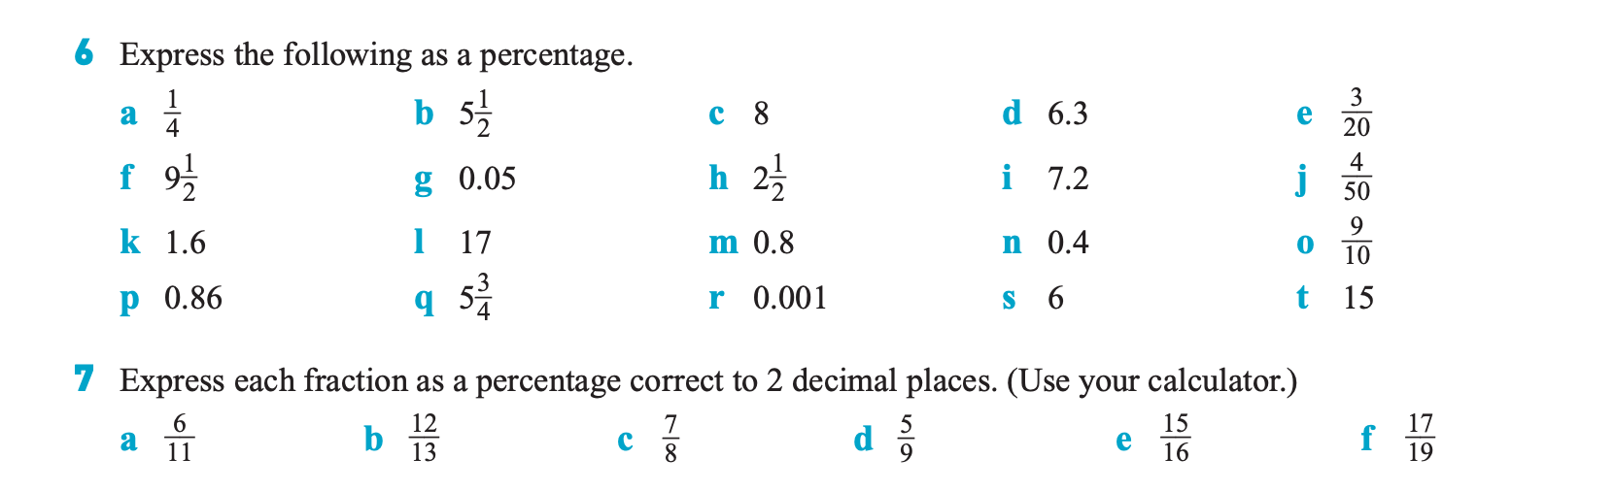

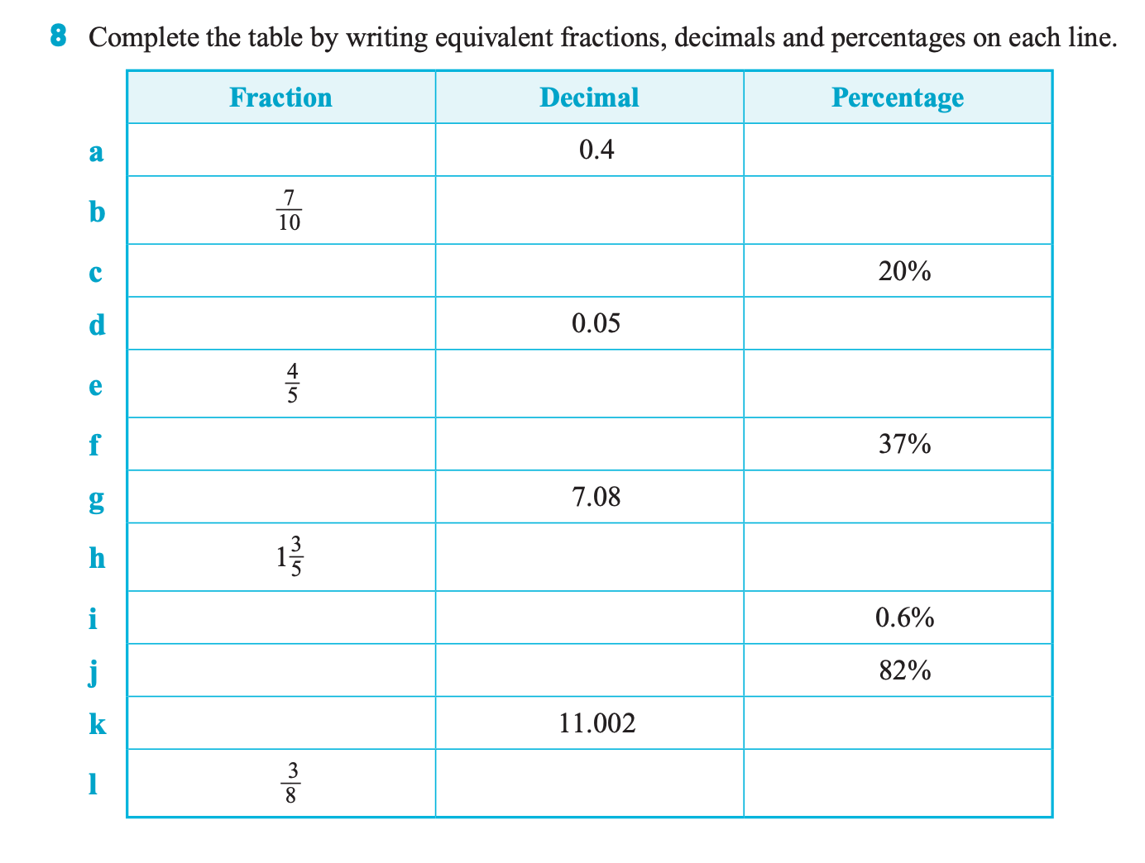

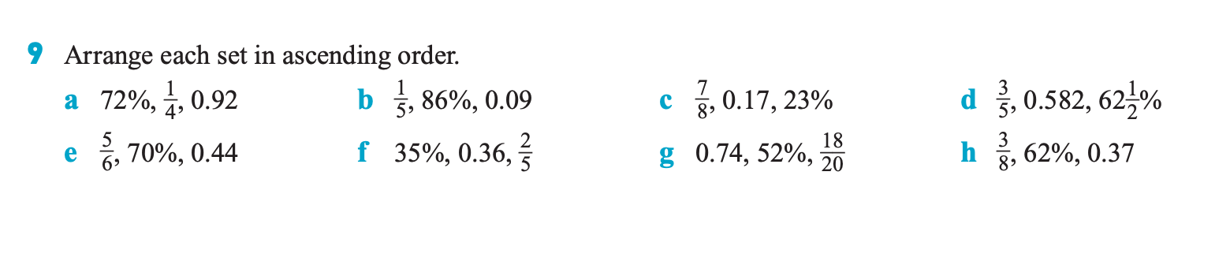

**Check your answers**

