Dashing Doggies | A | B | C
 | Explain why the article focuses on making right choices and if it reminds you of anything else important like that. | Definition finder:  - Consultant  - Ironic  - Expenses | Write about the personalities of all the different characters throughout the play.
 | Describe what Fred, Marama, Charlotte and Jamie do throughout the play. | Compare and contrast what the characters do with what you are doing right now. | What is an example of alliteration in the play?
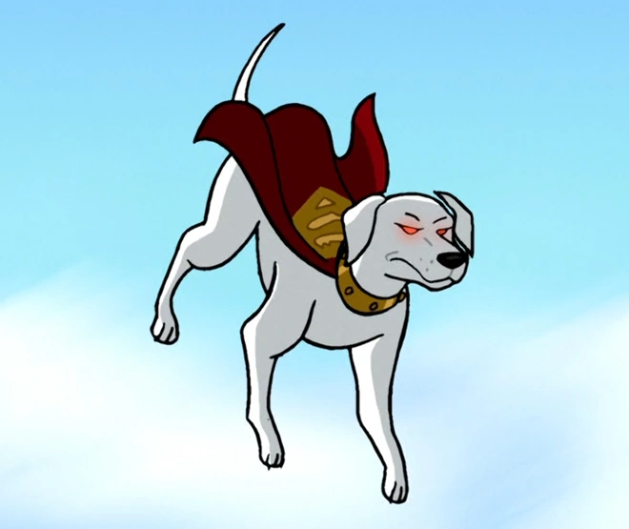 | Draw, design and label your own business for dogs. | Describe what you would have done if you were in the same situation as Fred, Marama, Charlotte and Jamie. | List the ways that the author prepares us for the ending of the play.

