**Year 8 Week 4**

**Māori Inventions:**

**Is it Really True that the Item Below is the Only Thing that Early Māori are known to have invented?**

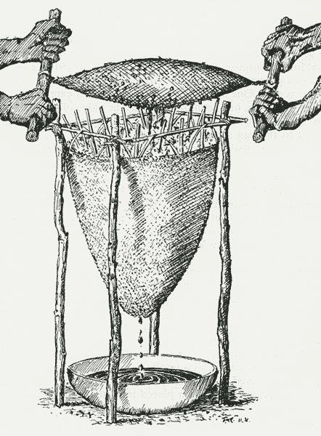

Early Māori invention – the kopa

**Success Criteria:** By the end of the week students will be able to recount several different ways that Māori and Pacifica peoples have contributed to the economy of New Zealand through invention.

Last year we briefly looked at some famous inventions by New Zealanders. One thing that stood out was the fact that there was just one invention credited to early Māori that was listed the *The Encyclopedia of New Zealand*.

**Lesson 1, Task 1:** **Handouts** – I will handout several paper sheets which outline famous inventions by Kiwis. Working in pairs, this week you are going to research inventions by Māori peoples and identify other inventions they were responsible for. You will then create your own invention story using a paper sheet on which you will write a summary of the history of the invention and at least six questions. Next week you will present your invention lessons to the class.

New Zealanders have invented hundreds of different items. Go to the New Zealand Government site on early Māori inventions –

<https://teara.govt.nz/en/diagram/25385/early-maori-invention-the-kopa>

On the site, you will learn about the early Māori invention of the kopa. This encyclopedia entry gives the impression that Māori are known to have invented just one thing! Yet, the early Māori were from Polynesia. Now go online and research Polynesian inventions – of which the Māori are descendants. Now see the different inventions that are credited to them. Pick one of these inventions and create your own lesson with it.

**Invention Sheet**

Summary of the history of the invention including a description of its purpose/use.

Write at least six question that the reader will have to answer about the invention.

Include at least one picture of the item along with a caption (a written description of the image).

Possible questions:

**Use as your guide the handouts.** You will be working on your lesson over the entire week. At the end of each lesson – share your information with your partner as an email attachment in case they miss the next class.