Tying it All Together:
From You and Me to Te Tiriti
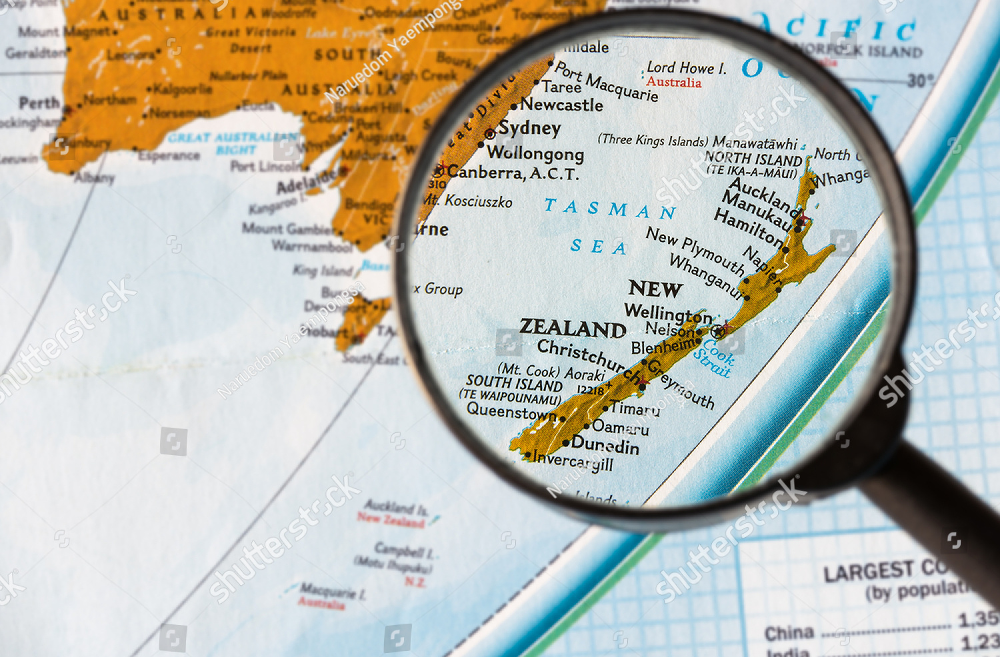

Over the last two/three weeks, we have talked about our histories. Questions such as who are we as people? What is our identity? How do we describe ourselves? What are our backgrounds? Now we are slowly going to be thinking wider, not just as individuals but as groups, people that have come together for a purpose. You are Year 7s that are new to MHJC, now is the time to really put yourself out there and decide how you want the year to be. But first, let’s reflect on what we have learned so far.

Global Studies

Global Studies at a Year 7 level is about introducing you to the world outside of yourself, outside of your immediate home. We are taking an ‘expanding’ approach to Global in Term 1. Meaning we start off small, and then get larger and larger in scope and what we are interested in talking about as a class. We are first looking at the individual, the person that you are. We are then growing our minds and thinking about groups, and the values that guide us, and eventually, the histories and values of our community and beyond. Below are some questions to focus your thinking on what we have been talking about in the last few weeks.

Question:
1. What does Global Studies mean to you? What do you think the goal of the class is, if there is a goal?

2. One of your classmates described Global Studies as thinking about ‘ecosystems’ of people. That is a word that describes all the life and actions in a location/environment. In an ‘ecosystem’ of people, what would we be looking at? Think about the word bubbles you wrote down in your Global books to help guide you.

Answers
1.

2.

Identity

We have looked at identity as a way of talking about ourselves. We looked at what makes up our identity, the facts of our lives and the choices we make - we can describe ourselves and choose how we want to be seen. In the Identity Game, you thought about what makes you ‘you’. And with our mapping activity, we then thought a bit more widely about where we came from. Think about our main Big Idea: that identity makes up our journey in life, and as students of MHJC, you are beginning another journey.

Questions

1. Your identity - who you are - is solely defined by facts about your life. You have no choice in what your identity is. True or false? Why?

2. When doing the Mapping Activity, was there a country you wanted to learn more about? If so, what country and what did you want to know? If not, what is a country you would like to learn more about in this class, and why?
Answers

1.

2.

Te Tiriti - Reading & Answering

We watched this video in class, but if you would like a refresher, the video is here.

This is a long read, but it gives more detail to information we went over in class. This will give you a chance to think about any questions you might not have had during class time.

A treaty is a bond, a promise, a group decision made jointly. They are values and ideas agreed upon by all involved. A treaty is an understanding, something meant to unite all who sign it. Because of this, the words and values being talked about need to be as clear as possible.

As you might know, especially with Waitangi Day being so recent, The Treaty of Waitangi (Te Tiriti o Waitangi) is the document most commonly seen forming the country as we know it. This is disputed (argued), as many consider the 1835 document He Whakaputanga (Declaration of Independence), signed on behalf of many iwi (tribes, communities) by many Maori chieftains, to be the true founding document of Aotearoa. It is a discussion going back over 100 years.

However, in the eyes of the Crown - the British government of 1840, and the NZ government of today that inherited its responsibilities and obligations when we became independent - the Treaty of Waitangi is our founding document and is treated as such. It was signed in 1840 between the British Crown (represented by the British government) and many Māori chiefs - not all iwi, as some people claim, but many representatives of those iwi. Some iwi, and some individual Māori today, do not recognise the Treaty as relating to them, as their ancestors did not sign it.

The Treaty was written in both English and Māori. However, there have been issues with the translation of the Treaty from English to Māori. It is agreed upon that the Māori version of the Treaty does not have the same meaning as the English version, these differences in meaning having dramatic effects on how New Zealand came to be and how it works today.

Take a two minute break!

One big problem is about the word 'sovereignty.' In the English version, it says that Māori chiefs gave 'sovereignty' to the British Crown. Sovereignty means the power to rule - exclusively and without limits. In the British point of view, the Crown was now ‘number one’ in this land, sharing power with no one else and completely without any competition - they were now the caretakers, full stop. Their belief was that Māori understood this, though many believe this was a lie and that the representatives who signed the Treaty did not understand and the Crown took advantage of that. In the Māori version of the Treaty, the word used is 'kawanatanga,' which means governance, a word & idea familiar to them through its mention in the Bible. Many Māori argue that they didn't give up their power to govern themselves completely; they only agreed to share power with the British, the Treaty meaning to form a partnership of understanding and shared values for how the country was going to be.

Another issue is about land. The Treaty promised to protect Māori land rights, but many Māori say that this hasn't always happened - this is factual, given the unfair buying and eventual taking of land ownership from their traditional owners over the next 100+ years. Most Māori feel that their land was taken unfairly by the government - and in some recent cases (Ihumātao in the last few years) there is an idea that it is still happening.

These issues have led to protests and discussions about the Treaty and its meaning. People are still working to understand and respect both the English and Māori versions of the Treaty so that everyone in New Zealand can live together fairly and peacefully."

Overall, the main idea you must understand is that the Treaty of Waitangi was not as clear as it should have been: these exact issues will be explored in much more detail throughout your time at MHJC. The key fact is that Te Tiriti remains controversial today because it was mistranslated - big ideas not clear, big ideas not communicated clearly towards Māori by those who drafted the document.

Take a few moments to catch your breath, that was a lot of reading!

Questions
1. Did all Māori sign the Treaty in 1840? Yes or no?

2. In a sentence or two, what was the big issue with how the British and Māori saw the idea of ‘sovereignty’?
Answers
1.

2.

Early Finishers/Extra Homework
The Aotearoa History Show - Episode 4 | Te Tiriti o Waitangi

This video from The Aotearoa History Show (funded by NZ on Air) goes into more depth about the history of Te Tiriti, which we will likely return to this year. It goes into why the Treaty of Waitangi came to be, the key players involved, and what some of the consequences were from how the Treaty signing was handled. It is a complex topic, so it is very okay to not understand what is happening, as you will be returning to this many times throughout your time in schooling.

Watch this video and write down any five facts that interest you, or a combination of facts & questions you might have after watching this video.

1.
2.
3.
4.
5.

