7W1/7W2 Mapping Activity
“Where in the world are we?”
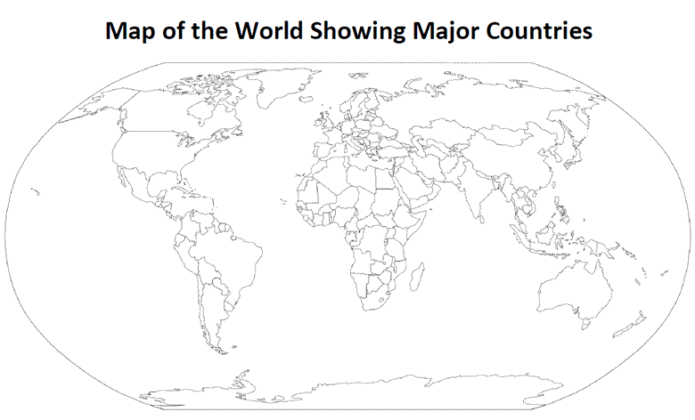
It is important to know where we came from, and I want to start introducing maps to you.
You will be tracing your family’s history across the map, as well as locating certain countries and shading them in.

Note: This is just the information sheet for you to use, you have given a sheet to paste into your books only once you are finished.

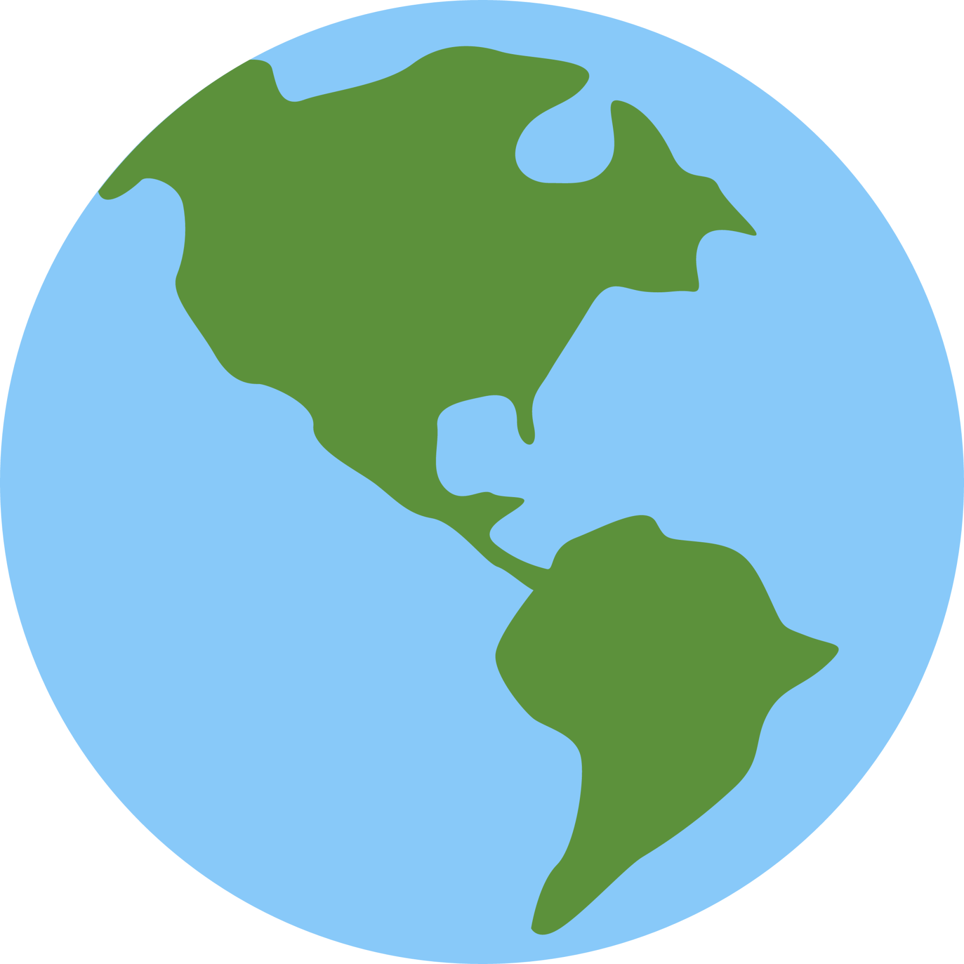
Task 1 - Basics
1. Write your name on the top of the sheet, under the ‘Map of the World’ title, plus today’s date.
Example: Mr. Mitchell, 4th Feb 2023.

2. On the top right corner of your map, the blank space next to the name, write ‘Map Colours’. Leave room for colours later.

3. Do not paste into your book - ONLY once we have finished.

Task 2 - Your World
1. Using dashed lines ( - - - -) of any colour, draw a line from NZ to the country/area your parents came from (or family, if you don’t know for sure).
Example: For my father, I would draw an orange line ( - - - - ) from NZ to Australia, and then from Australia to Scotland. Use a different colour for each line. Put an example of those colours in your ‘Map Colours’ corner so we can see which country is what colour.
Example: green for India, pink for China, blue for Fiji etc.
2. Label the countries you have connected a line to: write their name next to the country, as best as you are able. Make sure to label New Zealand too!
If the country is too small, make it clear where the country is - draw an arrow from the name to the country on the map.
Nice and neat!

3. On your map, draw a star next to countries you have visited, and colour + label those countries too. Make sure to label those countries in the mapping colours - if you used pink for China, write that. Talk to your friends at the table about whether they have traveled to those countries too!
Task 3 - Wider World

1. You must now pick ONE list of countries and locate them on the map using your device, and then shade them in. Use different colours for each country, and then add those colours to your ‘Map Colours’ corner on the top right, like before.
Countries - List 1 | Countries - List 2
Japan  Brazil  Canada  Egypt  South Africa  Russia  Italy | China  Madagascar  Argentina  Australia  America (including Alaska)  Germany  India

2. Make sure to label those countries like the ones you did in Task 2.
3. Finally, paste the sheet into your book once you have finished.

⭐ Star Task ⭐
1. If you have finished, go to the next page in your book and write the title + date.
2. Pick three countries you have coloured in on your map. You must now look up their a) national animal, b) national flower and c) a famous food or dish from that country. You will then write those answers in your book. Repeat with a different country if you are finished and bored.
Example:
Uruguay
A) Southern lapwing
B) Ceibo Erythrina
C) Charred pork roast

3. Pick someone at your table. Talk to them about where their family came from, and get them to show you on their map where they are from. You must then tell them one interesting fact about your home country, and they must tell you one interesting fact about theirs - write this down in your book.

Extra Finishers
Find the five largest countries in the world:
A) Largest size
B) Largest population
C) Who eats the most pork in the world

Write this in your book and label from largest to smallest.
1, 2, 3 etc

