Week 2:

The Power of Water

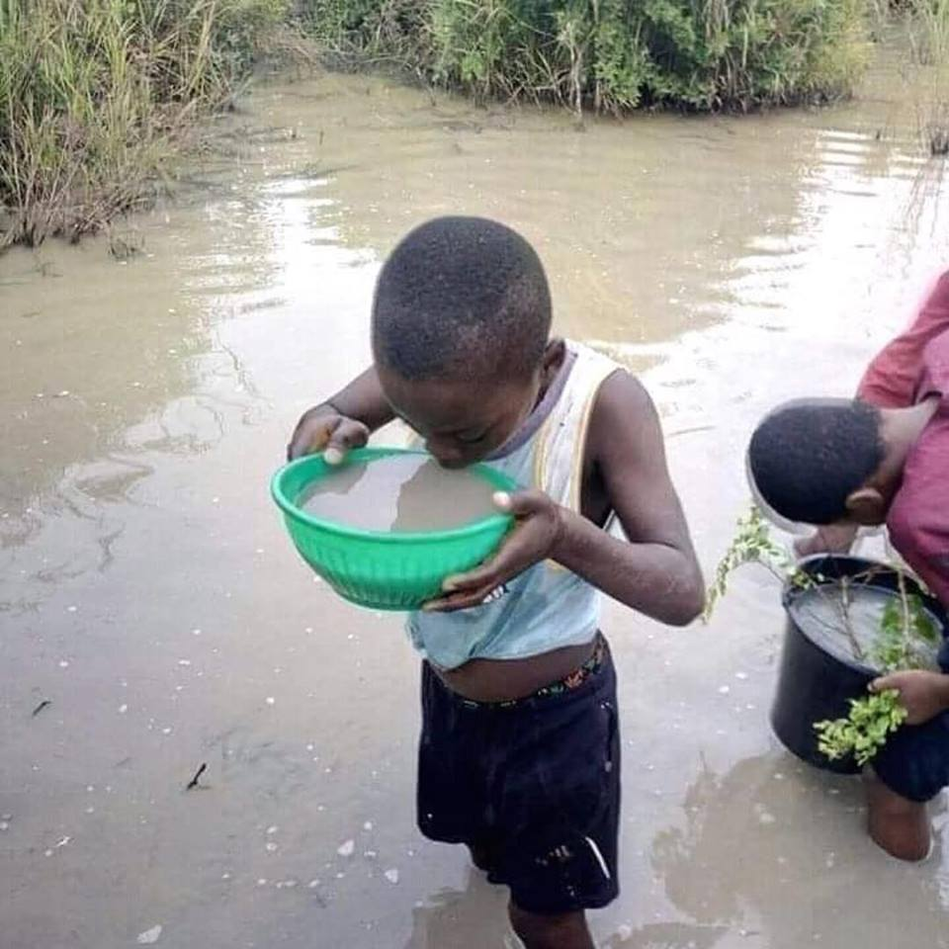

Clean water is super important for everyone, especially when we're growing up. Imagine if you woke up and couldn't turn on the tap for clean water. Lots of kids around the world face this every day. When water isn't clean, it can make people sick with stomach aches, fevers, and an array of illnesses. It's not just about feeling sick; it's hard to go to school and have fun when you're not feeling well. Plus, some kids have to walk really far to get water, which means less time for hanging out with friends or doing homework.

Week 2 Lesson 1:

The Importance of Water to Humans

"Water is the driving force of all nature."
- Leonardo da Vinci

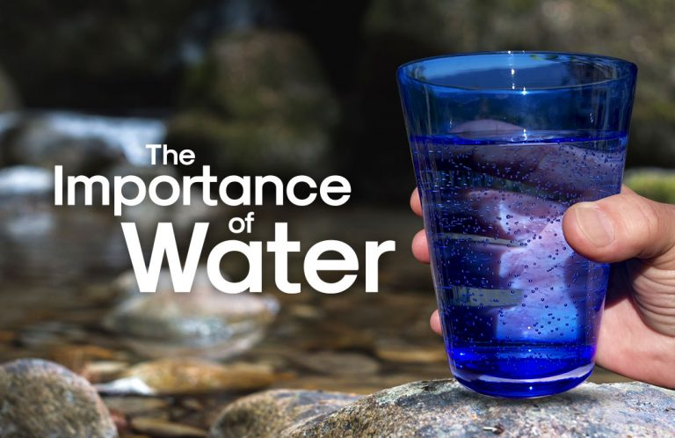

Success Criteria
Students will gain an understanding as to why water is essential to human health and well-being and will be able to list several benefits of water to good health.

Class Discussion:

Water – like electricity, is something that most people take for granted, until they lose access to it. Can you provide examples of where this has happened to you – perhaps on a camping trip or when the power went out and you could not get a drink, flush the toilet, brush your teeth or even cook.
Task 1: Have a look at the two graphics on the importance of water to humans:

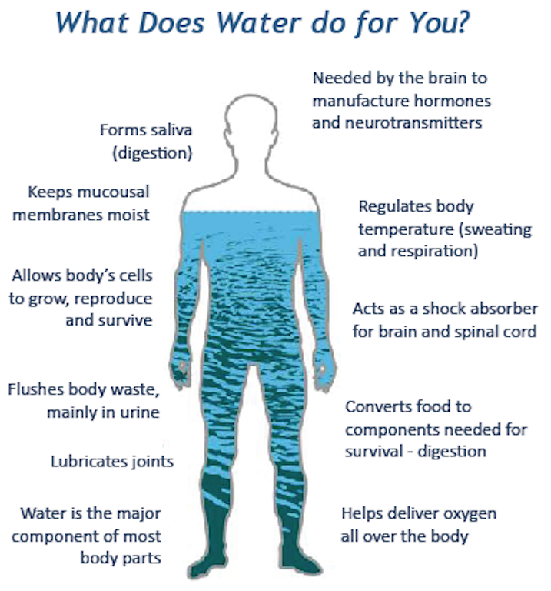

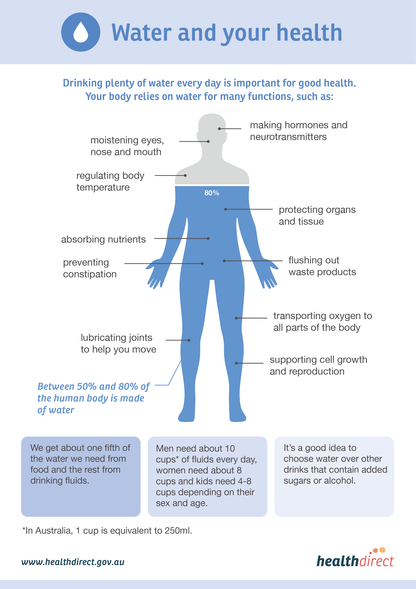

Did you know that drinking unclean water kills millions of people every year?

Task 1: Go to ‘The World Counts’ website:
https://www.theworldcounts.com/challenges/freshwater/deaths-from-dirty-water

After reading the article, write several key dot-points summarizing information on the relationship between clean water and health:

Task 2: (‘Before video’) Watch the video clip – ‘Life without clean water’ on the importance of clean drinking water in one village in Ethiopia at:
https://www.youtube.com/watch?v=yPxMOzN0Uq4&t=11s (6:39 sec.)

Task 3: (‘After video’) Now watch the clip ‘Water changes everything’ on the same village AFTER a new well was built and they had access to clean water at: https://www.youtube.com/watch?v=_rugChFs88c (3:45 sec.)

After watching both video clips describing what life was like before and after access to clean drinking water, create a series of key dot-points about life in the village before and after.

Life BEFORE Life AFTER

- -
- -
- -
- -
- -
- -
- -
- -
- -
- -
Homework: Make sure that your books are up-to-date.
Week 2 Lesson 2

The Problem of getting Clean Drinking Water
in Less Developed Countries
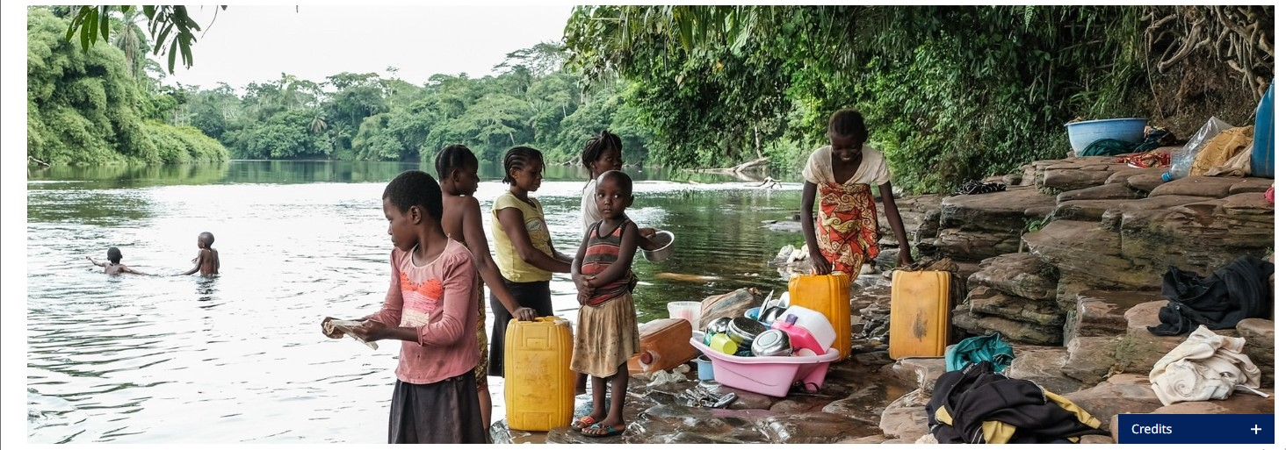
While it is something that most Kiwis take for granted, having access to clean drinking water is a huge problem for many people around the world and often makes them sick.

Key facts * source: United Nations and World Health Organization
- Contaminated drinking water can transmit diseases such as diarrhoea, cholera, dysentery, typhoid, and polio and is estimated to cause about 505,000 deaths each year.
- In 2022, 73% of the global population (6 billion people) used a safely managed drinking-water service – that is, one located on premises, available when needed, and free from contamination. That leaves 27% who do not, which is over a billion people worldwide.

Task 1: Look up these diseases. Describe the symptoms and cause:

1. Diarrhoea:

2. Cholera

3. Dysentery

4. Typhoid

5. Polio

Task 2: Based on the reading below, create a poster designed to raise awareness about the problem that women and girls face in relation to water. It should include one hand-drawn image along with key facts and figures about how women and girls are worst affected.

Reading:

Women and girls bear brunt of water and sanitation crisis – New United Nations & World Health Organization Report
6 July 2023
Women and girls responsible for fetching water in 7 out of 10 households without supplies on premises, according to first in-depth analysis of gender inequalities in drinking water, sanitation, and hygiene in households
Globally, women are most likely to be responsible for fetching water for households, while girls are nearly twice as likely as boys to bear the responsibility, and spend more time doing it each day, according to a new report released today by UNICEF and WHO.
The report describes gender inequalities in low-income countries.
“Every step a girl takes to collect water is a step away from learning, play, and safety,” said Cecilia Sharp of the UN. “Unsafe water …robs girls of their potential” and harms their well-being.
According to the report, globally, 1.8 billion people live in households without water supplies on the premises. Women and girls aged 15 and older are primarily responsible for water collection in 7 out of 10 such households, compared with 3 in 10 households for their male peers. Girls under 15 (7 %) are also more likely than boys under 15 (4 %) to fetch water. In most cases, women and girls make longer journeys to collect it, losing time in education, work, and leisure, and putting themselves at risk of physical injury and dangers on the way.
The report also shows that more than half a billion people still share sanitation facilities with other households, compromising women’s and girls’ privacy, dignity, and safety.
“The latest data from WHO shows a stark reality: 1.4 million lives are lost each year due to inadequate water, sanitation and hygiene,” said Dr Maria Neira of the World Health Organization.
The findings go on to show that a lack of access to hygiene also disproportionately affects women and girls. In many countries, women and girls are primarily responsible for domestic chores and caring for others – including cleaning, preparing food, and looking after the sick – which likely exposes them to diseases and other risks to their health without the protection of handwashing. Additional time spent on domestic chores can also limit girls’ chances of completing secondary school and gaining employment.
Today, around 2.2 billion people – or 1 in 4 – still lack safely managed drinking water at home. Around 2 billion people – or 1 in 4 – cannot wash their hands with soap and water at home.
Reading source: https://www.who.int/news/item/06-07-2023-women-and-girls-bear-brunt-of-water-and-sanitation-crisis---new-unicef-who-report
*Reading has been modified by Mr. Bartholomew to make it more suitable.

