Week 3: The Kentucky Fried Rat
& Other Urban Legends

Success Criteria
Students will gain a basic understanding of urban legends and become familiar with three legends that are alive and well – and making the rounds. By the end of the week they will be able to write a summary of the Kentucky Fried Rat urban legend.

Lesson 1: The Kentucky Fried Rat & It’s Meaning

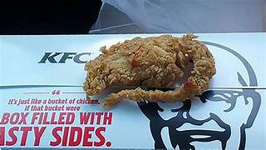

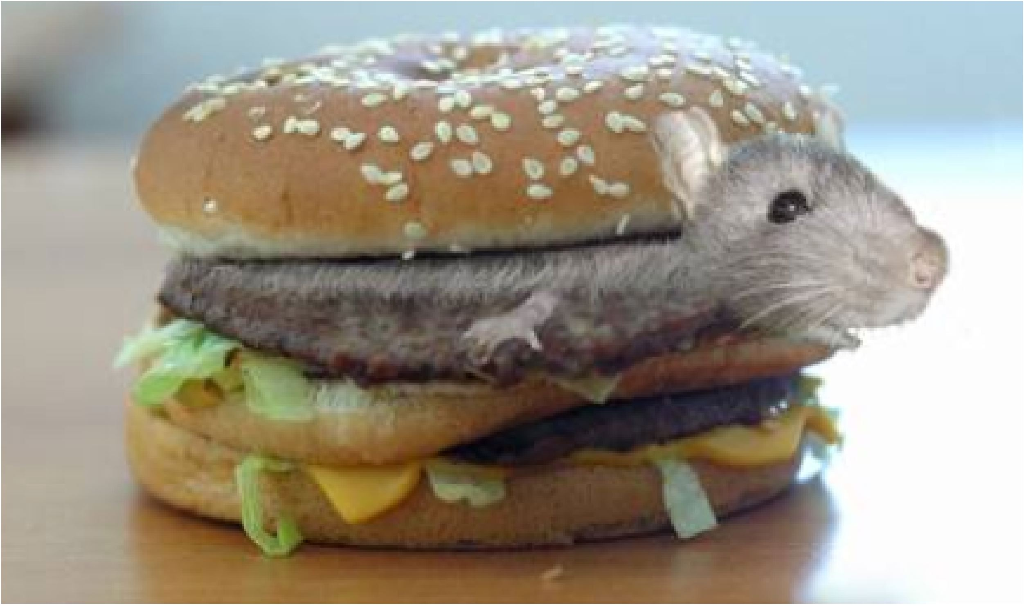
Urban legends are ‘Friend of a Friend stories’ that can never be traced back to their origins. Jan Brunvand believes they perform an important function because they have hidden meanings that fill psychological needs. He identifies three key components of these accounts: 1) they must be interesting, 2) believable, and 3) offer lessons. He describes them as living folklore.

Urban legends involve improbable happenings that are repeated as true and embellished during retelling. It is common for different versions of the same story to appear in different places and times. The sources of these accounts are often attributed to the media, such as the news or popular talk shows. Another common source is what folklorists refer to as FOAFS (friend-of-a-friend stories) where the sources are usually impossible to verify.

Task 1: Watch the CNN story on the Kentucky Fried Rat

On occasion, people do claim to get a fried rat in their KFC, and most turn out to be hoaxes by people trying to get money from the company. Here is a common story that aired on CNN: https://www.youtube.com/watch?v=2q9QUwdEL40

Stories about contaminated food are a common source of urban legends. Perhaps the most famous is the “Kentucky Fried Rat” story, which has circulated across the United States for decades. It usually involves a husband and wife who get a drive-thru order of chicken at KFC (Kentucky Fried Chicken). The wife remarks about the funny taste, only to realize that she has been munching on a rat! Suddenly she goes into shock, is rushed to a hospital, and dies. Folklorist Gary Fine examined 115 different versions of this story and made an interesting finding. In every case the victim is a woman – who has clearly neglected her traditional responsibilities for preparing the family meals as she did not make supper the night and went to KFC instead. Her reward is the fried rat.

1. What is the message from the ‘Kentucky Fried Rat’ story?

2. Why is it women who always seem to find the rat and bite into it, but not the husband?

3. More recent stories of Kentucky Fried Rats are starting to include more males. Why do you think that is?

Extension Exercise:

Why All of Those Horrifying Urban Legends About KFC Just Won't Die
Deep-fried rats and mutant chickens…

By Jelisa Castrodale, VICE, July 26, 2017 (text modified by Mr Bartholomew).

Once you've been the victim of a rumor or the subject of an urban legend, it can be difficult, if not flat-out impossible, to shake it. For instance, mention a story you heard from a friend-of-a-friend about KFC, and wait for someone to finish your sentence with either "those genetically modified mutant spider chickens?" or "that guy who got the fried rat?"

For some reason, KFC seems to find itself on the receiving end of one piece of hearsay after another, a situation that has persisted for many years. Some of these legends are so common that KFC has been forced to confront them head-on. In a section on its website called "Chicken Chattin'," KFC addresses many of these stories, seemingly trying its best to be cool about it.
The "mutant chicken" story or (one of many variations involving six-legged "spider chickens") made its most recent appearance in everyone's inbox last year, but its origins have been traced back to a pre-internet word-of-mouth story that started to spread in 1995. The legend of the mutant beak-, feather-, and feet-free "Kentucky Fried Creature" began circulating online four years later, and like countless other legends, it seems to have spun off from fears about scientific advances and new technologies.

It's probably no coincidence that the theme of genetically engineered food spilled out of the Internet rumor mill in the early 2000s when 'Frankenfoods' were a hot topic of discussion there, and public interest in the issue were high. Frankenfoods refers to foods that have been genetically modified and some people are afraid of them because they are new, even though most scientists believe they are safe.

Rather than send a series of tweets hashtagged #FAKENEWS, KFC called its attorney. In 2015, KFC China filed a lawsuit against three companies responsible for spreading the mutant chicken story—complete with Photoshopped pictures of what it alleged to be genetically modified birds—on its WeChat accounts. According to the legal filing, KFC found 4,000 "defamatory messages" on the chat service that were read more than 100,000 times. In January 2016, a Shanghai court ruled in favor of KFC, ordering the companies to pay $127,000 in damages and, perhaps most importantly, to apologize for spreading the story.

The alleged deep-fried rat seems to be the second most popular KFC tale that refuses to die, and, sadly, it will probably continue as long as people post pictures of weird-looking chicken tenders online. Sociologist Gary Alan Fine started examining the story in 1980 when he wrote "The Kentucky Fried Rat: Legends and Modern Society." At the time, Fine had already catalogued 115 different versions of the story.

1. Why is the KFC ‘mutant chicken’ story so popular?
2. For how long has the mutant chicken story been around?
3. Year after year, the mutant chicken and KFC rat stories have continued to circulate. What is KFC doing to try to stop these stories from spreading?
Week 3: Lesson 2:



Part 1: Alligators in the Sewers: The Meaning Behind the Tales
Read the article, ‘Alligators in the Sewers!’ (see article on the next page) and answer the following questions:

1. In 1935, the New York Times newspaper published an article claiming that someone had discovered an alligator in a city sewer system. List as many pieces of evidence that you can to support the view that the story was NOT true.

2. How long ago have similar stories been circulating in the United States?

3. In 1982, the design chief in the New York City Bureau of Sewers, John T. Flaherty, admitted to a reporter that there were ‘monsters’ in the city’s sewers. What was he referring to?

4. Historian Mark Barber argues that it is impossible for the alligator story to be true. Why?

5. Why does Barber think these stories continue to spread?

6. Name a similar legend that circulated in the sewers of ancient Rome. 4

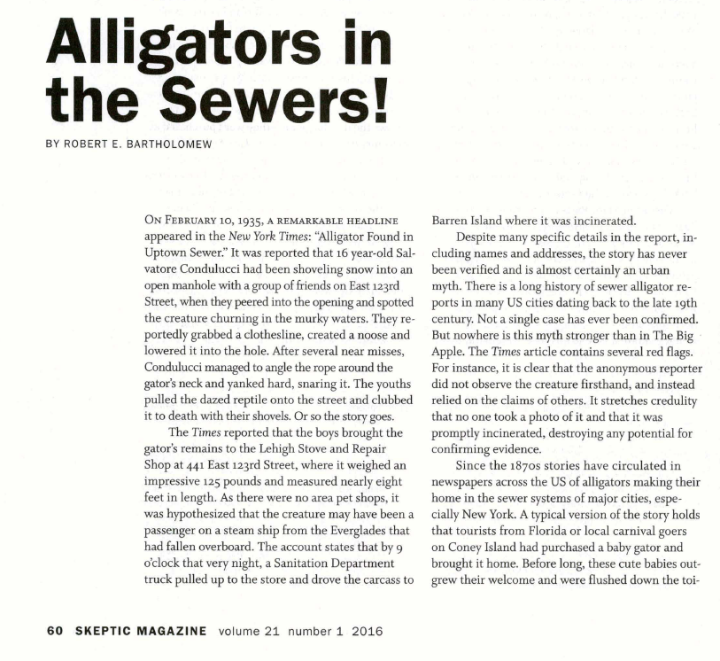

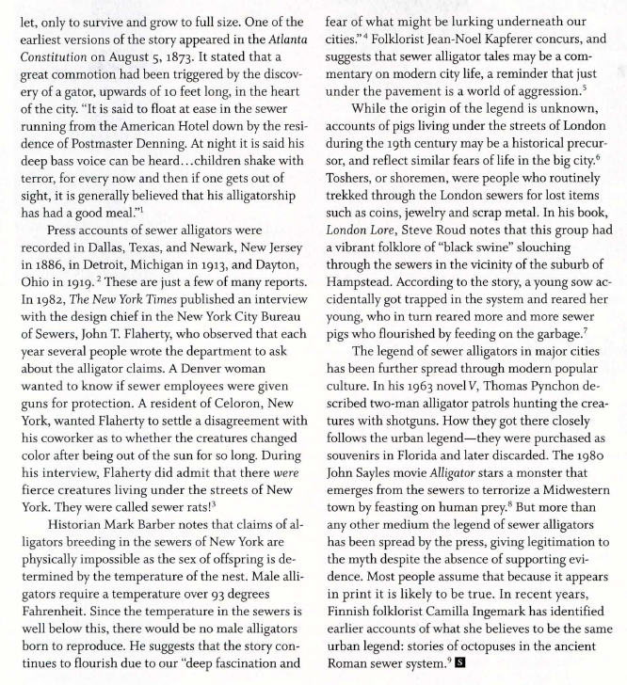
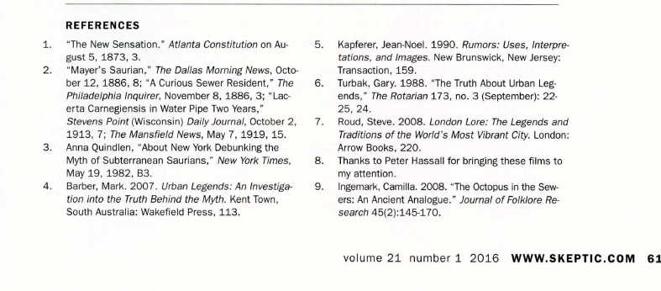

Week 3, Lesson 3: The 2016 Clown Scare

Why is it that so many people do not feel comfortable around clowns? It may be because 80% of human communication is nonverbal. People are used to reading the facial expressions of others. Clowns wear facial makeup, so we cannot see their expressions. Also, we don’t know who is under the makeup.
For a few months in 2016, something remarkable happened in New Zealand and around the world – people sighted mysterious clowns and a panic developed around it.

Watch the video clip on the outbreak of clown sightings in New Zealand, then answer the questions below:
https://www.nzherald.co.nz/nz/police-urge-calm-over-creepy-clown-sightings/3LZHQTZK7SPZ43KUPSQFLARGKE/

1. Up until the 1920s, clowns were considered funny. What has happened since the 20s to make clowns something to be feared?

2. What has Hollywood done to drive the fear of clowns?

3. Robert Bartholomew states: "Every panic has its underlying fear and here I think it has to do with the uncertainties that are going on in the world today. It's part of the greater social panic about the fear of strangers and terrorists and an unpredictable world." Explain what he means in your own words.

Extension exercise: Read page 2 of the article ‘Clown Panic!’ by Robert Bartholomew (on the next page).

1. How were clowns viewed on TV in the 1960s?

2. What happened in the 1980s to create a widespread fear of clowns?

3. What is the pattern to clusters of creepy clown reports?

