Week 1: Lesson 1 – The Power of Fairytales

Success Criteria
Students will gain a basic understanding of fairytales and learn that while they may be fictional, they often have a powerful impact – for the better – on the people who read them.

Lesson 1:

Fairytales are not just fictional stories about imaginary people. Fairytales are powerful stories that children read or have read to them – stories that teach them about life, overcoming adversity, and to never give up.

Task 1: J.K. Rowling and the Power of Fairytales

Read the following article on the latest book by J.K. Rowling
https://www.betterreading.com.au/kids-ya/fabulous-fantasy-the-power-and-magic-of-fairy-tales/

Answer the following questions based on the reading:

1. Why did J.K. Rowling put her new book The Ickabog, online and free for any child to read?

2. What does psychologist Sally Goddard Blythe think is so powerful about reading fairytales and listening to them read to you?

3. Dr Blythe writes that reading fairy tales helps children deal with the uncertainties of life. Why does she say this is good?

4. Dr Blythe writes that learning about “wicked stepmothers, witches, trolls, wolves and imps that make life generally difficult for everyone supply another important life lesson.” What does she say that lesson is?

5. What does she say usually happens to ‘good’ characters in fairytales?

6. What is the message in the story The Ugly Duckling?

7. What is the message in the story Pinocchio?

8. What is the main point of Little Red Riding Hood?

Week 1, Lesson 2:
The Ugly Duckling and the Power of a Story

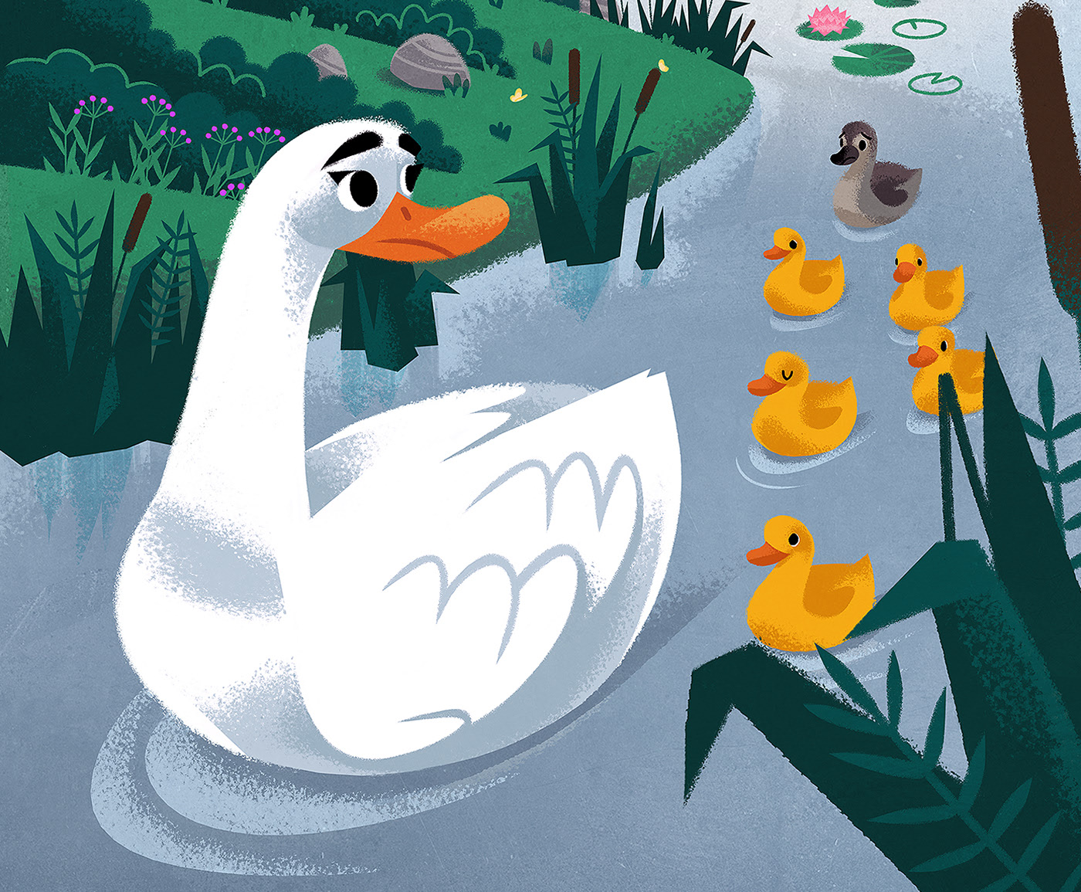

How a fairytale can help us to overcome feelings of low self-esteem (that we’re not good enough or are different from others and therefore not as good as them).

The story of The Ugly Duckling.

Plot Summary: This fairy tale is a story of a duckling who, when hatched along with his brothers and sisters, is ridiculed and made fun of because they perceive him as ugly. He wanders alone through the fall and winter, and suffers from fear, loneliness, and sadness. In the spring he flies away from the marsh and meets up with a group of swans and realizes that he was actually a swan but as an egg, it had accidentally become mixed in with some duck eggs and everyone though he weas a duck at birth, even though he looked different to the other ducks. In the end, the ‘ugly duck’ had become a beautiful swan.

Listen to the interview by a Connecticut Psychologist Dr. Robert Hamm on the fairytale ‘The Ugly Duckling’ and the power of the story

Psychological Insights: "The Ugly Duckling Syndrome"
https://www.youtube.com/watch?v=0YnjiHFeYHo

(Listen from the 1-minute mark to the 9-minute mark).

- Be sure to watch the entire 8-minutes of the clip before writing your answers. Write a summary of ‘The Ugly Duck Syndrome.’

- Write a summary of how people who experience ‘The Ugly Duck Syndrome’ can overcome their fears and feel better about themselves.

Week 1, Lesson 3:

The Repunzel Fairytale

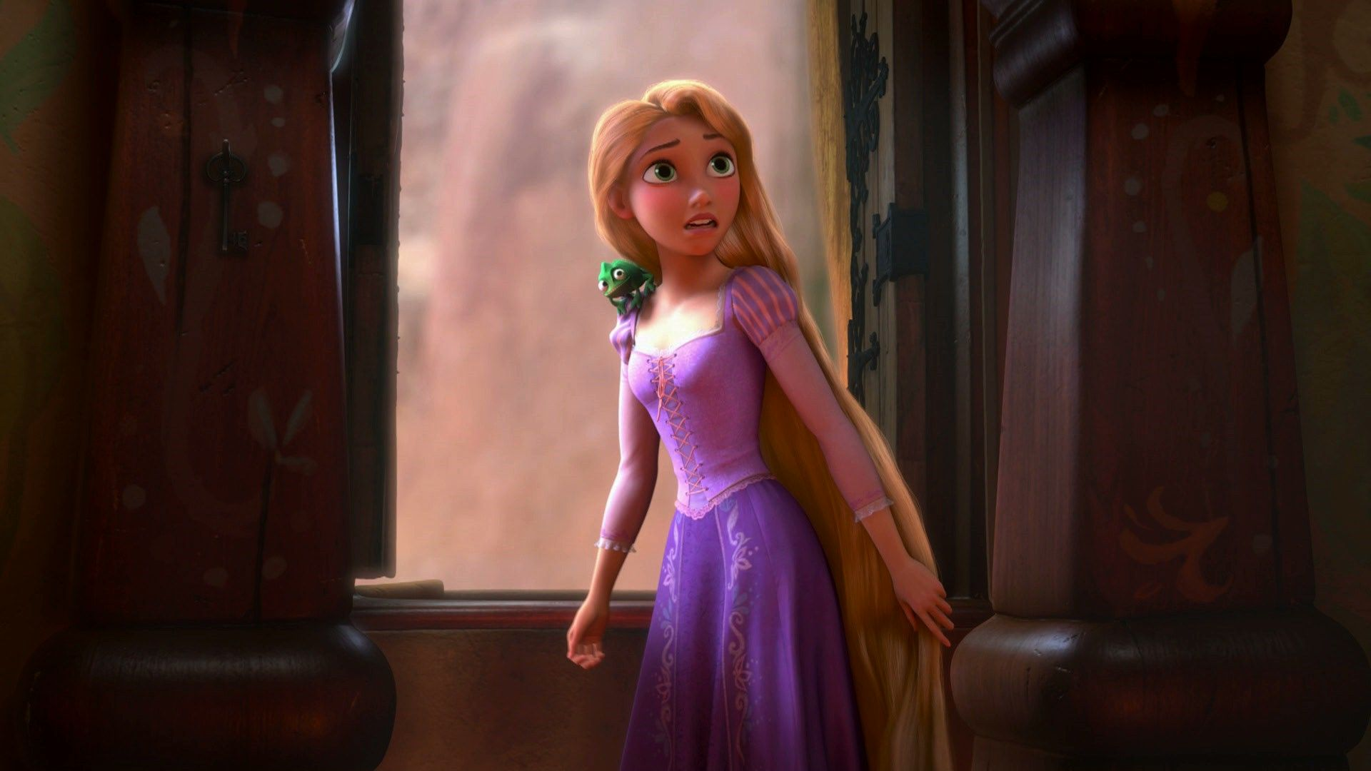

Class discussion: What are some of our favorite stories? What is their appeal?

Task 1: Listen to the story of Repunzel – about a woman trapped in a prison tower.
https://www.youtube.com/watch?v=2U0q3JhmDqM (5:28 sec.)

‘The Healing Power of Fairytales.’
How did reading about this story help the woman in the interview to live a better life?

Task 2: Watch the clip ‘FAIRY TALES explained by Hans Wilhelm.’
https://www.youtube.com/watch?v=0yTR-LUV8VM

1. Why do the main characters in most fairytales have no names or very common names (at least they were common at the time they were written)?

STOP LISTENING at the 2:30 second mark. Do not watch the rest of the clip. 4

Task 3: Watch this clip of the book, Rabbit’s Wedding. This book – about a black and white rabbit who became friends and got married, was banned from some libraries in the American state of Alabama in 1959. They saw it not just as a fictional story but as a way of supporting marriages between African Americans and ‘whites.’ Watching this clip today, it seems incredible that this book as actually banned from some libraries. That racist politicians in 1959 America were afraid of children reading this story and the impact it might have, shows you the power of a story – even a fictional one.
https://www.youtube.com/watch?v=LkIADVhvnoM

