Week 10: Lesson 1:

Why kids can’t stop pressing Poppits:

The Psychology behind the new toy fad


Popits continue to be all the rage among middle school students in New Zealand.
Watch the video clip on why some scientists think they may actually have a benefit for some children.

Success Criteria:
Students are going to become knowledgeable on the psychology behind the pop-it fad that is sweeping through New Zealand schools and the functions it may serve. They will also become familiar with the 4 phases of a fad: The Hidden Phase, The Breakout Phase, The Peak Phase, and the Decline Phase.

Task 1: Watch the BBC clip on the popularity of Poppits.
https://www.youtube.com/watch?v=vCExjnOo6pM

1. List some of the reasons given for why some students like to push poppits?

2. Can you think of any other reasons that may motivate students to use them?

Task 2: Read the article “How a Monkey Launched the Popit Toy Craze by Ben King of the BBC at:
https://www.bbc.com/news/business-58408570

Answer the following questions:

1. Name the two people who invented the original Popit.

2. How much money are Popits thought to generate each year?

3. Of this amount, what percentage are believed to be legal and not pirated (made illegally?).

4. What the video of the money with the Popit. Why do you think this video made the Popit so popular?

Lessons 2 & 3:

The 4 Stages of a Fad

Read the article on the life history of a fad. Write the definitions of the underlined words in your Red Books. Write out the questions at the end of the article below and answer them in your Red Books:

Read about the four phases of a fad:
1 The Latent Phase.

During the latent period (latent means hidden), the fad emerges but lies relatively dormant and most people are not even aware of it. Some writers contend that most, if not all fads, are recycled from existing themes that are later rediscovered and only give the appearance of being the latest rage. For instance, the tree- and flagpole-sitting fads of the late 1920s and early ’30s can be traced to early Christian Europe. While a string attached to a spool spiked in popularity during the early 1930s and again in the 1960s, the yo-yo was not new. Similar devices were used as either toys or weapons in a variety of cultures dating back to ancient Greece. Even bungee jumping has long been practiced in the jungles of Papua New Guinea and the Solomon Islands, where natives continue to leap off wooden towers with only a vine tied to one ankle in order to prove one’s manhood. Occasionally, jumpers miscalculate.

Watch - Vine Jumping in Pentecost Island, Vanuatu – these people were the first bungy jumpers. 1:43 sec.
https://www.youtube.com/watch?v=k17p4kzlASE
Before the Hula-Hoop exploded in popularity, it was experiencing an obscure existence as a bamboo hoop in Australian gym classes, who in turn had gotten the idea from Pacific islanders.


Young girls with hula-hoops

Yet, in 1958 when it was marketed by the Wham-O Company in the United States, tens of millions of tubes were sold in a single year, before the market for the hoops suddenly collapsed. In fact, bamboo hoops have long been in use as a toy in many cultures dating back over a thousand years, but instead of being gyrated with the body, they were often rolled with a stick or the hand. Some Indians in Canada have long practiced a hoop dance using up to fifty wooden hoops to create shapes such as butterflies, eagles, snakes, and flowers.

2 The Breakout Phase
During the breakout phase, the item or activity is adopted by people other than those who used it in the latent period, spreading mainly by word-of-mouth and the media. The spread is boosted when those who use it during the period, actively promote it. Until the early 1970s, Citizen Band radios led a relatively obscure existence among truckers and were sold at a few specialty locations such as select truck stops, truck garages, and in little-known mail-order catalogues. Once CBs started to catch on outside the trucker community, they soon found a wider audience and eventually wound up on department store shelves.
The plastic throwing disc was marketed in 1955 under the name “Pluto Platter” and renamed the following year as the Frisbee. A similar game had long been popular at Yale University where students had a tradition of tossing pie plates, made by the Frisbie Pie Company of Bridgeport, Connecticut, across the campus lawns. Frisbees gained initial popularity on several eastern US college campuses where Wham-O recruited students to sell them.



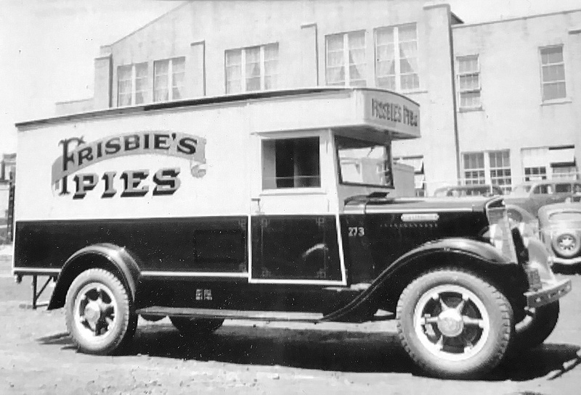

Stage 3.

The third stage is the peaking period, characterized by a rapid, dramatic increase in appearance, coinciding with frequent media coverage. During this phase, if a fad doesn’t already have a readily identifiable name, the media coins one, such as the slicked-back “D.A.” (duck’s ass) hair style of the 1950s. During the roaring ’20s, a relatively small number of sassy young women defied the conservative mores of the period: they drank alcohol during the American government banned it’s use; smoked cigarettes when it was considered unladylike; and wore bold, revealing dresses that flaunted their sexuality. They quickly gained the label of “flappers.” Soon, older, more traditional women began adopting some of their habits such as short skirts, haircuts, and makeup.

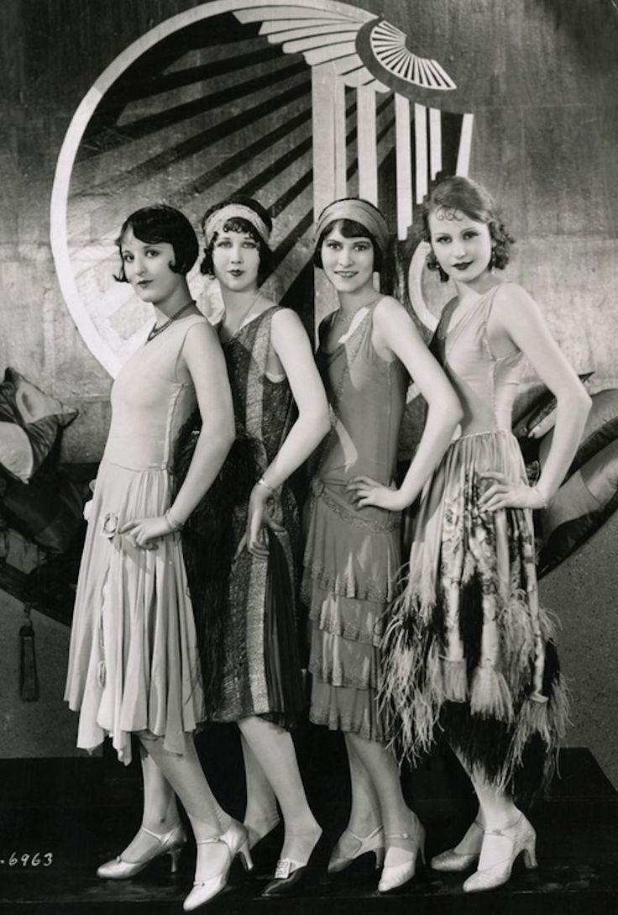
Flappers from the 1920s – showing off their new clothing style.

Some fads come ready-made, such as the Hula-Hoop; others, like the flappers, are soon given a label. In September 1930, the US Department Government estimated that there were an astounding thirty thousand mini-golf courses. During the peak period, it seems as though everyone is either doing it or talking about it, has one or has to have one. This saturation effect seems to predict the eventual decline, as once fads peak, the excitement and novelty have worn off, and they are unable to maintain their intensity.

Occasionally fads endure due to new marketing strategies. Between 1956 and 1966, Milton Levine sold over 12 million ant farms. A major reason for the longevity of the ant farm was that Levine gave away fancy versions made of mahogany to TV personalities, such as Dick Clark, who placed them on their TV sets with other knickknacks. Levine once said: “Ants work day and night, they look out for the common good and never procrastinate. . . . Humanity can learn a lot from the ant.”

Decline

The decline phase begins when excitement and interest rapidly wane. The rapid rise of a fad is met with a steep decline in interest. Sociologist David Miller observes that during this stage, the once “hot” item is typically discarded or stored in closets and garages to gather dust, never to be used again. If traces linger, it is because the fad has remained only with the few original users from the dormant or latent phase. In the case of activities, the goldfish swallowing rage that swept across college campuses in the spring of 1939, lasted only two months before the novelty wore off. Not only did goldfish swallowing become unpopular, it was viewed in a negative light. What was initially a hilarious fad was soon being condemned as cruelty to fish, and public health officials were warning of the dangers of getting tapeworms. Some communities even passed ordinances making it illegal to gulp the critters, and colleges threatened to expel swallowers.

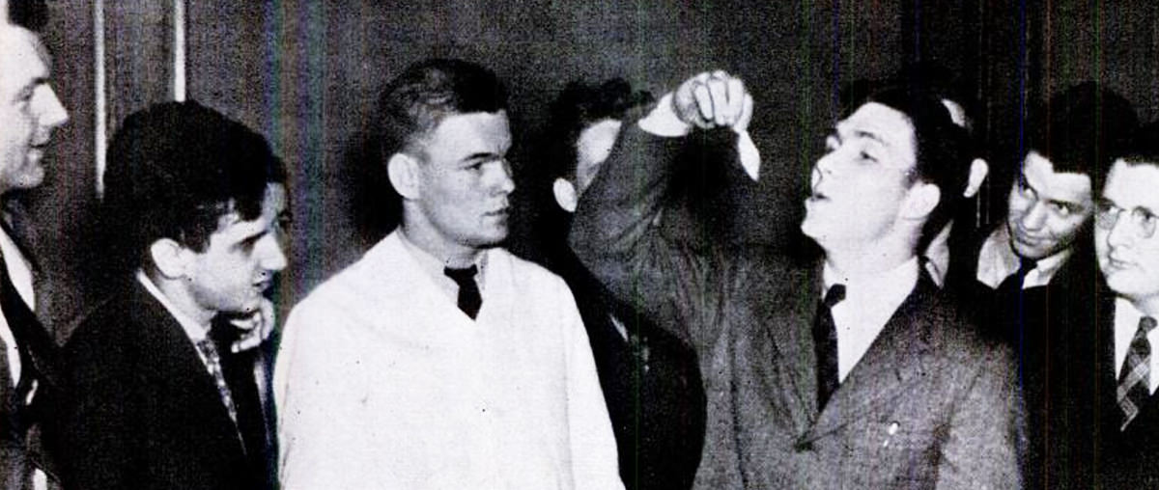
The goldfish swallowing fad was all the rage in 1939.

Sometimes a fad will die out, only to be revived in a different form. A classic example is the 1959 penchant for phone booth stuffing that petered out but was rekindled years later in the form of Volkswagen stuffing. Occasionally fads become part of the establishment, though their popularity and the fever-pitch of desire has waned. These include Frisbees, skateboards, yo-yos, and miniature golf. There was an explosive interest in miniature or Tom Thumb golf during the early 1930s, but soon people grew disinterested and most outlets went bankrupt. Fads sometimes also decline due to supply and demand. During World War II, for example, the availability of silk from Japan was interrupted after the Japanese attack of Pearl Harbor, prompting the US Government to ban silk stockings as silk was vital in the production of parachutes. As a result, a new fad was born: newly marketed leg makeup exploded in popularity as women on the home front applied liquid foundation to simulate the appearance of hose. Many ladies would then also use an eyebrow pencil to give the appearance of a black “seam.”

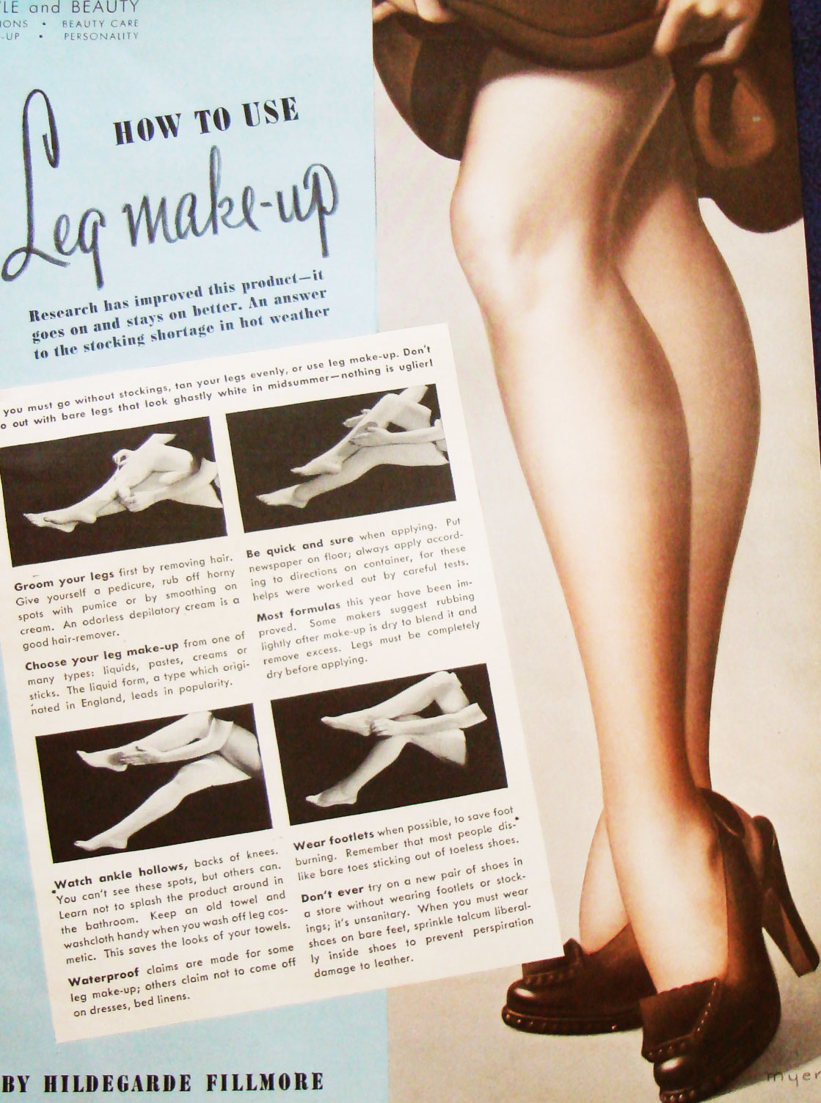
An ad for paint-on panty hose (leg stockings) during World War 2.

Questions – write out in full and answer in your Red Books:
1. How far back in time can the yoyo be traced back to?
2. Who were the original bungy jumpers?
3. In what part of the world did the hula hoop originate from?
4. How did the Frisbee originate?
5. What are some feature of flappers (how did they look and act?).
6. What led to the popularity of ant farms?
7. What shortage during World War 2 led to the popularity of paint-on panty hose.
8. Name the 4 stages of a fad and write a summary of each stage in one or two sentences.

Definitions:
1. dormant
2. gyrated
3. sassy
4. dramatic
5. wane
6. bankrupt
7. disinterested
8. expel
9. ordinance
10. novelty

