Mātauranga Māori Assessment
The Fall and Rise of Mātauranga Māori
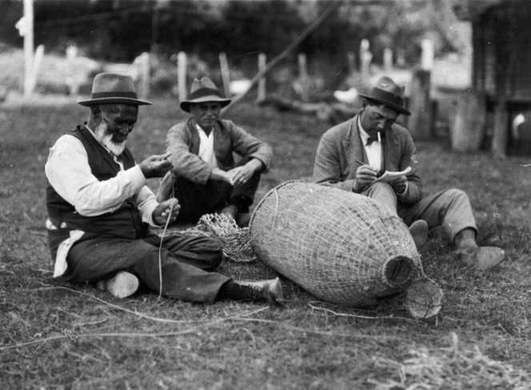
English KNOWS
Ngā āhuatanga reo | Features and structures of language
KNOW: Codes, conventions, and features of different types of texts are often subtle and able to be flexibly applied. Recognising them and the effects they have in different types of texts supports the analysis and crafting of texts.
KNOW: Structural elements can be arranged for deliberate effect to build up meaning across a text.
We are FOCUSING on explanation writing by choosing language that is appropriate to the topic, audience, and purpose.
Success Criteria

I can categorise my ideas into paragraphs with clear ideas and following a writing frame eg. TEXAS, PEDAL etc.

Achievement Objective: Social Studies Knowledge - People contest ideas about identity and knowledge as they challenge injustices about identity and social norms.
Task: Māori Knowledge (Mātauranga Māori) was once a valuable source of information that was used by the mana whenua (people of the land/first settlers) for everyday survival in Aotearoa New Zealand. Using your knowledge of Mātauranga Māori, you will document how the early European settlers looked down on Māori knowledge and viewed it as insignificant, and how it has come to be more valued in recent times.
You will produce either
1) A news report and video on the validity of Māori culture and show how it was once looked down upon and devalued, but in recent times researchers have found it to be of great use and often contains elements of science.
2) A brochure.
Your news report or brochure will have 3 sections:
Section 1: The Devaluing of Maori Culture – In the past Maori culture has been looked down upon as having little value or use. Document this using the resources we have used in class.
Section 2: The Value of Mātauranga Māori – Describe how can Mātauranga Māori be a valuable source of information and provide knowledge of various plants and their uses as food, medicine and building materials. It was also essential to successful navigation in the Pacific including Wayfinding.
Section 3: Is Matauranga Maori Science? Explain and justify your position.
Sources: You are only allowed to use the readings that we have used in class or have been given to you as resources.

Resources:
1. Class Notes;
2. Class Lessons from Weeks 1 to 5.
3. Mātauranga Māori & Science Website at:
https://www.sciencelearn.org.nz/resources/2545-matauranga-maori-and-science
https://www.nzherald.co.nz/kahu/the-power-and-potential-of-matauranga-maori-in-education/NETWMNBI5FHTLJCBKR75ZGWWDA/
https://www.thepress.co.nz/nz-news/350293744/speaking-value-matauranga-maori-science
https://e-tangata.co.nz/comment-and-analysis/understanding-matauranga-maori/
https://newsroom.co.nz/2021/07/31/dismissing-matauranga-maori-racism-and-arrogance-in-academia/
https://kep.org.nz/assets/resources/site/Voices7-16.Matauranga-Maori.pdf

Key Points to remember:

a. As a general rule, the greater the depth and relevance of your responses in addressing the topic, the higher the mark.

b. If you use quotations, limit them to no longer than a sentence.

c. Write in your own words. Do not copy and paste from the internet, or use AI to write this assessment.

Reminder about the T-E-X-A-S paragraph writing method

T-E-X-A-S

T - Topic. Here you state what you'll be talking about in the paragraph. It only needs to be one line, just enough to specify what you're talking about.

E - Explain. Here you will elaborate on your Topic, giving the reader more information about what it is. One or two lines should suffice. You could also define key words or concepts.

X - Example.

A - Analysis. How does your example support your argument? This should be a significant part of your paragraph. 'This shows how..." or "Here we see..." .

S - Summary. Reword your Topic statement with more affirmative grammar.

Year 9 Global Rubric
Criteria | WORKING TOWARDS Curriculum expectation | Working AT curriculum expectation | Working ABOVE curriculum expectation | Working BEYOND curriculum expectation
Impact of the challenge on people/communities/etc. | You have outlined the impact of Mātauranga Māori on people and communities | You have summarised the impact of Mātauranga Māori on people and communities | You have explained the impact of Mātauranga Māori on people and communities | You have discussed the impact of Mātauranga Māori on people and communities
Actions taken - challenging social norms | You have described some actions taken by European settlers in challenging the usefulness of Mātauranga Māori | You have described with examples some actions taken by European settlers in challenging the usefulness of Mātauranga Māori | You have described in detail with examples some actions taken by European settlers in challenging the utility of Mātauranga Māori | You have explained with examples some actions taken by European settlers in challenging the utility of Mātauranga Māori
Time management | You have yet to complete and submit your assessment | You have submitted your assessment late | You have submitted your assessment by the date | You have submitted your assessment by the date
Overall | WORKING TOWARDS Curriculum expectation | Working AT curriculum expectation | Working ABOVE curriculum expectation | Working BEYOND curriculum expectation

Year 9 English Rubric

 | Working Towards  Curriculum Expectation | At  Curriculum Expectation | Above  Curriculum Expectation | Beyond  Curriculum Expectation
Understanding text conventions (incl Purpose and audience) | You are working towards creating a text that is relevant to the task, often including appropriate and deliberately selected structures and conventions which support the text’s purpose and ideas  (Structures and conventions include visual techniques, verbal techniques, tone and register) | You have created a text that is relevant to the task, consistently including appropriate and deliberately selected structures and conventions which are linked to the text’s purpose and ideas  (Structures and conventions include visual techniques,  verbal techniques, tone and register) | You have created an effective text which conveys ideas and purpose through deliberate use of structures and conventions.  (Structures and conventions include visual techniques, verbal techniques, tone and register) | You have constructed a compelling text which draws together deliberately selected structures and conventions to enhance the reader’s understanding of your intended ideas and purpose  (Structures and conventions include visual techniques,  verbal techniques, tone and register)
Language Use [Vocabulary and Language Devices] | You are working towards using interesting language (including some language techniques) and a writing style which is appropriate to your audience | You have started to control your use of interesting language/ language techniques relevant to your topic, as well as a writing style appropriate to your  audience | You have deliberately used a wide range of language features effectively while sustaining a writing style which is appropriate to your audience | You have consistently and deliberately used a wide range of language features effectively while sustaining a writing style which is appropriate to your audience
Accuracy in Writing | You have made errors in grammar, spelling, and/or punctuation and these are intrusive at times as the reader has to infer meaning | You have made errors in grammar, spelling, and/or punctuation, but your meaning is mostly clear and minimal reader inference is needed. | You have edited your writing to ensure you have minimal errors in grammar, spelling, and/or punctuation and that your meaning is clear. | You have carefully edited your writing to ensure that your meaning is consistently clear.

