Week 5
Mātauranga Māori and Astronomy

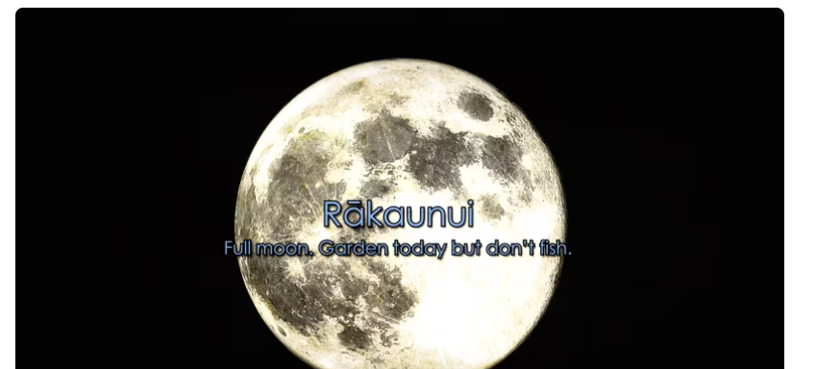
Success criteria:
At the end of this week, students will have a basic understanding of Mātauranga Māori in relation to astronomy, and how Māori used the stars to navigate the ocean, plant crops by season of the year, harvest kaimoana, and to tell the time.

Week 5 Lesson 1 & 2:
Māori astronomy

Task 1: In you Red Book, at the top of a blank page write Week 1, Lesson 1, today’s date, and the heading ‘Revisiting Māori astronomy.’

Task 1b: In your Red Books write down the following definitions and use the word in a sentence. The first one has been done for you as an example:

1. dense: compacted and close together.

Example: The fog was so dense that airplanes could not fly into Wellington.

2. Tāne

3. ethnographer

4. compass

5. align

6. waiata

7. rākaunui

8. kaumatua

9. revitalize

10. Matariki

11. narrative

12. kōrero

Task 2: Next go to the website: ‘‘Revitalising Māori astronomy’ at:
https://www.sciencelearn.org.nz/resources/1274-revitalising-maori-astronomy

Watch the documentary, ‘Rākaunui, full Moon, Garden Today but don’t Fish,
And answer the following questions in your Red Books.

1. How were the stars important for Māori life and how is it related to Māori Whakapapa? (4:45 second mark)

2. Where do Māori believe they originally came from?

3. Much of Māori astronomical knowledge – tātai arorangi started to be lost after the early Europeans arrived in New Zealand. Why? (7:00 sec. mark).

4. Some people look down on Māori stories as being silly. Why is this wrong? (8:00 sec. mark)

5. How is the ‘SMART group’ trying to save the history of Tātai arorangi (9:00 sec.).

6. What are some of the uses of astronomy in Māori life (13:25 sec mark).

7. The Māori used the stars to tells the season and time? How could they tell when it was Winter (13:40 sec.)?

8. What star did they look for to tell it was Summer?

9. The Matariki was important because each year when it appeared it ________ the Māori calendar.

10. Māori have a big connection with planting and harvesting crops. When there was a full moon, crops were thought to grow better (16:15 sec.). How did they believe this happened?

11. How were the stars important in navigating? (17:25)

12. Navigators used a ________ compass to navigate

Homework: Make sure your Red Books are set up and are up-to-date.

Week 5 Lesson 3
Week 8

Mātauranga Māori:

New Zealand’s First Matariki Public Holiday

In Māori culture, Matariki is both the name of the Pleiades star cluster and of the celebration of its first rising in late June or early July. This marks the beginning of the new year in the Māori lunar calendar. It will be celebrated on Friday July 14th this year.

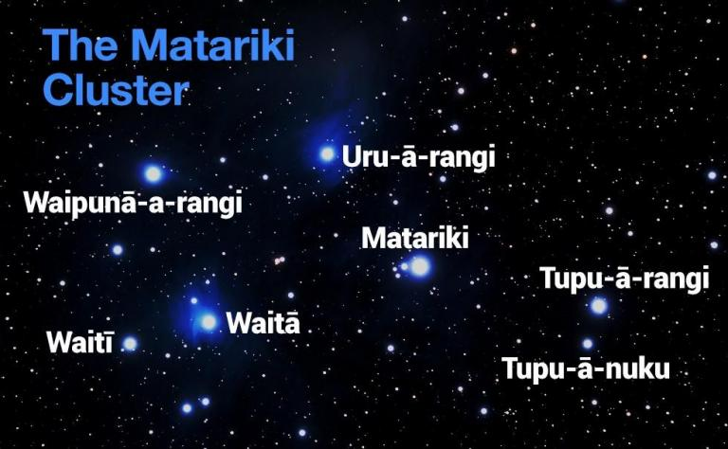

Success criteria:
Students will have a thorough familiarity with the many events that are being held across the greater Auckland region that will be conducted in celebration of the upcoming Matariki holiday and will be able to identify at least two of them and the significance of the celebration.

Task:
You will create a POSTER in your Red Books that describes, in alphabetical order, the many Matariki-related events that will be held across Auckland and their significance.

The PURPOSE of the brochure it to get people excited to attend these events. It will include the following:

1. Begin with a catchy title designed to attract attention and get people to read your brochure.

2. List several different events

3. Describe when and where they are being held

4. What is the significance and meaning of each event in Māori culture.

Your POSTER can be made over 1-2 pages in your Red Book or on a word file.

