Week 4 Global –

Kaitiakitanga (Māori Guardianship)

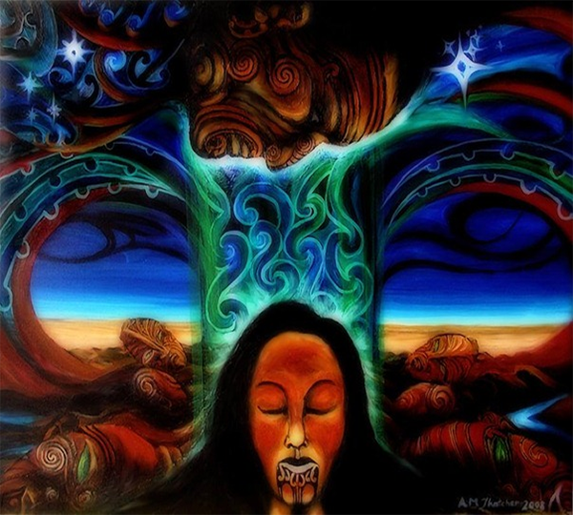

This week will look at the traditional concept of kaitiakitanga which is part of a complex, social, cultural, economic and spiritual system that has been established through long association of iwi and hapū with land and waters. In Lesson 3 we will be focusing on a current event on feral cats in New Zealand - which we will relate to kaitiakitanga later in the week.

Success Criteria
Students will be able to recite key definitions in relation to kaitiakitanga and how this concept relates to mana, tapu, mauri, and rāhui.

Week 4, Lessons 1 & 2

Māori Guardianship


Task 1. In you Red Book, write ‘Lesson 1: ‘Māori Guardianship.’

Task 2. We will watch the video: KAITIAKITANGA - THE UMBRELLA WAY OF LIFE, as a class at: https://www.youtube.com/watch?v=BTTN_V5ZcBc

Class discussion on ‘What is Kaitiakitanga?’

Task 3: Write into your books, the following definition of Kaitiakitanga:

Kaitiakitanga means guardianship and protection. It is a way of managing the environment, based on the Māori world view. A kaitiaki is a guardian. This can be a person or group that cares for an area such as a lake or forest. They are given that role by the local iwi.

Task 4: We are going to look at the story of Kaitiakitanga – guardianship and conservation. Go to: https://teara.govt.nz/en/kaitiakitanga-guardianship-and-conservation/page-1

And read sections 1 to 7. Answer the following questions in your Red Books:

Section 1: Understanding Kaitiakitanga
Read this section for pleasure – it is an overview. There are no questions to answer.

Section 2: Connected to nature
What is the difference between ‘Tangata whenua’ and ‘Taunaha whenua?’

Section 3: Traditional kaitiakitanga
Give 4 examples where customary practices have kept a balance between a community and nature.
a.
b.
c.
d.

Section 4: Kaitiaki – guardians
List all of the different definitions of the word ‘Tiaki.’
a.
b.
c.
d.
e.

f. Hunga is a group with _______ purpose.

g. In Maori culture, what does a kaitiaki do?

h. Can an animal be a kaitiaki? If yes, provide an example.

Section 5: Key Concepts
Define the following words:

a. Mana
b. Tapu
c. Mauri

Section 6: Rāhui – prohibitions

a. Define the word ‘Rāhui.’
b. Give an example.

Section 7: Kaitiakitanga today

a. Name 3 examples of Kaitiakitanga in action.
b. Define the word stewardship.

Task 3: Create a poster in your Red Books that highlights at least 3 elements of ‘Māori Guardianship. What are key themes we have discussed?

Week 4 Lesson 3:

Current Events Analysis: Choose Your Own


Mission Heights Junior College Global Studies

Student name:
Today’s date:

Name of publication: _______________________________

Title of the Article: _______________________________

Author of the Article: _______________________________

Describe what the article is about (using five complete sentences):

Who: _______________________

What: _______________________

Where: _______________________

When: _______________________

Why: ________________________

Examination for bias –

1. Reporters are usually taught to be neutral and unbiased, not letting their emotions get in the way when discussing the facts.

a. Has the author done this?

b. What factors might influence the author’s writing (for example, their culture, nationality (the country they are from), age, gender, religion?

c. How does this article potentially affect your life?

d. What conclusion might you arrive at after reading this article?

2. How could the author have made this article better? Was there a part that was confusing or they could they have added information that would make it easier to understand?

List at least 5 key dot-point takeaways from the article:

Example of what I am looking for

Name: Joe Smith (your name goes here)
Date: June 7, 2024 (today’s date)

Name of publication: The New Zealand Independent
(underline the name of a newspaper or magazine)

Title of the Article: "Mystery Rash Solved"
(place quotation marks around the title)

Author of the Article: Mary Jones

Describe what the article is about (using complete sentences):

Doctors at the Centers for Disease Control in Atlanta in the United States, have been studying a mystery rash affecting students in 14 states since October. They conclude that the rashes are not serious and may be caused by a virus. A small number of ‘rashes’ were determined to have been caused by students rubbing sandpaper on their skin in order to get out of going to school by faking a rash! Some parents were concerned that the rash was the result of a terrorist attack.

Who: American doctors
What: mystery rash
Where: 14 American states
When: since October 2021
Why: worry over health

Key Definitions to keep in mind:

1. Fact: something that is true and cannot be dispute. “Ian Morrison is the principal of Mission Heights Junior College,” is a fact.

2. Opinion: a viewpoint, judgment or assessment. “Ian Morrison is a great principal” is an opinion (although we know it is true!)

3. Neutral: trying to be fair by not taking sides.

4. Biased: showing favoritism; supporting a particular viewpoint.

5. Current Event: recent news events

6. International: anywhere outside of New Zealand.

7. National: anywhere within New Zealand.

8. District: within the control of the Auckland Council

9. Regional: greater Auckland (eg, a 50 km radius of the Sky Tower). This is an arbitrary definition created for convenience

10. Local: within the Botany, Flat Bush & Howick area (roughly)

11. What is ‘local’ is open to interpretation and will vary from person to person, but use my definitions.

12. Journalist: another name for a reporter; a writer who aims for a mass audience. Reporters are usually expected to be neutral in their writing, unless they are writing an editorial, in which case they are expected to give their views on a particular subject, even if it is one-sided. Such articles appear on the editorial page and are clearly labeled as an opinion.

13. Complete sentence: must have a noun (the subject) and a verb (something that the subject did or is doing). A noun is a person, place or thing. A verb is an action word. Hence, a complete sentence would be: “The girl jumped.” (“The girl” = the subject; “jumped” = predicate or verb).

