Week 3, Lesson 1

Rongoā Māori Knowledge & Western Science

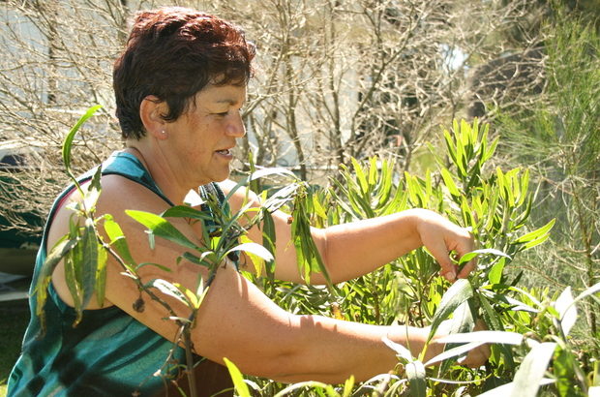

Success criteria:
At the end of this week, students will have a thorough understanding of Mātauranga Māori in relation to traditional Māori healing.

Task 1: In you Red Book, write ‘Lesson 1: ‘An Introduction to Traditional Māori Healing.’ Next go to the following site: https://www.sciencelearn.org.nz/resources/185-rongoa-maori - read the article on Rongoā Māori and answer the following questions:

1. Write the definition of Rongoā Māori.

Class discussion: How many people are aware of different uses that Māori or Pacifica people have for various plants that grow in New Zealand? Can any students name any of these plants and their uses?

2. How was Māori health when James Cook arrived in New Zealand?

3. Describe how the Māori had a holistic approach to healing. What is it?

4. Look up the definition of ‘Rongoā’ online and write it down.

5. According to the reading, Māori used a holistic approach to healing. Define the word ‘holistic.’

Task 2: The holistic approach to healing that has been used by Māori included four things. What were they? Write what they were and what it means in Māori. Number 1 has already been done – write it into your book.

1. mauri (spark or life force)

2.

3.

4.

Week 3, Lesson 2

Rongoā Māori Knowledge & Healing

Under the section, ‘Rongoā Fighting Infection,’ write down the six plants and how they are used to keep Māori healthy. Also draw a picture of each plant in your book. Number 1 has already been done as an example.
1. Koromiko
The tips of the leaves can be chewed to help with such conditions as diarrhoea. During World War II, the dried leaves from this plant were shipped to Kiwi soldiers and it was reported to have been very effective.
The tips of the leaves were also chopped up and placed on skin sores of babies. Today scientists have identified the active ingredient as phenolic glycocide.
Picture Below:
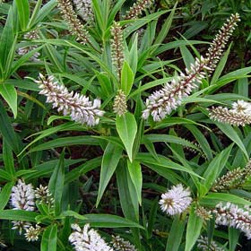
2. Kōwhai

3. Harakeke (flax)

4. Pōhutukawa

5. Pūriri

6. Kawakawa
Week 3 Lesson 3:

Current Event Analysis #1
The Strange Case of the Japanese KFC Christmas

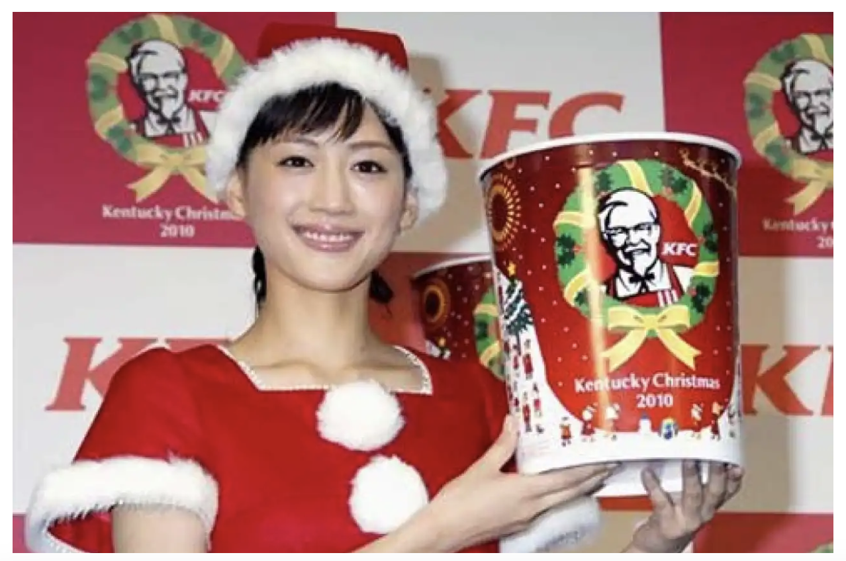

Believe it or not – and do believe it because it’s true – in Japan there is a tradition of eating Kentucky Fried Chicken at Christmas!

Task 1: Watch the video ‘How KFC became a Japanese Tradition.’ https://www.youtube.com/watch?v=DYDDxfpV-WE

Task 2: Read the article on Great Waikato Crocodile Hunt of 1886 at: https://www.timeout.com/tokyo/things-to-do/whats-the-deal-with-kfc-and-christmas-in-japan

1. Who is the Japanese man who is credited with starting the tradition of KFC at Christmas?

2. What year is the tradition believed to have started?

3. What two factors made birthing this new tradition rather easy?

4. How big is the tradition in terms of sales?

5. How has KFC gotten even more customers?

6. Based on watching the video clip, create at least six key dot-points.

a.
b.
c.
d.
e.

