Week 3:
Nature v Nurture
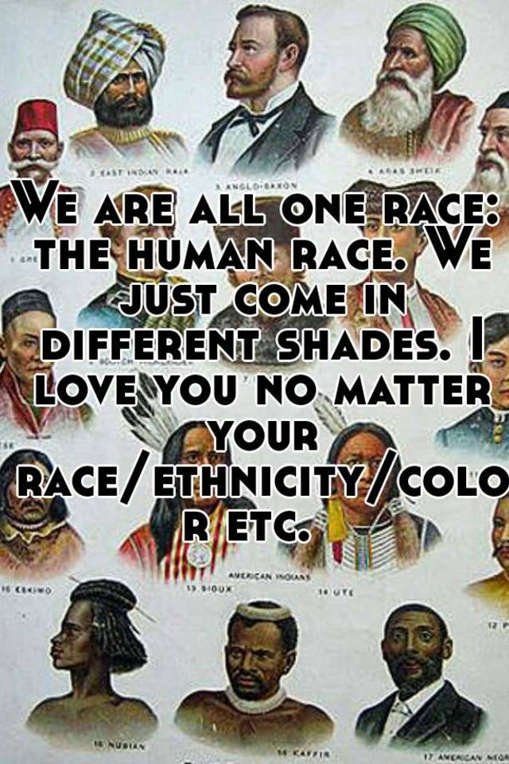

Success Criteria:

By the end of the week students will be able to recount at least 3 aspects surrounding genetics versus environment and the myth of race.

This week we will be watching the documentary, Race: The Power of an Illusion.

Lesson 1:

1. “And the beauty of the race business is that you can identify people by just ______ __ _____. “ (1:40 sec.)

2. “The idea of race assumes that simple external differences rooted in biology, are linked to more complex external differences. List 3 examples (2:00)

a.
b.
c.
3. “…in fact that race is not based on ________, but race is rather an idea that we ascribe to _________.

4. There is a common belief that people of colour are better at sports than lighter-skinned people. THIS HAS NOT BEEN SCIENTIFICALLY PROVEN!

5. Only one in every 1,000 nucleotides that make up our genetic code is different from one ______ to another. Any two fruit flies may be as different genetically from each other as a human is from a ____________.

6. List the different ways that scientists tried to differentiate one ‘race’ from another.

a. One example is by measuring their facial angles, saying the more slanted foreheads showed they were closer to the primitives. What are some others? (10:30 sec.)
b.
c.
d.
e.
f.
g.
h.

7. No less than 28 states in the USA passed laws banning African Americans from marrying Europeans to safeguard ________ ________ __________. (15:50 sec.)

8. Look up the definition of eugenics.

9. How did the ‘Wind Tribe’ get its name? What country did they live in? (18:00 sec.)

10. The Nazis believed in eugenics and that the German Aryan race was superior to all others. Where did Hitler get the idea of eugenics from?

11. When Jesse Owens won gold medals at the 1936 German Olympics, what did the American team coach say was the reason Owens was so fast?

12. How can you measure race? (23:00 sec.)
Lesson 2:

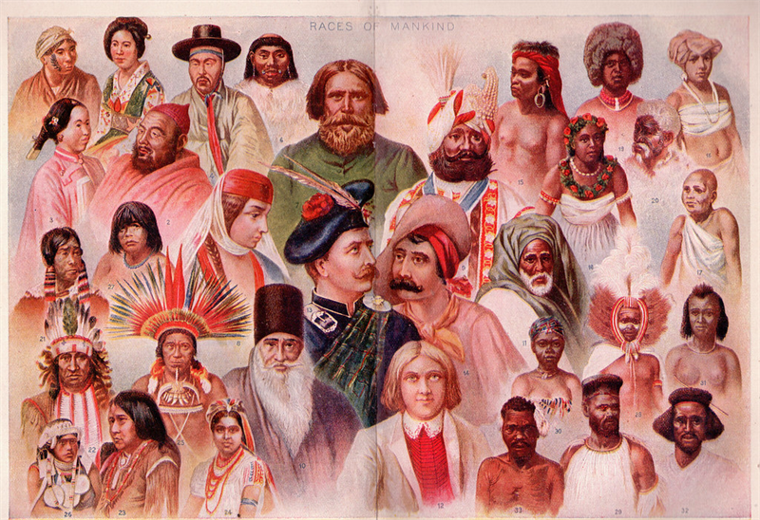
Continue watching and answering the questions from the documentary:

13. People who have dark melanin (the pigment that gives your skin its colour) have ancestors who grew up where?

14. Explain the Vitamin D theory of dark and light melanin?

15. People like to talk about the genes for sporting ability, for making money, for music, but we have to be careful – why?

16. In 1928-1929, the world champions at basketball were all of one ‘race.’ What ‘race’ dominated American basketball in the 1930s? This had changed by 1992 when America’s Olympic ‘Dream Team’ basketballers were almost all ___________-_________.

17. In the 1960s, Richard Lewontin tried to find out how different and similar groups were around the world. How did he go about doing this?

18. Are the people who we call black more like each other than they are like people who we call white, genetically speaking. The answer is no – there is as much or more diversity and genetic difference within any racial group as there is between people of different racial groups. (38:00 sec.)

19. It was once thought that Sickle Cell Disease occurred in ‘black’ people, but we now know that instead of genetics, there is a better way to explain the presence of this disease. What is it related to in the environment?

20. Humans first came from which continent and then spread around the world?

Lesson 3:

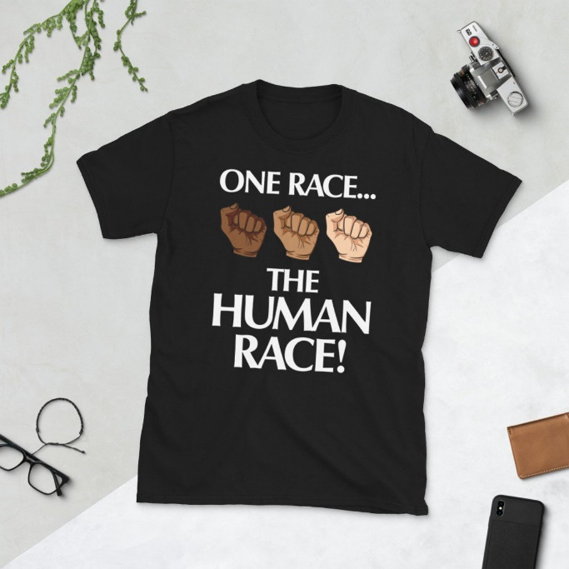

Between the 49 and 51-minute marks, it is noted that just because race isn’t something that isn’t biological, doesn’t mean it’s not real.

Task: List the different ways that are discussed at this point in the documentary (from the 49-minute mark onward), as to which social factors (environmental factors) are more important and influential in how someone will become successful. Next, create a poster a page in your Red Books discussing this.

