Week 3 – Survival

Threat to the Planet:
An Inconvenient Truth

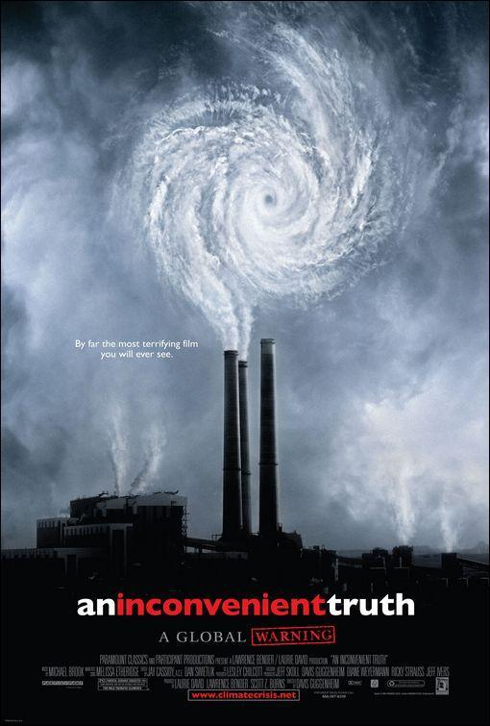

Success Criteria
Students will become familiar with key scientific evidence that supports the idea that human-created CO² in the earth’s atmosphere is responsible for global warming and that it is an imminent threat to humanity. Students will be able to identify who Roger Revelle is and why his research is so significant.

This week we are going to focus on the documentary/film, ‘An Inconvenient Truth’ (by Al Gore). We will also watch it in class. The documentary will be stopped and started as students answer the key questions below, in your Red Books. If you are not in class during these days, you are expected to access the film through Google Classroom, then write down and answer the questions. While this came out about 15 years ago, many of its predictions have already come true and the conclusions are just as valid today as they were then.

We are devoting all 3 lessons this week to the film because global warming is a threat to our very existence as a species! We are going to do a nice job and write down and answer every question over this period. At times, I will stop the film to discuss. If you can shorten the question by re-writing it – by all means do so.

Lesson 1: Task 1 = Class discussion

What do students think about the threat from climate change? What about recent wild weather in Auckland (floods) and New Zealand in general (Cyclone Gabrielle).

Lesson 1 – we will watch the film (stopping on occasion) ending at the 20-minute mark. Questions:

1. Al Gore says what gets us into trouble is not what we don't know but ___________________________________________________________________________________________________________. (8:00 mark)

2. What is the most vulnerable part of the earth's ecological system? (8:40 sec.)

3. Why is it so vulnerable?

4. After watching the cartoon, write a simple explanation of global warming that a child would understand. In other words - give a very simple explanation for global warming as discussed in the cartoon. (10:23 sec. to 12:00 sec)

5. In the mid-1950s, few scientists were concerned that humanity was adding carbon dioxide gas (CO2) to the atmosphere by burning fossil fuels. One of those who was, was Roger Revelle who was the first scientists to propose measuring the amount of ______________ in the atmosphere (12:15 sec.)

6. Why did Professor Revelle pick the Pacific Ocean to do his tests on the atmosphere?

7. Why does the pattern of Co2 in the atmosphere go up and down, over and over again? (14:30 sec.)

8. What does Al Gore say has been relentless since at least 1958? (16:45 Sec.)

9. What does Mr Gore say is happening to many glaciers around the world? (16:50 sec.)

10. Al Gore says that the ice has a story to tell. The ice core samples which reflect temperature changes over the past 1,000 years show us what? (18:50 sec.)

Lesson 2:
We will view the film, occasionally pausing for class discussions and stop at the 45:00-mark.

11. In Antarctica, scientists can study the ice and tell what the temperature was as far back as _____________ years (20:40 sec.)

12. Al Gore says that when there is more carbon dioxide in the air, the ______________ gets warmer (22:00)
13. If you look back at the temperature trend since the American Civil War (in the 1860s), at the time this film, 'An Inconvenient Truth,' was made, "the ten hottest years on record occurred ____________________

14. Now go online and Google "the 10 hottest years on record" and write down when they were.

15. Not only have air temperatures been increasing over the past century, but also the temperature of the _______________. (29:40 sec.)

16. When the oceans get warmer, it causes bigger ____________________. (30:30 sec.)

17. The science textbooks have had to be rewritten because they say it's impossible to have ___________________________. (31:00 sec.)

18. Hurricane Katrina hit New Orleans in 2005. It went from a Category 1 to bordering on a Category 5 in a short amount of time because of the _____________________? (31:30 sec.)

19. In 2005 in Mumbai, India, there were ____ inches of rain in ______ hours. (37:50 sec.)

20. Global warming not only causes more flooding but more ________ (38:00 sec.)

21. What has happened to Lake Chad near Darfur? (39:00 sec.)

22. What does global warming do to the soil?

23. How is global warming affecting the Arctic region at the bottom of the world? (42:00 sec.)

24. What speeds up the ice caps melting at the poles? (44:00 sec.)

Lesson 3:
We will view the film, occasionally pausing for class discussions and finishing from the 45:00-mark.

25. How does the Arctic Ice Cap act like a giant mirror?

26. The earth's climate is like a big engine for redistributing __________from the equator to the ______ and it does that by means of _______ currents and _______ currents. (46:20 sec.)

27. On a worldwide basis, what is the average temperature of the earth?

28. Global warming is changing the seasons. It is also resulting in more invasive species. What insect that bites humans, is climbing to higher altitudes with the warming temperatures and putting more people at risk for diseases like malaria?
29. Name some other insects that are likely to cause problems as the temperatures warm. (51:00 sec.)
a.
b.
c.
d.

30. What are some animal pests that are likely to grow in numbers with warming?
a.
b.
c.
d.
e.

31. How is global warming affecting Antarctica (54:30 sec.)

32. If the Greenland ice sheet were to melt, it would raise global sea levels by ______________. (57:00 Sec.)

33. The pools of water on the top of melting ice sheets make the glaciers look like Swiss ____________.

34. What is a moulin? How do they make the glacier or ice sheets melt faster?

35. Because of what is happening in Greenland right now, the ______ of the world will have to be redrawn (59: sec.).

36. At the 1-hour mark (60:00 sec.) watch closely what will happen if the ice sheets were to melt. There is nothing to answer here - but this is a key part of the documentary. Watch closely.

