Week 1: Lesson 1

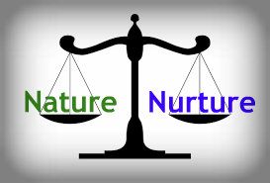
Success criteria: By the end of the week students will have been able to distinguish and recount key differences between the concepts of nature and nurture.

Task 1:
New Unit – Setting Up Your Books
In your Red Book, about a third of the way down the page, use a ruler to draw a line across the page. Above the line write ‘Nature v Nurture.’

Class discussion
How much are we affected by our genetics? (Nature)
How much is affected by our environment? (Nurture)

Class Discussion & Review from Year 9
- Some key points about nature and nurture – can you remember?

- 1. Race is a myth, but many people believe that it is real, and therefore it is used as a basis for discrimination.

- 2. Race is an illusion. What is the meaning of this? What is an illusion? Why is race considered to be an illusion?
- 3. Is the myth of race considered to be settled science or is it open to debate? There is no debate among reputable scientists – race is a fairy tale – a biological myth.

- 4. What is melanin?

What determines your IQ?
Your IQ supposedly refers to how smart you are.
Your IQ stands for your Intelligence Quotient and is a total score derived from a set of standardized tests.
Watch the following video – ‘Where does intelligence come from?’ at: https://www.youtube.com/watch?v=BmOfPw_h6mc
After watching the video clip, complete the task below
.
*Note - There is a debate over how much weight people should place on someone’s IQ because a number of factors can affect your score including the school you attend and your ethnic group.

Task:
At the top of a page in your Red Book, write the words ‘Nature’ and ‘Nurture’ and draw a line between them extending down the page. Under each heading, write down key features of these terms (Nature & Nurture) based on looking at the information on the next two pages.

Nature Nurture

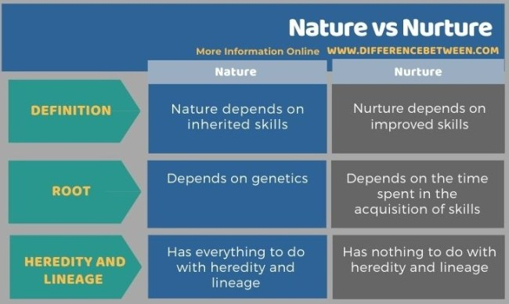

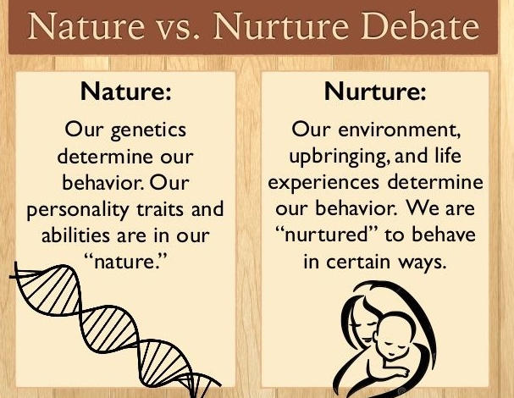

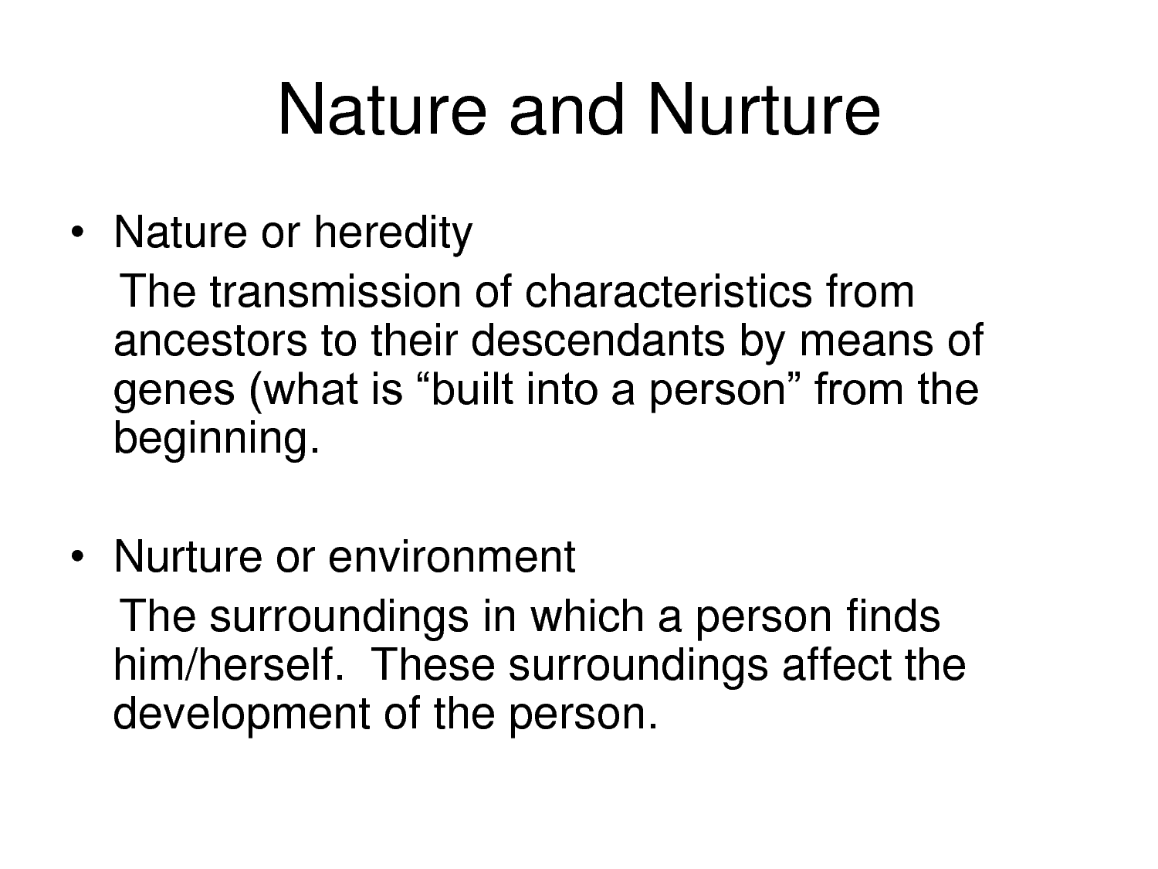

Week 2 Lesson 2
The Power of Environment & Belief
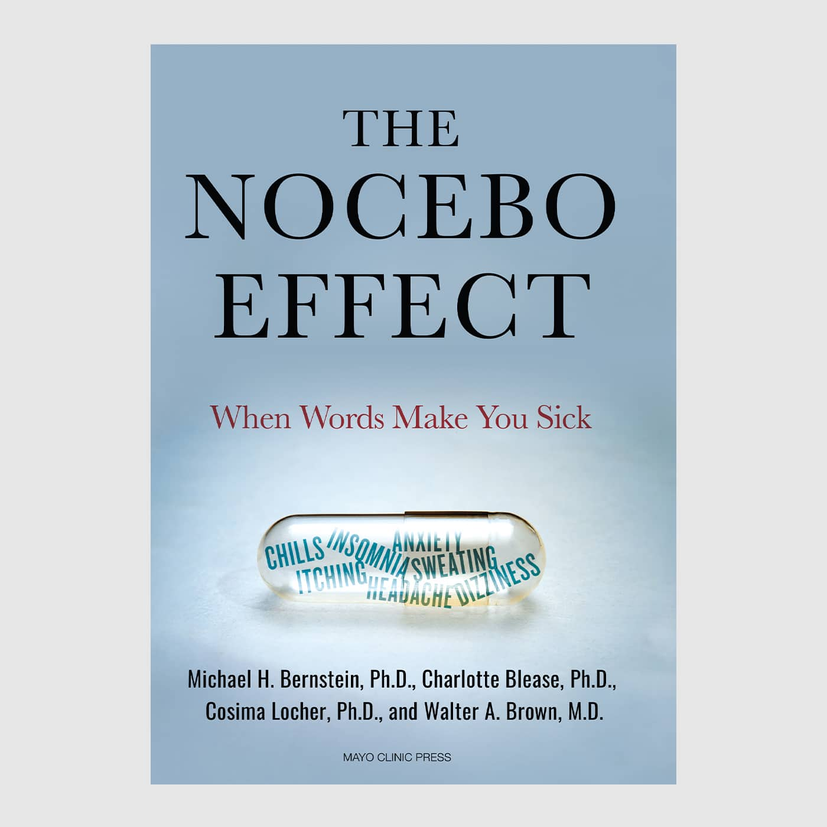

The Power of Environment

- As a class we will watch the following video:
- https://www.youtube.com/watch?v=OUdXMoY6fLY (stop at the 11:30 sec. mark)
Write out and respond the following questions:
1. What is the Nocebo Effect? Look it up online and write out the definition. Do the same for the Placebo Effect.
A.) Nocebo Effect:
B.) Placebo Effect
2. Have you ever experienced something similar to what happened in the video?
3. Was the reaction in the video to the red light, an example of the nocebo or placebo effect?
4. What is the ‘hot dog torture’ device? Is that more an example of nature or nurture?
5. Write a half-page summary describing what happened in the bone density experiment.

Lesson 3: The Power of Nurture

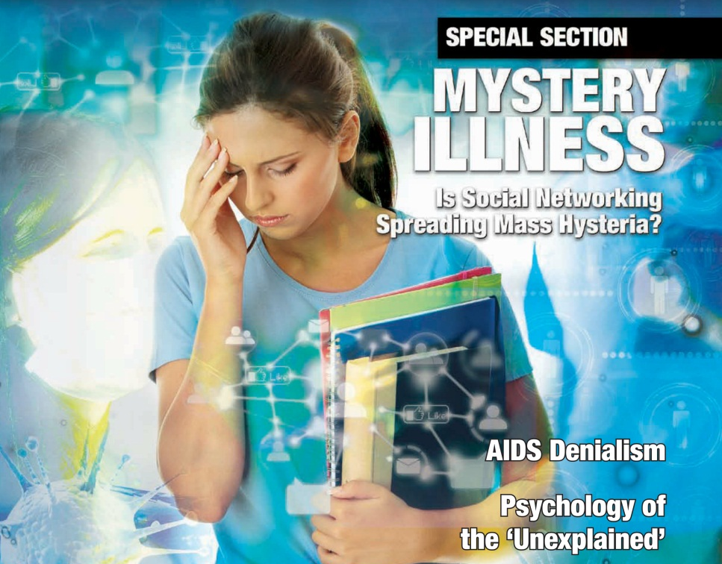

The Mysterious Illness in Nelson that Never Was…
- A few years ago in Nelson, a group of students during Sport’s Day went into a swimming pool. Within a few minutes, one of them jumped back out and vomited! Suddenly over a dozen other students became unwell and got out of the pool. Soon ambulances came to the pool and took several students to hospital. Within a few hours, all of the students had been checked out by doctors and seemed fine, although their hearts were racing, and they appeared nervous. Tests were conducted on water samples taken from the swimming pool. The water was normal. It was later concluded that this was an outbreak of mass suggestion triggered by the power of suggestion.
- Mass hysteria (commonly referred to as mass psychogenic illness) can happen to anyone as it is based on a belief. Just like the placebo effect where you can take a sugar pill and think you will feel better – and often you will. Think of mass hysteria as the placebo effect in reverse.

Class Discussion
- Read the article, “Why are females prone to mass hysteria?” in Psychology Today Magazine at: https://www.psychologytoday.com/nz/blog/its-catching/201703/why-are-females-prone-mass-hysteria

Write out and answer the following questions in your Red Books:
- What is the case for nature – that females are genetically prone to ‘mass hysteria’ (psychogenic illness) where they can make themselves sick just by thinking about it?
- Make the case for nurture. What is the evidence that psychogenic illness is a result of their environment?

Complete the following definitions in your books:
- 1. Feminist
- 2. Psychological
- 3. Pacifist
- 4. Collective
- 5. Stigma
- 6. conversion
- 7. Shaman
- 8. Repercussion
- 9. Subconscious

